***Embedded System & Robotics***



**PREFACE**

“Learn AVR in 15 days”, is an initiative to explore the AVR microcontroller and its interfacing as much as possible in 15 days. The best part of this initiative is that you can learn the basics of programming an AVR microcontroller which is the best microcontroller used in industry for almost all Low-level applications development that involves tea/coffee vending machines, Display systems, RFID detection system, automatic door lock, home automation systems, office automation etc.

This book has been written in such a way that the person reading this book get to know the basics of the embedded programming and startsimplementing his/her ideas related to the embedded world by himself without much effort. The book has very less theory just to make the person understand the basics behind working of a peripheral and their interaction with the brains of the embedded devices i.e. microcontrollers.

The book starts with an introduction to embedded system, microcontroller, various different parts of microcontrollers, some basics of embedded programming., interfacing LEDs, SSDs, LCDs, Motors etc to intermediate complicated devices like Stepper motor, keypads. The book also introduce the person to some internal circuits in microcontrollers which the person can utilize in implementing his/her ideas e.g. TIMERs, one of the most sophisticated circuits inside the microcontrollers.

For those who think that programming is a difficult task, let us clear it that programming an embedded

device is not about programming they are about implementing logics. You just need to know few basics of

'C' like implementing the loops and fuction, rest you have to implement your ideas using these.

As you start writing programs by yourself, you will feel the same. Creating fuctions and calling them at

right time is what embedded programming is all about.

Hope you enjoy reading this book as much as we enjoyed writing it. Webtek labs…….. !!!!!

websit[e : **info@webteklabs.com**](http://www.i3indyatechnologies.com)



websit[e : **info@webteklabs.com**](http://www.i3indyatechnologies.com)



websit[e : **info@webteklabs.com**](http://www.i3indyatechnologies.com)



**TRANING SYLLABUS**

DAY TOPICS

1 Introduction to i3indya & Robotics

Introduction to Embedded System

AVR Series Micro-Controllers & ATMEGA 16

Drivers & Software Installation

2 LED Interfacing with ATMEGA 16 – Theory

**Practical 1:** Glowing LEDs in a pattern of your choice

Seven Segment Displays – Theory

**Practical 2:** Displaying Digits on Seven Segment Displays LED Matrix – Theory

Practical 3: Generating Patterns on LED Matrix

**Practical 4:** Display Alphabets on LED Matrix

3 LCD Interfacing with ATMEGA 16 – Theory

**Practical 5:** Displaying Text on LCD

4 LCD Interfacing Continued..

**Practical 6:** Scrolling Text on LCD

**Practical 7:** Creating Simple Animation on LCD

**Project 1:** Digital Clock

5 DC Motor Interfacing with ATMEGA 16 – Theory

L293D IC & Its Need - Theory

**Practical 8:** Learning Interfacing of Motor with LEDs & LCD

**Practical 9:** Controlling Direction of Rotation of a Motor

Stepper Motor Interfacing with ATMEGA 16 - Theory

websit[e : **info@webteklabs.com**](http://www.i3indyatechnologies.com)

**Practical 10:** Rotation in forward and backward direction

**Practical 11:** Controlling speed of stepper motor

**Practical 12:** Rotating stepper motor at given angle/distance

6 Working of IR Sensors – Theory

Digital IR Sensors – Theory

**Practical 13:** Detecting White and Black surface with Digital IR Sensors.

**Practical 14:** Controlling Motor with Digital IR Sensor.

**Practical 15:** Calculating Speed of a moving robot.

Introduction to ADC – Theory

Analog IR Sensors - Theory

**Practical 16:** Measuring Distance of an object using Analog IR Sensors.

**Practical 17:** Controlling Motor using Analog IR Sensor.

7 **Project 2:** Line Follower Robot

**Project 3:** Wall Follower Robot **Project 4:** Tachometer Prototype **Project 5:** Visitor Counting Application

Assignment & Revision

8 Buzzer interfacing with ATMEGA 16 – Theory

**Practical 18:** Generating Beep through Buzzer

Interfacing of Temperature Sensor – Theory

**Practical 19:** Calibrating Sensor value with Temperature Range

**Project 6:** Digital Thermometer

**Project 7:** Temperature Controlled Fan

**Project 8:** High Temperature Alarm

9 Keypad Interfacing with ATMEGA 16 – Theory

**Practical 20:** ON\OFF LED\Motor\Buzzer using single key

Linear Keypad - Theory

**Practical 21:** Controlling Motor (ON\OFF, Direction of Rotation) using Linear Keypad

**Practical 22:** Writing text on LCD using Linear Keypad

**Project 9:** Stop Watch

10 Matrix Keypad Interfacing – Theory

**Project 10:** Keypad Operated Robot

**Project 11:** Mobile Phone Keypad prototype

websit[e : **info@webteklabs.com**](http://www.i3indyatechnologies.com)

11 **Project 12:** Password Controlled Application – ATM Prototype

**Project 13:** Calculator

Assignment

12 PWM – Theory

**Practical 23:** Controlling brightness of a LED.

Speaker Interfacing with ATMEGA 16

**Practical 24:** Generating different frequencies from Speaker

**Practical 25:** Integrating Keypad with Speaker

**Practical 26:** Integrating IR Sensor with Speaker

**Project 14:** Digital PIANO

13 Interfacing RGB LED

**Practical 27:** Generating different colours from RGB LED

**Practical 28:** Integrating Keypad with RGB LED

**Practical 29:** Traffic light prototype using single LED

Interfacing LDR Sensor with ATMEGA 16

**Practical 30:** Colour detection using LDR sensor in Analog Mode

**Project 15:** Colour Changing Spy Bot using LDR & RGB LED*

14 More Projects You can do

15 Exam – Theory & Practical

websit[e : **info@webteklabs.com**](http://www.i3indyatechnologies.com)

websit[e : **info@webteklabs.com**](http://www.i3indyatechnologies.com)

1

-

DAY

TOPICS TO BE COVERED

è Introduction to Embedded Systems

è Introduction to AVR microcontrollers

& ATmega16

è Drivers & software Installation

**Description:**

1st day you will learn about the embedded system and robotics and about its future scope and industry trends. We have also mentioned about the Embedded C programming steps along with operators, function and conditional loop explanation.After this you have to install the required software like AVRstudio4, WINavr and drivers for USBasp programmers.You will also learn about ATmega16 MCU pin description along with its specification.

websit[e : **info@webteklabs.com**](http://www.i3indyatechnologies.com)



**EMBEDDED SYSTEMS**

Embedded Systems is simply the brain of the most of the electronics based systems to access, process, and store and control the data. Few simple electronics circuits can be intelligently hardware designed without a microprocessor or microcontroller but is not worth the economics except for simple passive operations. So it's more or less, must to put this so called silicon brain, which we engineers call as microcontroller, in all electronics systems.

*“A combination of hardware and software which together form a component of a larger machine.Embedded systems are designed to do some specific task, rather than be a general-purpose computer for multiple tasks.”*

**Embedded Systems Applications?**

Being an electronic engineer, you might have seen PC desktop's motherboard; it's an embedded system. It has microprocessor (Pentium or Athlon), memory (DRAM DIMM module and onboard SRAM), I/O interface (keyboard, mouse etc..), Peripheral communication interface (PCI, USB port, etc).

This PC system's architecture is designed for application such as net surfing, excel, word, PowerPoint, and

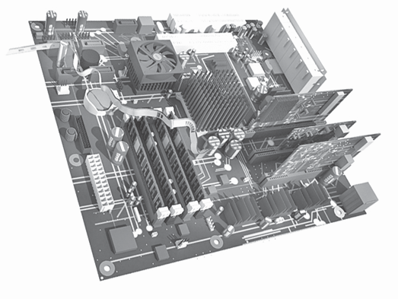

you know the rest!!! Say you want to use same computer to monitor the engine of your bike or car.

Can you think of using big PC for that purpose? It's so impractical. The I/P and O/P are totally different, here comes customizing your own microprocessor/microcontroller, memory, display, I/O and peripheral interface and also the operating system.

This field of designing application specific computer systems is called embedded systems development.

3 websit[e : **info@webteklabs.com**](http://www.i3indyatechnologies.com)

If the response of the computer system need to be real time and highly reliable then it's called Real Time Embedded System. The real time means, say in a control system where a speed of motor need to varied the moment some parameter deflect from its original value, then it's real time; no waiting or hanging.

To define in a sentence,***“Embedded Systems is a special purpose computer system/board, which encapsulates all the devices such as processor, memory, interface and control in single package or board to perform only someapplication specific tasks.”***

You can think of embedded system as:

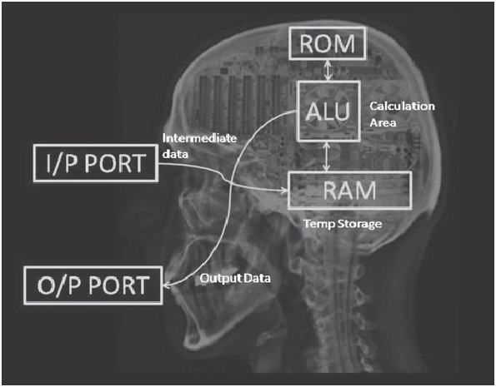

Every Embedded system consists of three parts:

1. The Input devices

2. The processing devices

3. The Output devices

Thus, the brain of an embedded system is a microcontroller or a microprocessor which processes all the input information provided to it by the input devices i.e. different sensors, actuators, they take their decisions depending upon the algorithm (Programs) defined/fed inside it and perform the action using the output devices such as motors, LCDs etc.

Embedded Systems is simply the brain of the most of the electronics based systems to access, process, and store and control the data. Few simple electronics circuits can be intelligently hardware designed without a microprocessor or microcontroller but is not worth the economics except for simple passive operations. So it's more or less must to put this so called silicon brain, which we engineers call as microcontroller in all electronics systems.

**The most common examples are:**

ª Cell-phones

ª Automatic Teller Machine

ª The Digital Interfaced Gasoline Station

ª Airborne Flight Control System

4 websit[e : **info@webteklabs.com**](http://www.i3indyatechnologies.com)

ª Automotive Engine Health Monitoring System

ª Home Security Systems

ª Modern Air-conditioners

ª Washing Machines

ª Medical Equipment

ª DVD Players

ª Printers

ª Medical Equipment

The list goes on Wherever the microcontroller is used it's embedded computer.

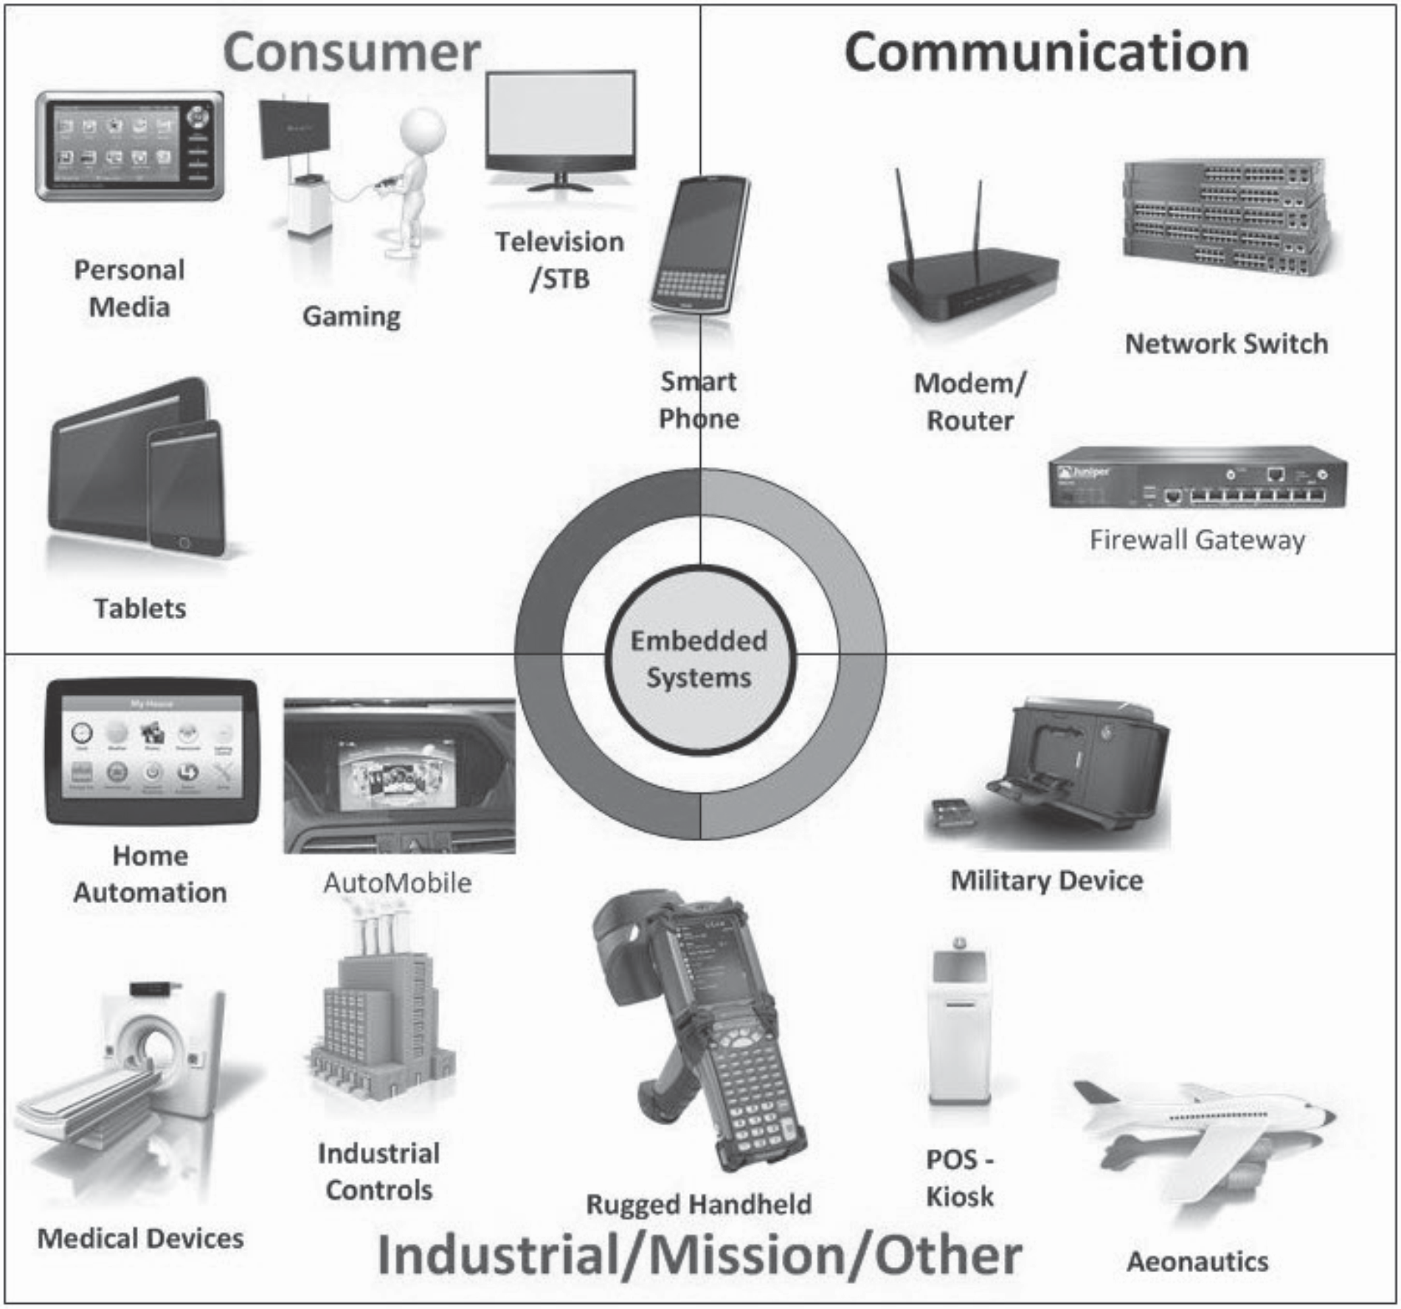

5

websit[e : **info@webteklabs.com**](http://www.i3indyatechnologies.com)

**HISTORY**



It was year 1969, and a team of Japanese engineers from the BUSICOM company arrived to United States with a requestthat a few integrated circuits for calculators be made using their projects. The proposition was set to INTEL, and MarcianHoff was responsible for the project. Since he was the one who has had experience in working with a computer (PC) PDP8, it occured to him to suggest a fundamentally different solution instead of the suggested construction. This solution presumed that the function of the integrated circuit is determined by a program stored in it. That meant that configuration would be more simple, but that it would require far more memory than the project that was proposed by Japanese engineers would require. After a while, though Japanese engineers tried finding an easier solution, Marcian's idea won, and the first microprocessor was born. In transforming an idea into a ready madeproduct

,FredericoFaggin was a major help to INTEL.

He transferred to INTEL, and in only 9 months had succeeded in making a product from its first conception. INTEL obtained the rights to sell this integral block in 1971. First, they bought the license from the BUSICOM company who had no ideawhat treasure they had. During that year, there appeared on the market a microprocessor called 4004. That was the first 4-bit microprocessor with the speed of 6 000 operations per second. Not long after that, American company CTC requested from INTEL and Texas Instruments to make an 8-bit microprocessor for use in terminals. Even though CTC gave up this idea in the end, Intel and Texas Instruments kept working on the microprocessor and in April of 1972, first 8-bit microprocessor appeard on the market under a name 8008. It was able to address 16Kb of memory, and it had 45 instructions and the speed of 300 000 operations per second. That microprocessor was the predecessor of all today's microprocessors. Intel kept their developments up in April of 1974, and they put on the market the 8-bit processor under a name 8080 which was able to address 64Kb of memory, and which had 75 instructions, and the price began at $360.

In another American company Motorola, they realized quickly what was happening, so they put out on the market an 8-bit microprocessor 6800. Chief constructor was Chuck Peddle, and along with the processor itself, Motorola was the first company to make other peripherals such as 6820 and 6850. At that time many companies recognized greater importance of microprocessors and began their own developments. Chuck Peddle leaved Motorola to join MOS Technology and kept working intensively on developing microprocessors.At the WESCON exhibit in United States in 1975, a critical event took place in the history of microprocessors. The MOS Technology announced it was marketing microprocessors 6501 and 6502 at $25 each, which buyers could purchase immediately. This was so sensational that many thought it was some kind of a scam, considering that competitors were selling 8080 and 6800 at $179 each. As an answer to its competitor, both Intel and Motorola lowered their prices on the first day of the exhibit down to $69.95 per microprocessor. Motorola quickly brought suit against MOS Technology and Chuck Peddle for copying the protected 6800. MOS Technology stopped making 6501, but kept producing

6502. The 6502 was a 8-bit microprocessor with 56 instructions and a capability of directly addressing

64Kb of memory. Due to low cost , 6502 becomes very popular, so it was installed into computers such as:

6 websit[e : **info@webteklabs.com**](http://www.i3indyatechnologies.com)

KIM-1, Apple I, Apple II, Atari, Comodore, Acorn, Oric, Galeb, Orao, Ultra, and many others. Soon appeared several makers of 6502 (Rockwell, Sznertek, GTE, NCR, Ricoh, and Comodore takes over MOS Technology) which was at the time of its prosperity sold at a rate of 15 million processors a year!

Others were not giving up though. FredericoFaggin leaves Intel, and starts his own Zilog Inc.In 1976 Zilog announced the Z80. During the making of this microprocessor, Faggin made a pivotal decision. Knowing that a great deal of programs have been already developed for 8080, Faggin realized that many would stay faithful to that microprocessor because of great expenditure which redoing of all of the programs would result in. Thus he decided that a new processor had to be compatible with 8080, or that it had to be capable of performing all of the programs which had already been written for 8080. Beside these characteristics, many new ones have been added, so that Z80 was a very powerful microprocessor in its time. It was able to address directly 64 Kb of memory, it had 176 instructions, a large number of registers, a built in option for refreshing the dynamic RAM memory, single-supply, greater speed of work etc. Z80 was a great success and everybody converted from 8080 to Z80. It could be said that Z80 was without a doubt commercially most successful 8-bit microprocessor of that time. Besides Zilog, other new manufacturers like Mostek, NEC, SHARP, and SGS also appeared. Z80 was the heart of many computers like Spectrum, Partner, TRS703, Z-3 .

In 1976, Intel came up with an improved version of 8-bit microprocessor named 8085. However, Z80 was so much better that Intel soon lost the battle. Altough a few more processors appeared on the market (6809, 2650, SC/MP etc.), everything was actually already decided. There weren't any more great improvements to make manufacturers convert to something new, so 6502 and Z80 along with 6800 remained as main representatives of the 8-bit microprocessors of that time.

**MICROCONTROLLER VS MICROPROCESSOR**



**What is a microcontroller? Microcontroller overview & Basic layout**

**Definition:** A microcontroller is a single chip containing at least a CPU, non-volatile memory, volatile memory, a timer and an I/O control unit.Basically a microcontroller can be described as a computer on a chip. The difference between a microcontroller and a regular PC is that the PC is a general purpose computer while a microcontroller is a computer dedicated to one or just a few tasks. A microcontroller apart from the above mentioned components usually also include, but not limited to, serial communication capabilities, interrupt controls and analog I/O capabilities. The figure below gives the basic layout of a general AVR microcontroller.

7 websit[e : **info@webteklabs.com**](http://www.i3indyatechnologies.com)



**Major manufacturers of microcontrollers include:**

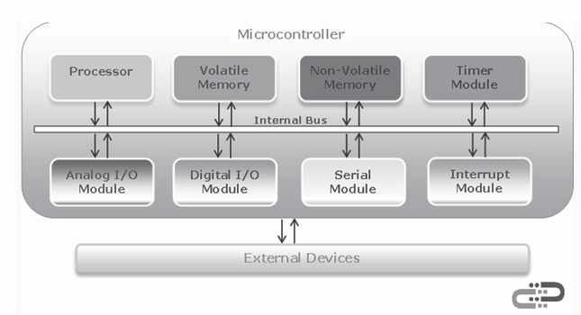

ª **Atmel Corp. -** Manufacturers of the popular AVR series of microcontrollers.

ª **Microchip Technology Inc. -** Manufacturers of the PIC series of microcontrollers.

ª **Texas Instruments Inc. -** One of the world's largest semiconductor companies.

ª **Renesas Technology Corp. -** A joint merger of Hitachi and Mitsubishi product lines.

8 websit[e : **info@webteklabs.com**](http://www.i3indyatechnologies.com)

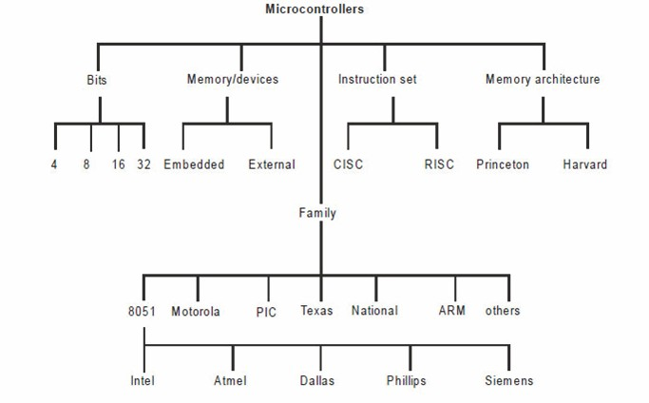

**Types of microcontrollers**

**Microcontroller Components/Peripherals:**

**Processor -** The processor refers to the Central Processing Unit (CPU) of the microcontroller. It contains the Arithmetic Logic Unit (ALU), Control Unit, Instruction Decoder and some Special Registers (Stack Pointer, Status Register, Program Counter, etc.).

**Volatile Memory-** This is memory used by the microcontroller for temporary data storage, system setup and peripherals configurations. Memory in this category includes SRAM and DRAM. AVR microcontrollers utilize SRAM.

**Non-Volatile Memory-** This is memory used by the microcontroller to store programs. Data can also be stored in this memory but the access time is much slower than that of RAM. Memory in this category includes ROM, PROM, EPROM, EEPROM and FLASH. The AVR microcontrollers utilize Flash for program storage, some AVR controllers contains a bit of EEPROM as well.

websit[e : **info@webteklabs.com**](http://www.i3indyatechnologies.com)9

**Timer Module-** Most microcontrollers have at least one timer/counter peripheral. Timer/Counter modules are used to perform timing or counting operations in the controller. These include time stamping, measuring intervals, counting events, etc.

**Interrupt Module-** Interrupts enable the microcontroller to monitor certain events in the background while executing an application program and react to the event if necessary pausing the original program. This is all coordinated by the interrupt module.

**Digital I/O Module-** This module allows digital/logic communication with the microcontroller and the

external world. Communication signals are that of TTL or CMOS logic.

**Analog I/O Modules-** These modules are used to input/output analog information from/to the external

w o r l d . A n a l o g m o d u l e s i n c l u d e A n a l o g C o m p a ra t o r s a n d A n a l o g - t o - D i g i t a l C o nve r t e r s .

**Serial Modules-** These modules are used for serial communication with the external world. An example is

the USART peripheral which utilizes the RS232 standard.

**Microcontroller vs Microprocessor**



**What is a microcontroller?**

A **Microcontroller** is basically a computer on a chip. It differs from normal desktop or laptop computers in that a microcontroller is an application specific computer that usually runs a **single program** performing dedicated task(s) while the latter two are general purpose computers that can run numerous programs depending on a user needs. A microcontroller contains on chip CPU, input/output interface, memory, clock, timer, and an assortment of other peripherals.

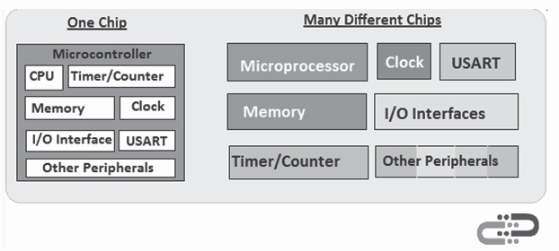

10 websit[e : **info@webteklabs.com**](http://www.i3indyatechnologies.com)

A **Microprocessor** on the other hand is just a CPU one has to add externally memory, clock, input/output

interfaces, timer and all other needed peripheral. This is the reason a microprocessor has so many pins.

**Advantages of a similar microcontroller v/s microprocessor product**



1. **Product smaller** - A microcontroller product has many components on one chip and so is more

compact. With a microprocessor product one have to add several other chips and so it's bulky.

2. **Cheaper** - All the components on a microcontroller is manufacturer on a single chip and so is much

cheaper than having to manufacture several chips as is the case for a microprocessor system.

**Some AVR chips:**

**AVR Microcontrollers Memory Map**

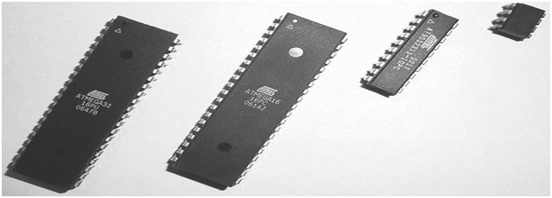

**What is a memory map?**

The memory map of a microcontroller is a diagram which gives the size, type and layout of the memories that are available in the microcontroller. The information use to construct the memory map is extracted from the datasheet of the microcontroller.

websit[e : **info@webteklabs.com**](http://www.i3indyatechnologies.com)

11

The diagram below gives the memory map for the **ATMega8515** AVR 8-bit Microcontroller from Atmel. The ATMega8515 microcontroller contains three (3) blocks of memory:

ª Program Memory,

ª EEPROM Memory and

ª Data Memory.

Data Memory Contains:

v 32 8-bits General Purpose

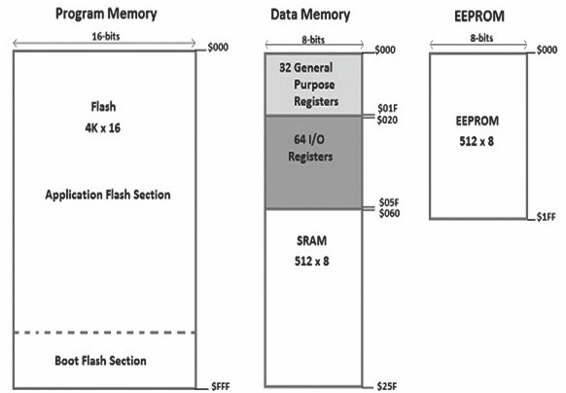

**Notes:**

1. Although this map includes the EEPROM as part of the memory map it is seen by some as a peripheral

and not included as part of the map.

2. This memory map is basic. We could expand the General Purpose and Input/output giving more

details.

3. The external memory option could also be included in the memory map.

4. Each section can also be seen as a memory map in and of itself. Namely the **Data Memory Map**, the

**Program Memory Map** and the **EEPROM Memory Map**.

websit[e : **info@webteklabs.com**](http://www.i3indyatechnologies.com)

**Program Counter**



The **Program Counter (PC)** is a register that is a part of all **central processing unit (CPU)** or **microprocessor**. All microcontrollers contain a microprocessor and thus have a program counter. The purpose of the program counter is to **hold/store** the **address** of the **next instruction** to be executed by the microcontroller's microprocessor.

The size (width) of the program counter of a microcontroller is measured in bits and is directly related to

the size of the microcontroller's program memory.

**Determining the size of the AVR Program Counter:**

As mentioned above the purpose of the program counter (PC) is to hold the address of the next instruction to be executed by the CPU. Instructions are stores in the program memory of a microcontroller and thus the PC width is directly related to the size of the microcontroller program memory. As an example let's determine the width of the program counter for the **ATMega16** and **ATMega32** AVR microcontrollers.

The width (size) of the program counter (PC) is basically the smallest possibly number of bits necessary to address the microcontroller program memory based on its organization. Let's say **n** is the width of the PC then n would be related to the size of the program memory by the following equation:

**2n = size of program memory**

**n = log(size of program memory)/(log2)**

For the **ATMega15** microcontroller the program memory is **8k-Bytes** organized as **4k-Words**. As such

the width of the ATMega15 microcontroller Program Counter n is given by:

**2n = 4k = 4x1024**

**n = log(4096)/log(2) = 12bits**

For the **ATMega16** microcontroller the program memory is **16k-Bytes** organized as **8k-Words**. As

such the width of the ATMega16 microcontroller Program Counter n is given by:

**2n = 8k = 8x1024**

**n = log(8192)/log(2) = 13bits**

websit[e : **info@webteklabs.com**](http://www.i3indyatechnologies.com)13

**AVR STACK & STACK POINTER**



**What is a stack?**

A **stack** is a consecutive block of data memory allocated by the programmer. This block of memory can be use both by the microcontroller internal control as well as the programmer to store data temporarily. The stack operates with a **Last in First out (LIFO)** mechanism; i.e the last thing store on the stack is the first thing to be retrieved from the stack.

**What is the Stack Pointer?**

The **stack pointer** is basically a register or registers that holds either "the memory address of the last location on that stack where data was stored" or "the memory address of the next available location on the stack to store data." The definition of the stack pointer depends on the design of the microcontroller.

In AVR microcontrollers, such as the ATMega8515, ATMega16, ATTiny13, etc., the **stack pointer** holds

the address on the next available location on the stack available to store data.

**The AVR Stack Pointer**

The AVR 8-bits microcontroller stack pointer can either consist of a single I/O register **SPL (Stack Pointer** **Low)** or two (2) I/O registers **SPL** and **SPH (Stack Pointer High)**. The size of the stack pointer depends on the amount of data memory a microcontroller contains. If the entire data memory can be addressed using 8-bits then the stack pointer is 8-bits wide i.e. SPL only, otherwise the stack pointer is consist of SPL and SPH.

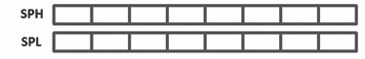

**A REGISTER**



A register is simply a collection of some bits (mostly 8 bits in case of 8bit MCUs). Either each different bit in a register has some purpose or the register as a whole holds a value. Registers serves as connection between a CPU and a Peripheral device (like ADC or TIMER). By modifying the register the CPU is actually

websit[e : **info@webteklabs.com**](http://www.i3indyatechnologies.com)

instructing the PERIPHERAL to do something or it is configuring it in some way. And by reading a register,

the CPU can know the state of peripheral or read associated data.

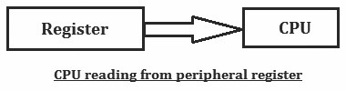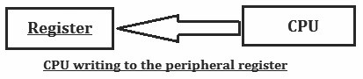

**INTRODUCTION TO EMBEDDED C**

We will be using C language to write the program, let's understand some of the basics of C, before starting

to write the programs. **Variables & Constants: Variables**

If you declare a variable in C , you ask the operating system for a piece of memory. This piece of memory you give a name and you can store something in that piece of memory . There are two basic kinds of variables in C which are numeric and character.

**Numeric variables:** Numeric variables can either be of the type integer (int) or of the type real (float). Integer (int) values are whole numbers (like 10 or -10). Real (float) values can have a decimal point in them. (Like 1.23 or -20.123).

**Character variables:** Character variables are letters of the alphabet, ASCII characters or numbers 0-9. If you declare a character variable you must always put the character between single quotes (like so 'A' ). So remember a number without single quotes is not the same as a character with single quotes.

**Constants:**The difference between variables and constants is that variables can change their value at any time but constants can never change their value. (The constants value is locked for the duration of the program). Constants can be very useful, Pi for instance is a good example to declare as a constant.

websit[e : **info@webteklabs.com**](http://www.i3indyatechnologies.com)15

**Data Types**

So you now know that there are three types of variables: numeric – integer, numeric-real and character. A variable has a type-name, a type and a range (minimum / maximum). In the following table you can see the type-name, type and range:

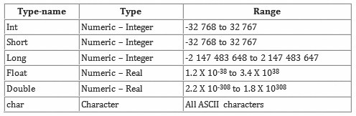

**Declaring**

So we now know differenttype-names and types of variables, but how do we declare them. Declaring a variable is very easy. First you have to declare the type-name. After the type-name you place the name of the variable. The name of a variable can be anything you like as long it includes only letters, underscores or numbers (However you cannot start the name with a number). But remember choose the names wisely. It is easier if a variable name reflects the use of that variable. (For instance: if you name a float PI, you always know what it means).

Now let's declare some variables, a variable MyIntegerVariable and MyCharacterVariable:

int main()

{

|  |  |  |
| --- | --- | --- |
|  |  |  |
|  |  |  |
|  |  |  |
|  | } |  |

intMyIntegerVariable;

intMyCharacterVariable;

return 0;

It is possible to declare more than one variable at the same time:

int main()

{

|  |  |  |
| --- | --- | --- |
|  |  |  |
|  |  |  |
|  |  |  |
|  | } |  |

int Variable1, Variable2, Variable3;

intabc, def, ghi;

return 0;

websit[e : **info@webteklabs.com**](http://www.i3indyatechnologies.com)

To declare a constant is not much different then declaring a variable. The only difference is that you have

the word const in front of it:

int main()

{

|  |  |  |
| --- | --- | --- |
|  |  |  |
|  |  |  |
|  |  |  |
|  | } |  |

const float PI = 3.14;

char = 'A';

return 0;

**Note:** As you can see, you can assign a value with the equal sign during declaration.

**Signed and unsigned variables**

The difference between signed and unsigned variables is that signed variables can be either negative orpositive but unsigned variables can only be positive. By using an unsigned variable you can increase the maximum positive range. When you declare a variable in the normal way it is automatically a signed variable. To declare an unsigned variable you just put the word unsigned before your variable declaration or signed for a signed variable although there is no reason to declare a variable as signed since they already are.

int main()

{

|  |  |  |
| --- | --- | --- |
|  |  |  |
|  |  |  |
|  |  |  |
|  | } |  |

unsignedint a;

signedintb;

intc;

**Calculations and variables**

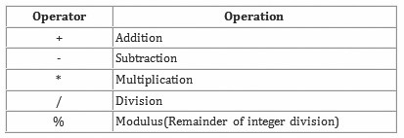

There are different operators that can be used for calculations which are listed in the following table:Now

that we know the different operators, let's calculate something:

int main()

{

|  |  |  |
| --- | --- | --- |
|  |  |  |
|  |  |  |
|  |  |  |
|  |  |  |
|  |  |  |
|  | } |  |

int a, b;

a = 1;

b = a + 1;

a = b - 1;

return 0;

17

websit[e : **info@webteklabs.com**](http://www.i3indyatechnologies.com)

**Boolean Operators**

Before we can take a look at test conditions we have to know what Boolean operators are. They are called Boolean operators because they give you either true or false when you use them to test a condition. The greater than sign “>”for instance is a Boolean operator.

In the table below you see all the Boolean operators:

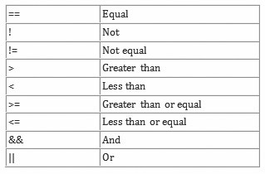

**EXAMPLES**

The following examples illustrate the logical operators:

int w, x, y, z;

if ( x < y && y < z )

printf( "x is less than z\n" );

In this example, the printf function is called to print a message if x is less than y and y is less than z. If x is greater than y, the second operand (y < z) is not evaluated and nothing is printed. Note that this could cause problems in cases where the second operand has side effects that are being relied on for some other reason.

printf( "%d" , (x == w || x == y || x == z) );

In this example, if x is equal to either w, y, or z, the second argument to the printf function evaluates to true and the value 1 is printed. Otherwise, it evaluates to false and the value 0 is printed. As soon as one of the conditions evaluates to true, evaluation ceases.

websit[e : **info@webteklabs.com**](http://www.i3indyatechnologies.com)

**The if statement**

The if statement can be used to test conditions so that we can alter the flow of a program. In other words: if a specific statement is true, execute this instruction. If not true, execute this instruction. So lets take a look at an example:

int main()

{

|  |  |  |
| --- | --- | --- |
|  |  |  |
|  |  |  |
|  |  |  |
|  |  |  |
|  | } |  |

intmynumber = 10;

if ( mynumber == 10 )

Do task 1

return 0;

Now take a look at the “if statement”: if the number stored in the variable mynumber is equal to ten, then

glow all the LEDs. Simple, isn't it. If the number is not equal to ten, then nothing will be done.

Now take another look at the “if statement”: look at the placement of the semi-colon. As you can see there is no semi-colon behind the “if statement”. If there is just one instruction (if the statement is true), you can place it after the“if statement” (with an indentation). Are multiple instructions necessary then you will have to use curly brackets, like so:

if ( mynumber == 10)

{

|  |  |  |
| --- | --- | --- |
|  |  |  |
|  |  |  |
|  | } |  |

Do task 1;

Do task 2;

Now we like to also print something if the “if statement” is not equal. We could do this by adding another “if statement” but there is an easier / better way. Which is using the so called “else statement” with the “if statement”.

int main()

{

intmynumber = 10;

if ( mynumber == 10 )

{ Do task 1;

Do task 2;

}

else

{ Do task 3;

Do task 4;

}

return 0;

19 websit[e : **info@webteklabs.com**](http://www.i3indyatechnologies.com)

**Note:** Take a look at the placement of the curly brackets and how the indentations are placed. This is all done to make reading easier and to make less mistakes in large programs. **Nested if statements**

If you use an “if statement” inside an “if statement” it is called nesting. Nested “if statements” can make a program very complex, but sometimes there is no other way. So use it wisely. Take a look at a nested “if statement” example below:

int main()

|  |  |  |  |
| --- | --- | --- | --- |
|  |  |  | |
|  |  | int grade = 48; | |
|  |  | if ( grade <= 10 ) | |
|  |  |  |  |
|  |  |  |  |
|  |  |  |  |
|  |  |  |  |
|  |  |  |  |
|  |  |  |  |
|  |  |  |  |
|  |  |  |  |
|  |  |  |  |
|  |  |  |  |
|  |  |  |  |
|  |  |  |  |
|  |  |  |  |
|  |  |  | |
|  | } |  | |

{

{ Do task 1;

Do task 2;

}

else

{ if ( grade < 60 )

{ Do task 3;

Do task 4;

}

else if ( grade >= 60 )

{ Do task 5;

Do task 6;

}

}

return 0;

**Note:** Again take a look at the placing of the curly brackets and the placing of the indentations. So let's walk through the example above:

If the grade is equal or below ten, you did not study. If the grade is above ten, the program will go into the “else statement”. In the “else statement” there is another “if statement” (this is nesting). This “if statement” checks the grade again. If the grade is below sixty, you must study harder. In the “else statement” from this “if statement” there is another “if statement”. It checks whether the grade is above or equal to sixty. If it is, you passed the test.

websit[e : **info@webteklabs.com**](http://www.i3indyatechnologies.com)

**Multiple condition testing**

It is possible to test two or more conditions at once in an “if statement” with the use of the AND (&&)

operator. Example:

**if ( a > 10 && b > 20 && c < 10 )**

If a is greater then ten and b is greater then twenty and c is smaller then ten, do something. So all three

conditions must be true, before something happens.

With the OR ( || ) operator you can test if one of two conditions are true. Example:

**if ( a = 10 || b < 20 )**

If a equals ten or b is smaller then twenty then do something. So if a or b is true, something happens.

**The switch statement**

The switch statement is almost the same as an “if statement”. The switch statement can have many conditions. You start the switch statement with a condition. If one of the variable equals the condition, the instructions are executed. It is also possible to add a default. If none of the variable equals the condition the default will be executed.

See the example below:

int main()

{ charmyinput;

// Input the value of myinput, input 'a' for task1, 'b' for task 2,

switch (myinput)

{ case 'a':

Task1;

break;

case 'b':

{ task2;

break;

}

default:

task3;

break;

}

return 0;

}

**Note:** break is used to exit the switch.

websit[e : **info@webteklabs.com**](http://www.i3indyatechnologies.com)21

**Loops:**

In every programming language, thus also in the C programming language, there are circumstances were you want to do the same thing many times. For instance you want to print the same words ten times. You could type ten printffunction, but it is easier to use a loop. The only thing you have to do is to setup a loop that execute the same printf function ten times.

There are three basic types of loops which are:

ª "for loop"

ª "while loop"

ª "do while loop"

**The for loop**

The “for loop” loops from one number to another number and increases by a specified value each time. The “for loop” uses the following structure:

**for (Start value; continue or end condition; increase value)**

**statement;**

Look at the example below:

int main()

|  |  |  |
| --- | --- | --- |
|  |  |  |
|  |  |  |
|  |  |  |
|  |  |  |
|  |  |  |
|  | } |  |

{ int i;

for (i = 0; i < 10; i++)

{ Do task 1;

}

return 0;

**Note:** A single instruction can be placed behind the “for loop” without the curly brackets.

Let's look at the “for loop” from the example: We first start by setting the variable i to 0. This is where we start to count. Then we say that the for loop must run if the counter i is smaller then ten. Last we say that every cycle i must be increased by one (I++).

In the example we used i++ which is the same as using i = i + 1. This is called incrementing. The instruction i++ adds 1 to i. If you want to subtract 1 from i you can use i--. It is also possible to use ++i or --i. The difference is is that with ++i (prefix incrementing) the one is added before the “for loop” tests if i < 10. With i++ (postfix incrementing) the one is added after the test i < 10. In case of a for loop this make no difference, but in while loop test it makes a difference. But before we look at a postfix and prefix increment while loop example, we first look at the while loop.

22 websit[e : **info@webteklabs.com**](http://www.i3indyatechnologies.com)

**The while loop**

The while loop can be used if you don't know how many times a loop must run. Here is an example:

int main()

|  |  |  |
| --- | --- | --- |
|  |  |  |
|  |  |  |
|  |  |  |
|  |  |  |
|  |  |  |
|  |  |  |
|  | } |  |

{ int counter;

counter = 0;

while ( counter < 100)

{ counter++;

}

return 0;

Let's take a look at the example: First you must always initialize the counter before the while loop starts ( counter = 1). Then the while loop will run if the variable counter is smaller then the variable 100. A last thing you have to remember is to increment the counter inside the loop (counter++). If you forget this the loop becomes infinitive.

As said before (after the for loop example) it makes a difference if prefix incrementing (++i) or postfix incrementing (i++) is used with while loop. Take a look at the following postfix and prefix increment while loop example:

int main(void)

|  |  |  |
| --- | --- | --- |
|  |  |  |
|  |  |  |
|  |  |  |
|  |  |  |
|  |  |  |
|  |  |  |
|  |  |  |
|  |  |  |
|  |  |  |
|  |  |  |
|  | } |  |

{ int i;

i = 0;

while(i++ < 5)

{ Do task 1;

}

i = 0;

while(++i < 5)

{ Do task 2;

}

return 0;

I++ will increment the value of i, but is using the pre-incremented value to test against < 5. That's why we

get task done 5 times.

++i will increment the value of i, but is using the incremented value to test against < 5. That's why we get

task done 4times.

websit[e : **info@webteklabs.com**](http://www.i3indyatechnologies.com)23

**The do while loop**

The “do while loop” is almost the same as the while loop. The “do while loop” has the following form:

do

{ do something;

}

while (expression);

Do something first and then test if we have to continue. The result is that the loop always runs once. (Because the expression test comes afterward). Take a look at an example:

int main()

{

|  |  |  |
| --- | --- | --- |
|  |  |  |
|  |  |  |
|  |  |  |
|  |  |  |
|  |  |  |
|  |  |  |
|  |  |  |
|  | } |  |

int counter, howmuch;

counter = 0;

do

{ counter++;

}

while ( counter < 100);

return 0;

**Note:** There is a semi-colon behind the while line.

**Break and continue**

To exit a loop you can use the break statement at any time. This can be very useful if you want to stop running a loop because a condition has been met other than the loop end condition. Take a look at the following example:

int main()

|  |  |  |  |
| --- | --- | --- | --- |
|  |  |  | |
|  |  |  | |
|  |  |  | |
|  |  |  |  |
|  |  |  |  |
|  |  |  |  |
|  |  |  |  |
|  |  |  | |
|  | } |  | |

{ int i;

i = 0;

while ( i < 20 )

{ i++;

if ( i == 10)

break;

}

return 0;

In the example above, the while loop will run, as long i is smaller then twenty. In the while loop there is an

if statement that states that if i equals ten the while loop must stop (break).

24 websit[e : **info@webteklabs.com**](http://www.i3indyatechnologies.com)

**BINARY NUMBERS & BIT MANIPULATION**



As we know that in digital world works on only two states ('1' & '0'), but what are these logic levels? These are basically two different voltage levels, high voltage level is referred as logic '1' whereas the low voltage level is termed as logic '0'. You may ask the question why it is not termed as any other name, like 'a' for 1 or

'b' for 0, or cat, dog, girl, boy etc etc… the only answer is 'for computational ease'.

There is no specific fixed definition of logic levels in electronics. Most commonly used level designation is

the one used in CMOS and TTL (Transistor Transistor Logic) families:

**Logic high –> designated as '1' Logic low –> designated as '0'**

Where high and low are actually 'higher' and 'lower' with respect to a reference voltage level (ideally

taken as 2.5V).

**Number systems in digital electronics**

Binary: - only '0' & '1'.

Hexadecimal:-0,1,2,3,4,5,6,7,8,9,A,B,C,D,E,F.

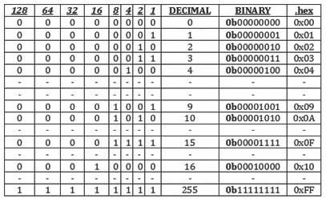

websit[e : **info@webteklabs.com**](http://www.i3indyatechnologies.com)25

**BINARY NUMBERS IN C**

(*have a look of above table*)



When you write i=101; in C it means you are setting the value of variable “i" to "one hundred and one" (in decimal). Many time in embedded programming we are not interested in the value of a variable but the state of each bits in the variable. Like when you want to set the bits of a register (I3REG) to a bit pattern like 10010111 (binary). Then you cannot write I3REG=10010111, because compiler will interpret

10010111 as decimal. To specify a binary number in C program you have to prefix it with 0b (zero

followed by b). So if you write

**I3REG=0b10010111;** It assigns the bit pattern 10010111 to the bits of Register I3REG. **HEX Numbers in C** (have a look of above table)

In same way if you prefix a number by 0x (a zero followed by x) then compiler interpret it like a HEX

number. So

I3REG=0x10; (10 in HEX is 16 in decimal)

I3REG=0xFF; (Set all bits to 11111111 or decimal 255)

**Setting a BIT in Register**

Here our aim is to set (set to logical 1) any given bit (say bit 5) of a given register (say I3REG). The syntax is

**I3REG=I3REG | 0b00100000;**

The above code will SET bit 5 to 1 leaving all other bits unchanged. What the above code does is that it ORs each Bit of I3REG with each bit of 0b00100000 and store the value back in I3REG. If you know how logical OR works then you will get it.

In short you can write the same code as

**I3REG|=0b00100000;**

Now let's come to practical usage. In practice each bit has got a name according to its work/function. Say our BIT (the 5th bit) has got name ENABLE, and what it does is clear by its name, when we set it to 1 it enables the peripheral and when cleared (0) it disables it. So the right way to set it is.

**I3REG|=(1<<ENABLE);**

The << is called left shift operator. It shifts the bits of LHS variable left by the amount on its RHS variable. If

you write

26 websit[e : **info@webteklabs.com**](http://www.i3indyatechnologies.com)

b=1<<3;

then, 1 whose binary value is 00000001 is shifted 3 places to left which results in 00001000

So if ENABLE is defined as 5 (as enable is 5th bit) then

**I3REG|=(1<<ENABLE);**

will result in

**I3REG|=(1<<5);**

which again results in

**I3REG|=(0b00100000);**

Now a beginner would ask "What's the Advantage?” and once you know it you would realize that

advantage is immense!

1. **Readability of code:** I3REG|=(1<<ENABLE); gives a clue that we are enabling the peripheral while I3REG|=0b00100000; does not give any clue what it is doing, we have to go to data sheet and find out which bit actually ENABLEs the peripheral. While ENABLE=5 is already defined in header files by the developer of compiler by carefully studying the datasheets of device.

2. **Easier Portability:** Suppose you use this code many times in your program (and your program is reasonably large and uses other register also) and you now want the same code to run on some other MCU model. The new MCU is of similar family but has slightly different bit scheme, say ENABLE is bit 2 instead of bit 5. Then you have to find all occurrence of I3REG|=(0b00100000); and change that to I3REG|=(0b00000100); But if you have used the other method then you simply need to inform the compiler (by its setting options) that you are going to use the other MCU and compiler will automatically get the definitions for the new device. And in this definition ENABLE=2 will already be defined by the compiler developer. So it will be lot easier.

**Clearing a BIT in Register**

For clearing a bit logical AND (symbol &) operator is used in place of logical OR (symbol |). The syntax is as

follows:-

I3REG&=~(1<<ENABLE);

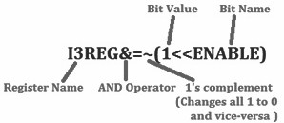

websit[e : **info@webteklabs.com**](http://www.i3indyatechnologies.com)27

This will clear (i.e. set to value 0) a given bit (identified by name ENABLE) in a register called I3REG. This

operation will not affect any other bits of register except ENABLE. Let us see how it works with the help of following steps. **(1<<ENABLE)**

è Replace ENABLE by its value i.e. 5

**(1<<5)**

è Execute Left Shift operation giving a value 0b00100000, since the command states to shift the

value of 1, 5 times towards left i.e. 0b00000001<<5

**~(1<<5) or ~(0b00100000)**

è Execute the complement operator on the resultant to give 0b11011111

**I3REG&=(0b11011111)**

so that only the value at the place of ENABLE (bit no. 5 in I3REG) is affected keeping all the other bit

|  |  |  |
| --- | --- | --- |
|  | è | When this statement is executed, the previous value of I3REG is bitwise ANDed with 0b11011111, |
|  |  |  |
|  | è | unchanged.  Assume I3REG previous value to be 0b11111010, then |

|  |  |
| --- | --- |
| **I3REG** | **11111010** |
|  | **11011111** |
| **Result** | **11011010** |

è Thus it can be noticed that the values of I3REG remain unchanged apart from bit no.5 which

becomes '0' thus reflecting the change we wanted.

So now you know how you can selectively clear any bit in any given register. If you want to clear more than

one bit at a time you can write like this

//This will clear bits ENABLE, FAST_MODE and BUSY, leaving all other bits untouched

**I3REG&=(~((1<<ENABLE)|(1<<FAST_MODE)|(1<<BUSY)));**

28 websit[e : **info@webteklabs.com**](http://www.i3indyatechnologies.com)

Similarly the syntax for setting (set to 1) multiple bits at a time is as follows

//This will set bits ENABLE,FAST_MODE and BUSY, leaving all other bits untouched

**I3REG|=((1<<ENABLE)|(1<<FAST_MODE)|(1<<BUSY)); Testing the status of a bit.**

Till now we were modifying the registers either setting or clearing bits. Now we will learn how can beknow that a specific bit is 0 or 1. To Know if a bit is 0 or 1 we AND it with a AND MASK. Suppose if we want to check bit 5 of a register I3REG then the AND MASK would be 0b00100000. If we AND this value with the current value of I3REG then result will be non-zero only if the 5th bit in I3REG is '1' else the result will be '0'.

The syntax would be like this.

|  |  |  |  |  |  |
| --- | --- | --- | --- | --- | --- |
|  |  |  |  |  | |
|  |  |  |  |  | |
|  |  |  |  |  |  |
|  |  |  |  |  |  |
|  |  |  |  |  |  |
|  |  |  |  |  |  |
|  |  |  |  |  |  |
|  |  |  |  |  |  |
|  |  |  |  | } |  |

if (I3REG & (1<<ENABLE))

{

//ENABLE is '1' in I3REG

...

}

else

{

//ENABLE is '0' in I3REG

websit[e : **info@webteklabs.com**](http://www.i3indyatechnologies.com)29

**ATMEGA16**



The AVR is a modified Harvard architecture 8-bit RISC single chip microcontroller which was developed by Atmel in 1996.Since it is a RISC architecture microcontroller, it will take only lesser decoding time for instructions and will be comparatively faster for Embedded Systems. In this book we will be using the microcontroller ATMEGA 16 and AVR studio as the programming environment. You can get ATMEGA 16 for around Rs.200/- in the Indian market.

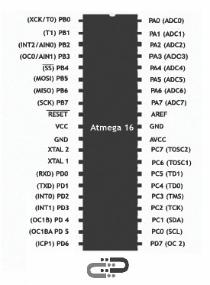

Before we start working on ATMEGA 16, have a look at ATMEGA 16 Pin out Diagram.

Atmega16 have 16 KB flash memory for storing the program and four 8 bit ports which they do label as PA (PORT A), PB (PORT B), PC (PORT C), and PD (PORT D).

**Associated I/O Registers**

Each of the AVR Digital I/O ports is associated with three (3) I/O register. A Data Direction Register (DDRx), A Pin Register (PINx) and a Port Register (PORTx). Where x is the port A, B, C, etc. .

**DDRx - Port X Data Direction Register**



30 websit[e : **info@webteklabs.com**](http://www.i3indyatechnologies.com)

DDRx is an 8-bit register which stores configuration information for the pins of Portx. Writing a 1 in the pin location in the DDRx makes the physical pin of that port an output pin and writing a 0 makes that pin an input pin.

**Note:** Each physical pin of a port is configured independently and thus a port can have some of its pins

configured as input an the others as output pins.

**PINx - Port X Input Pins Register**



PINx is an 8-bit register that stores the logic value, the current state, of the physical pins on Portx. So to

read the values on the pins of Portx, you read the values that are in its PIN register.

**PORTx - Port X Data Register**



PORTx is an 8-bit register which stores the logic values that currently being outputted on the physical pins of Portx if the pins are configured as output pins. So to write values to a port, you write the values to the PORT register of that port.

Now you are familiar with Atmega16 pin configuration. Now we will learn about how to connect Microcontroller (MUC) to the PC for programming!

***Introduction***

***to webteklabs Training Kit Content***

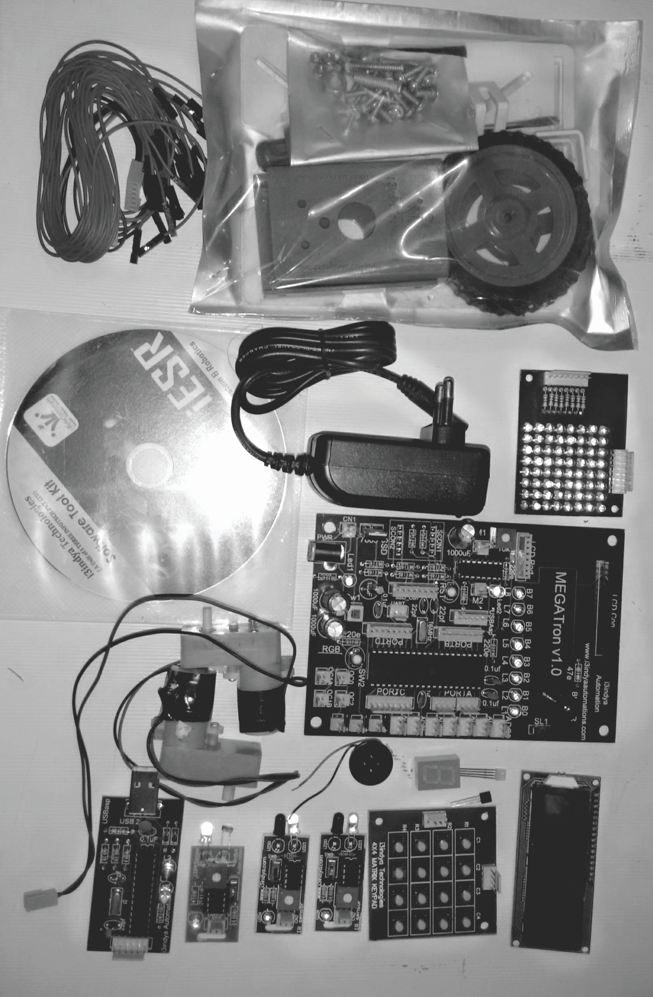

TRAINING KIT BOOK - 1

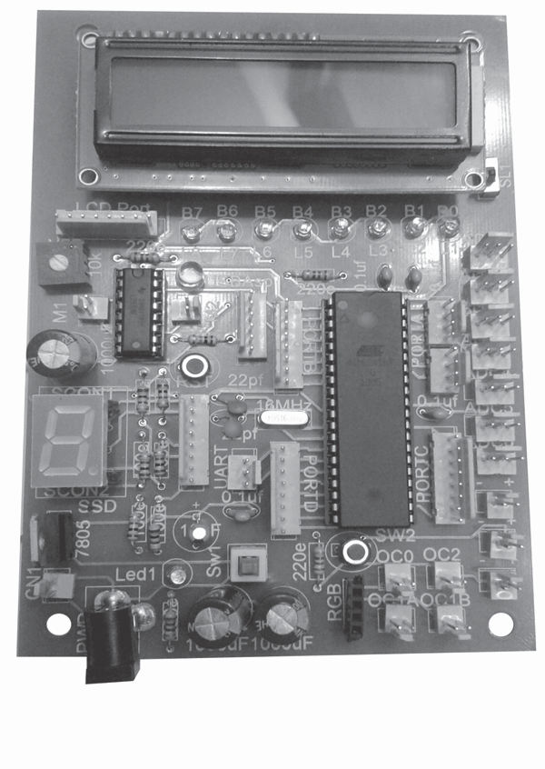

**MEGATron™ BOARD**

33 websit[e : **info@webteklabs.com**](http://www.i3indyatechnologies.com)

Copyright All Right Reserved

**MEGATron™ BOARD MANUAL**

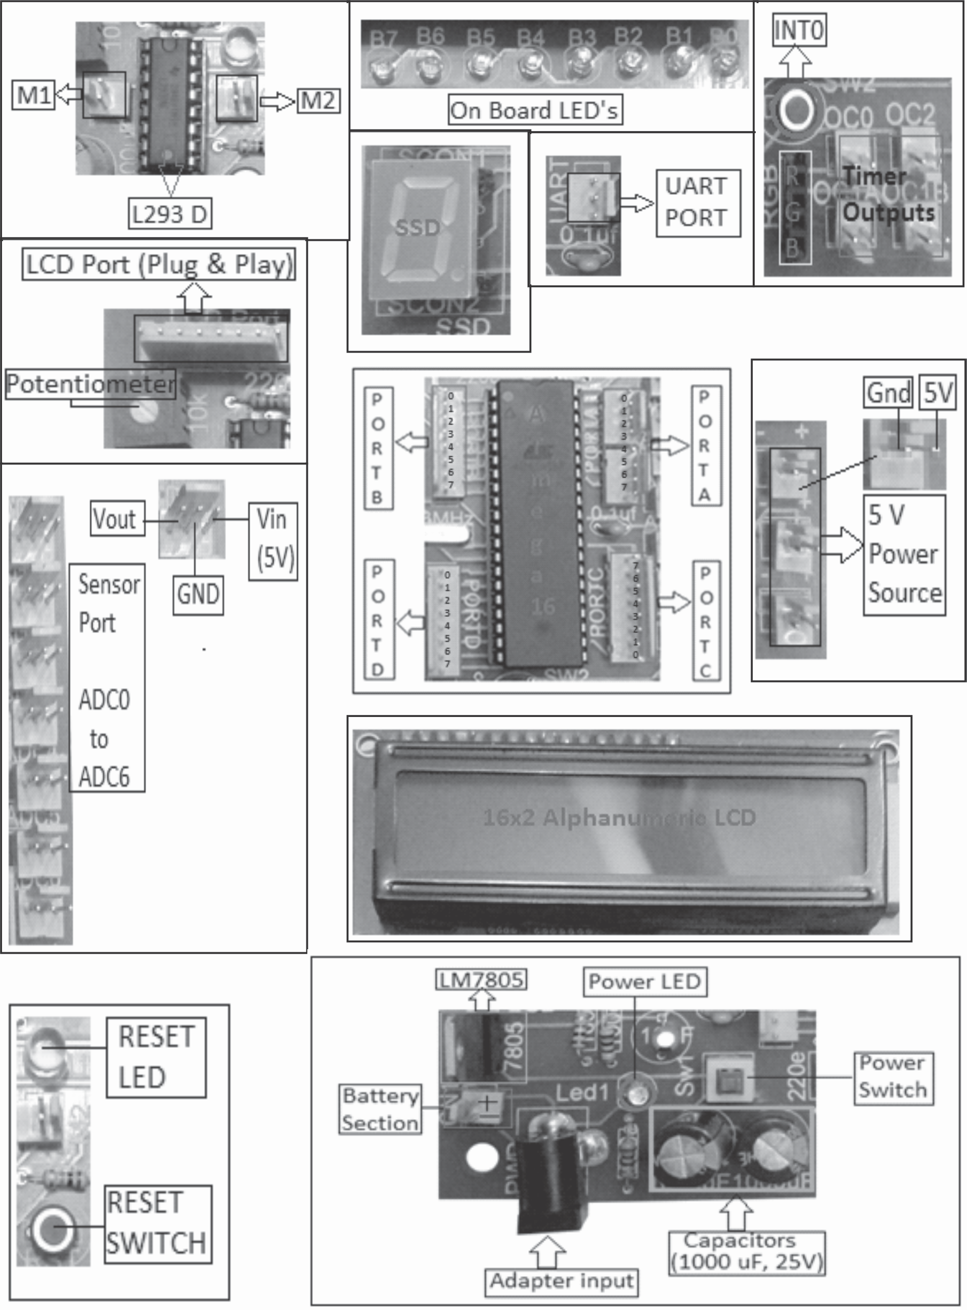

TRAINING KIT

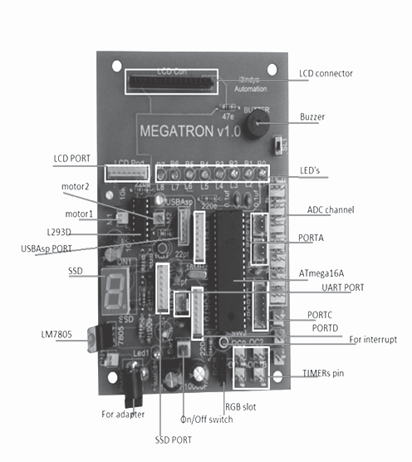

websit[e : **info@webteklabs.com**](http://www.i3indyatechnologies.com)

35

**MEGATron™ Board consists of following sections:**



1. **Microcontroller PORTs**: As we have already explained that there are four PORTs of ATmega16 MCU, so we have provided the feasibility for using all four PORTs which are shown by the following figure.

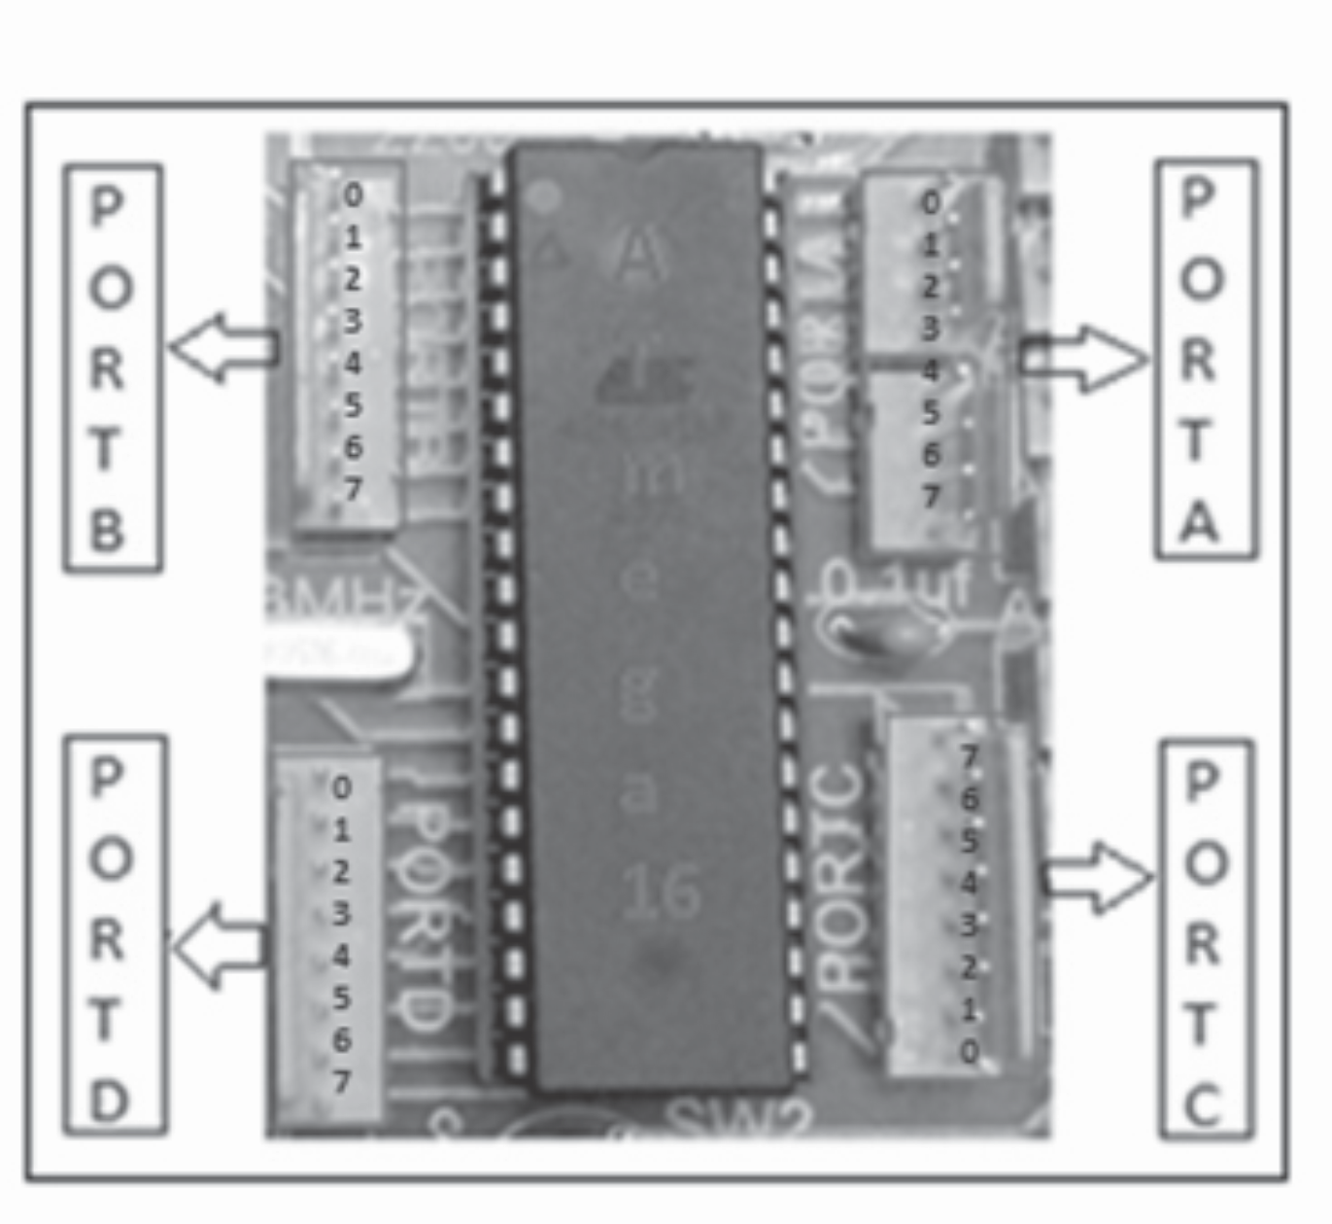

2. **Programmer Section:** This is the connector where you will connect USBasp programmer for programming the microcontroller chip(ATmega16). The 6 pin on the connector are connected to the MOSI, MISO, SCK, RESET, VCC and GND pins of the MCU in the same sequence.

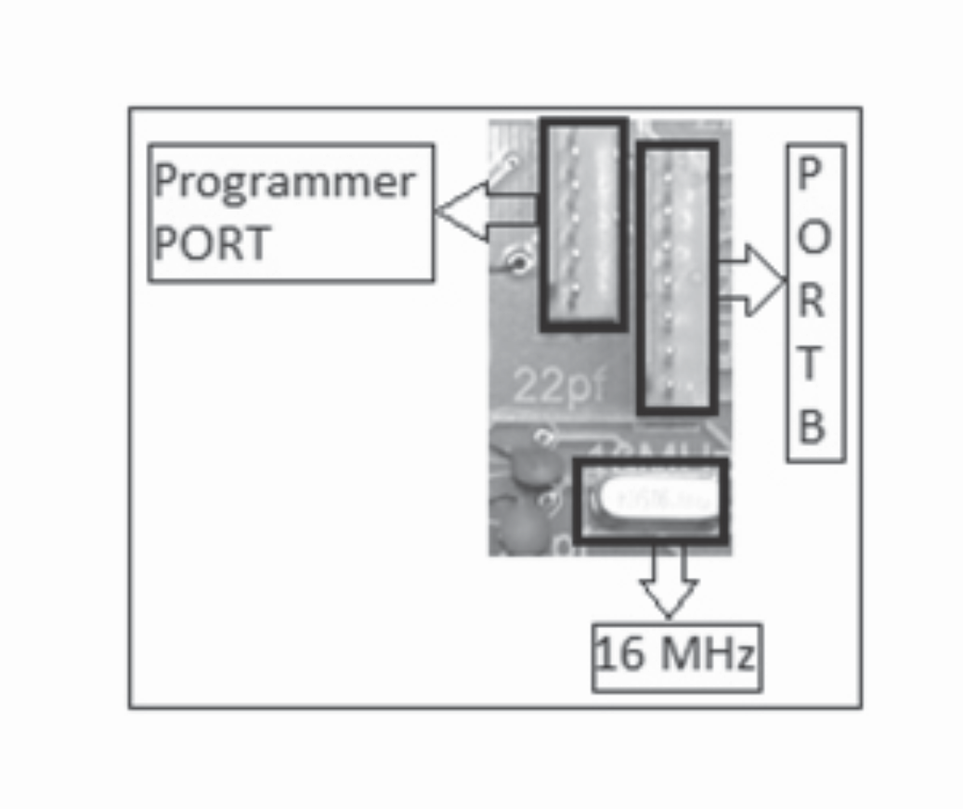

websit[e : **info@webteklabs.com**](http://www.i3indyatechnologies.com)36

Copyright All Right Reserved

3. **16x2 LCD Connector point:** This is the point where you connect your LCD, while connecting the LCD remember the numbering of LCD pins. The numbers are mentioned on the development board and to the back of the LCD, so while connecting the LCD make sure to match the number written on the development board and the back of LCD.

4. **Buzzer:** The Buzzer on MEGATron™ Board is connected to pin no. 8 of PORTA (i.e. PA7). The connection is inbuilt so if you want to have a look at the connection, turn the board on the track side and have a look to the circuit then you will find that it is connected to PA7 and a switch is connected in the path.

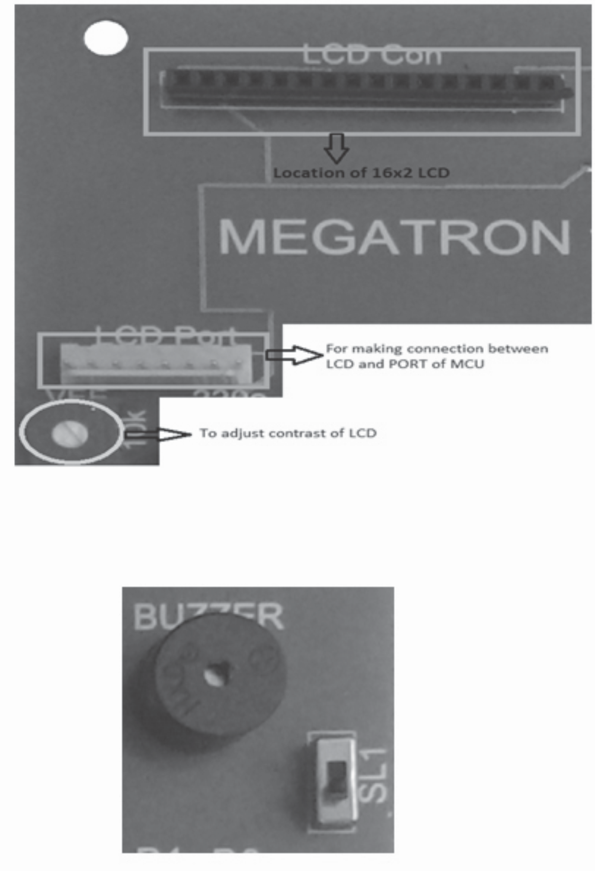

5. **LEDs:** The 8 LEDs are connected to PORTB of microcontroller, so in order to glow the LEDs you need to

define to work with PORTB.

6. **A** ors e.g. I t t of ATm

**DC/Sensor Section:** This is the sensor section where you will be connecting your different sens R sensor, LDR sensor etc. This section is connected o PORTA of ATmega16, which is the ADC por ega16. The connection of the 3 pin male connector available on this port is as:

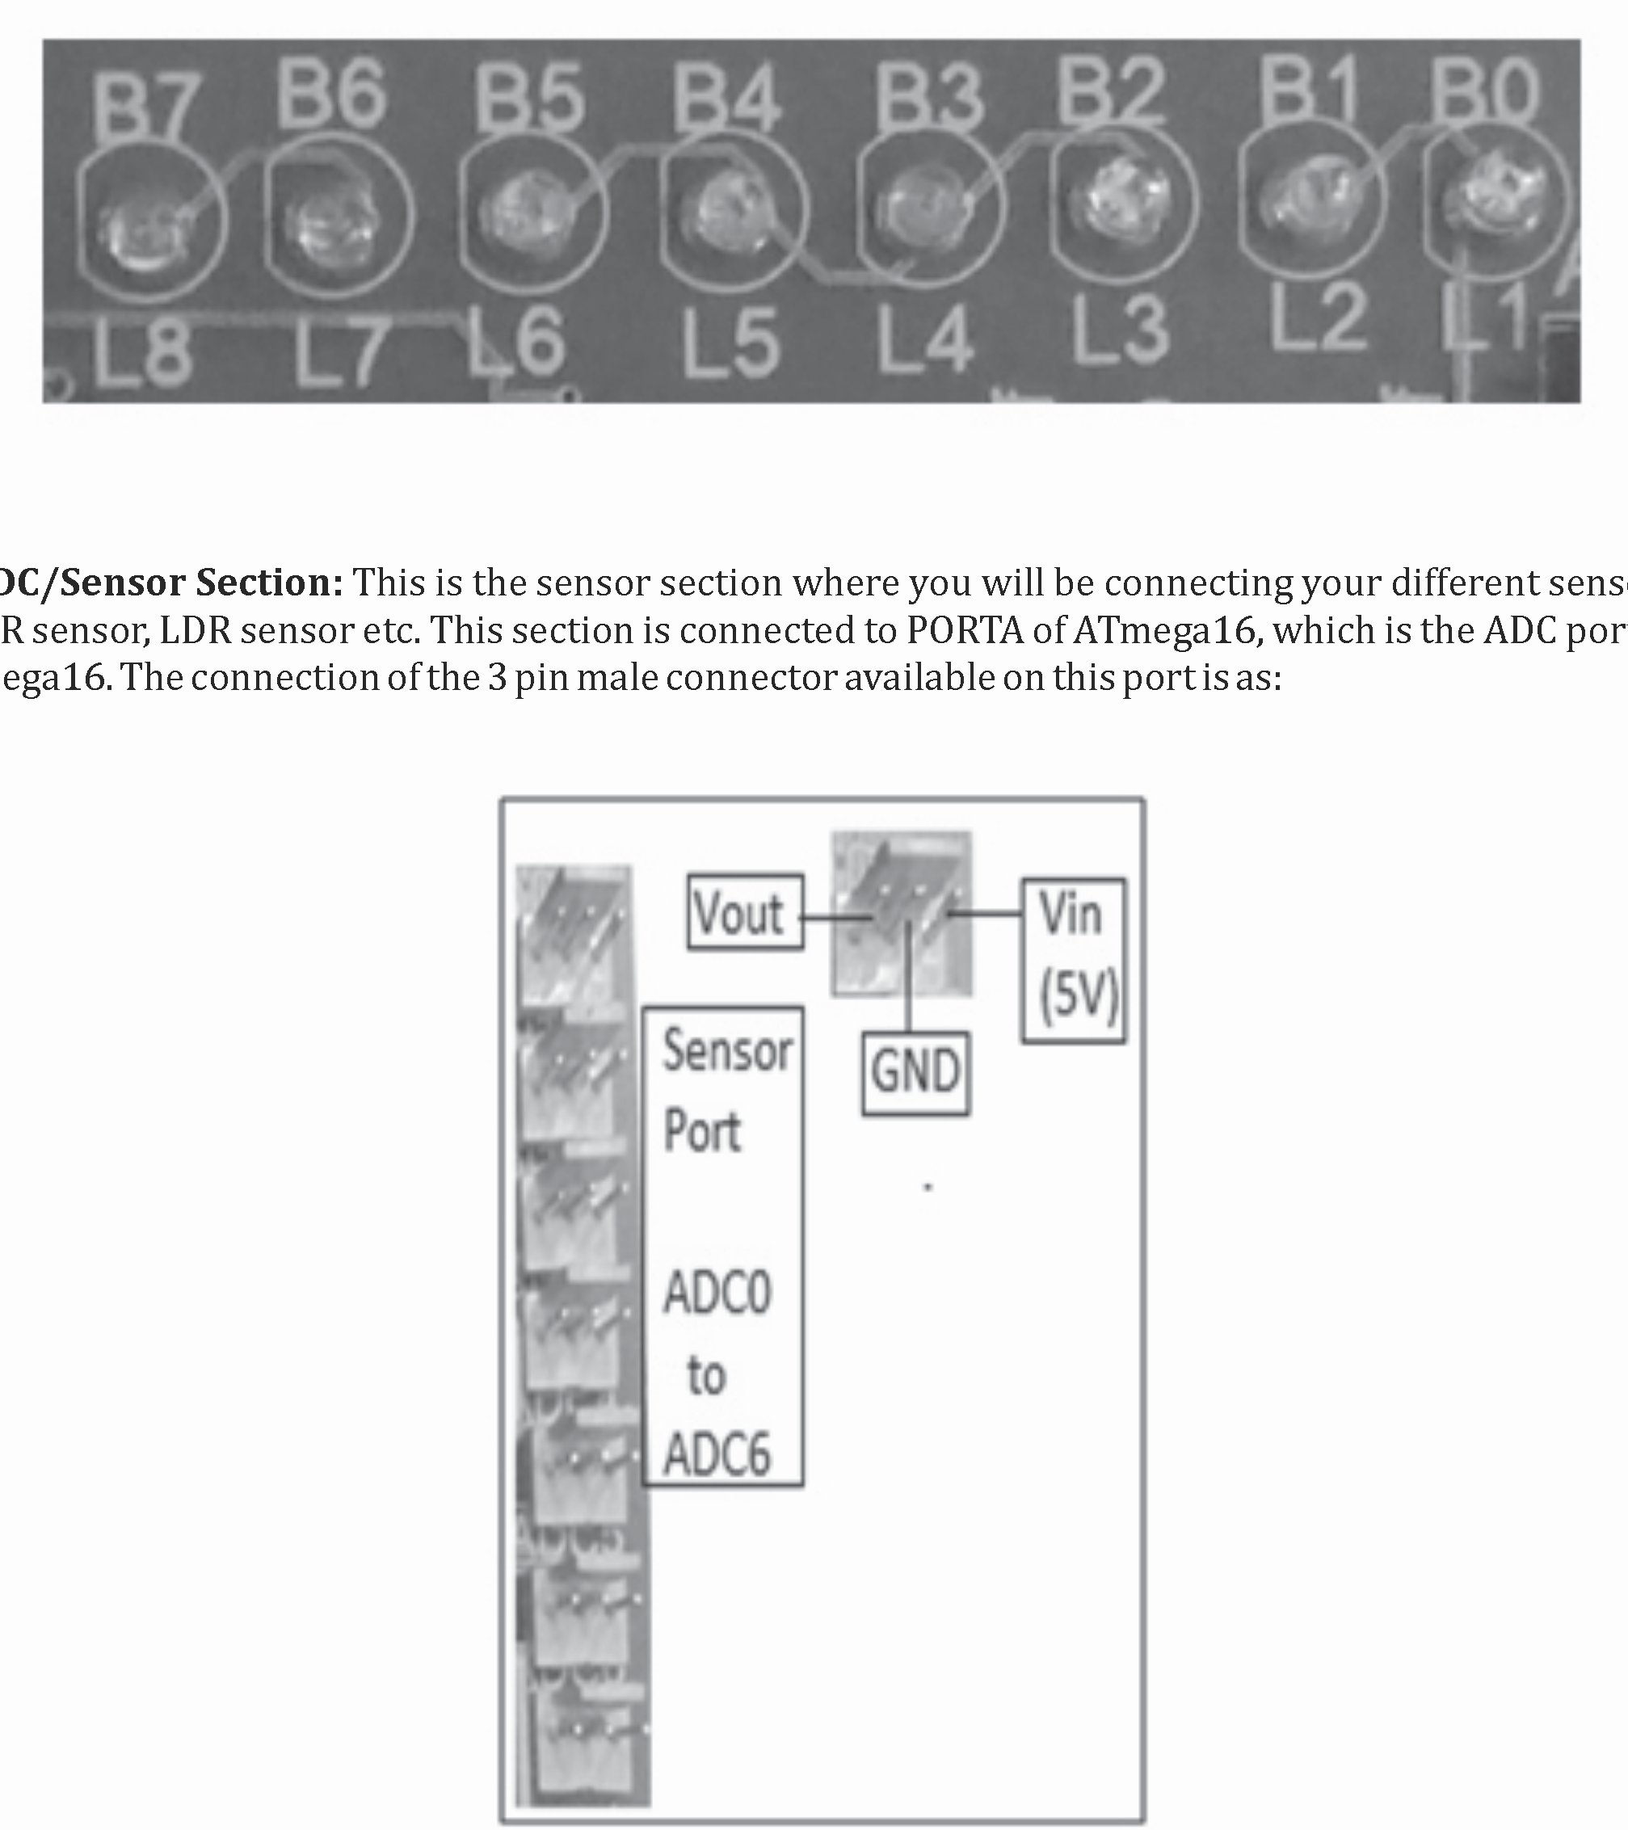

7. **Motor section:** This section contains IC L293D, the motor driver IC. The input pins of the IC L293D are connected to the lower nibble (PB0 to PB3) of PORTB of ATmega16. For complete details about the circuit of how IC L293D drives the DC motor, please refer the chapter on DC motor interfacing with ATmega16.

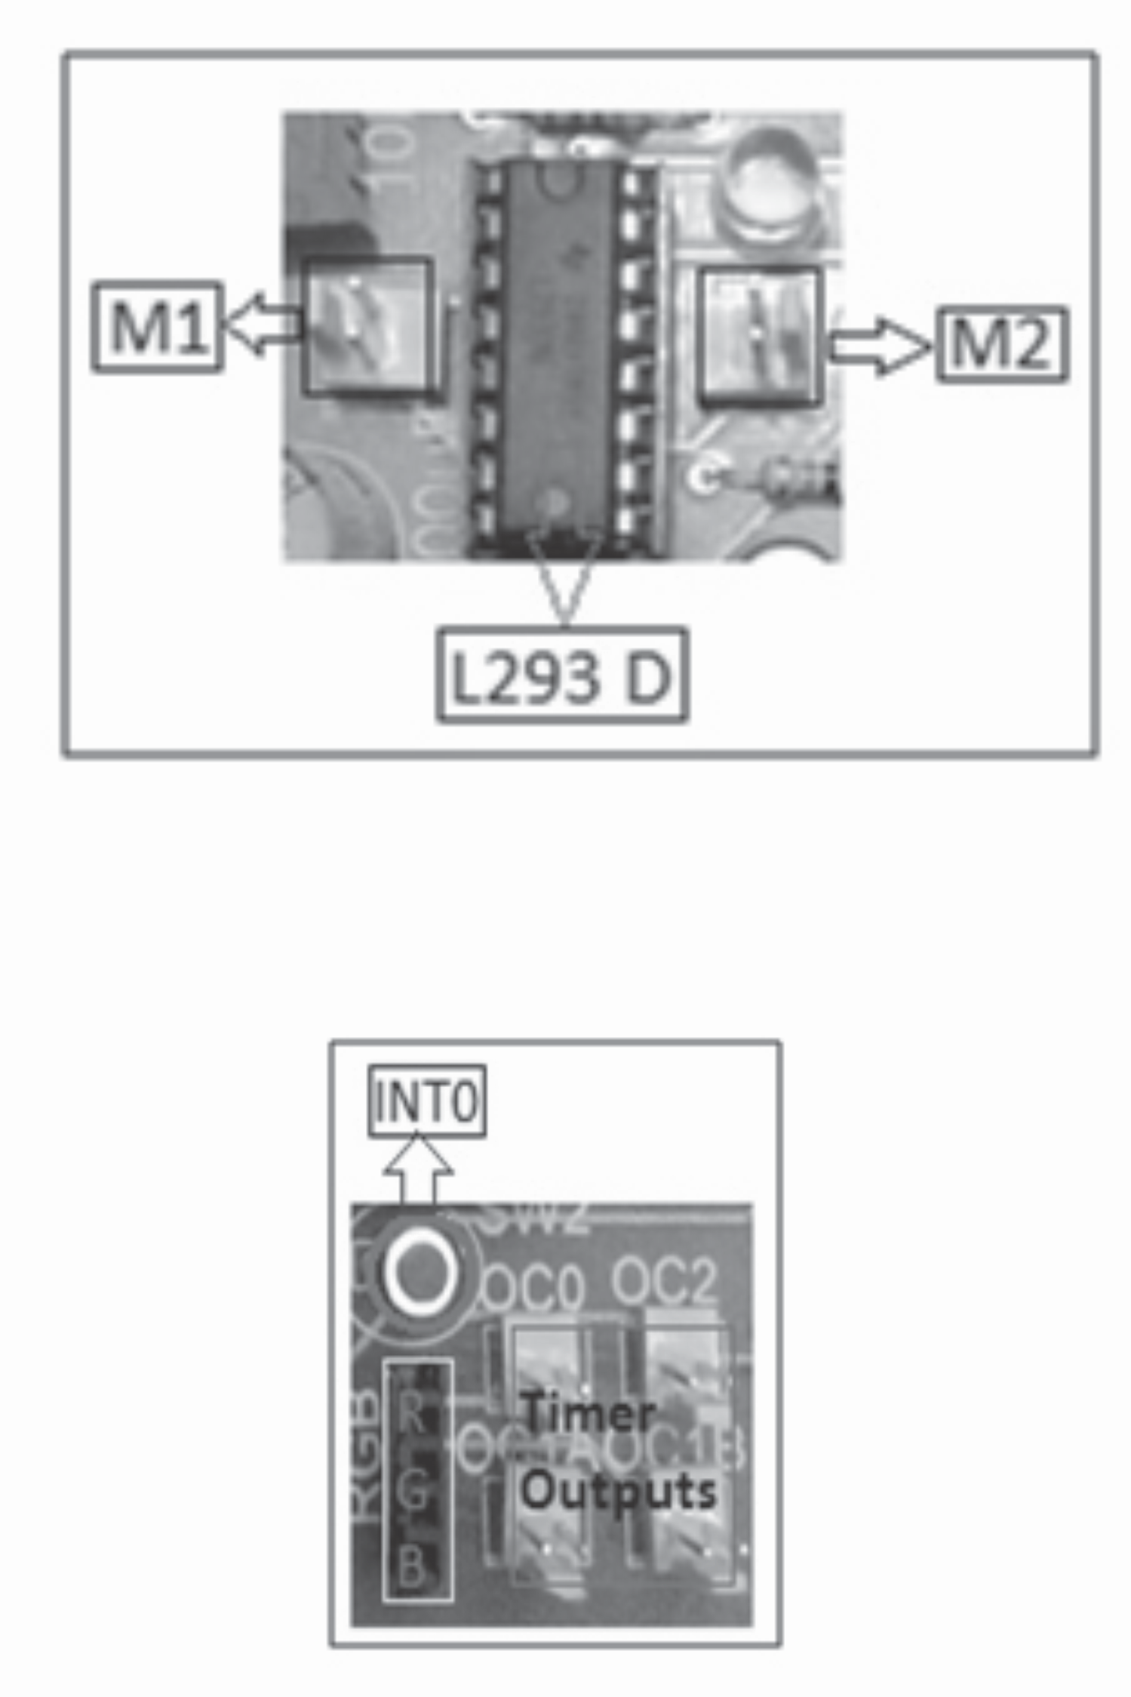

8. **Timer & Interrupt Section:** This is the section, where you will get the output of the TIMER circuits of ATmega16. You will be playing the speakers, glowing the RGB LED using this section. There is a pushbutton which is connected to INT0 of ATmega16 which is for providing interrupt.

39

websit[e : **info@webteklabs.com**](http://www.i3indyatechnologies.com)

**SOFTWARE INSTALLATION**



**1. Hardware programmer (USBasp) Installation**

To connect microcontroller with PC for programming we need an AVR programmer. We are usingUSBasp. The programmer will have a USB cable that can be used to connect with PC and an SPI cable which can be connected to the MCU.

Connecting SPI cable to PC

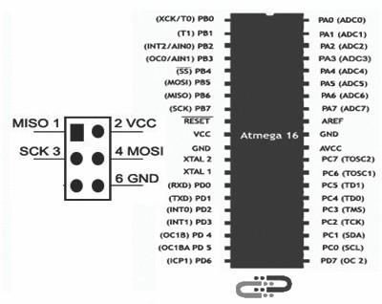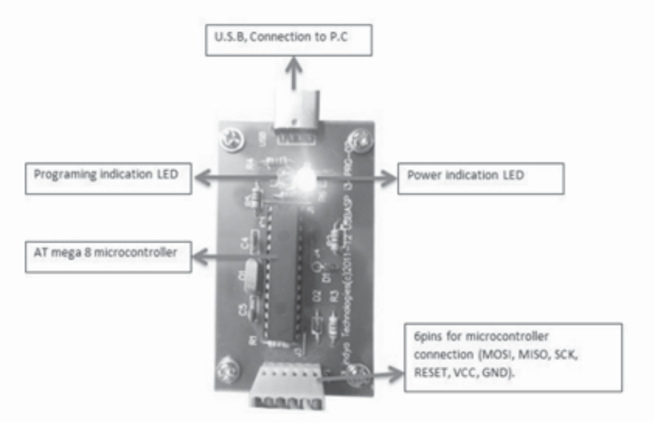

40

It will be more convenient if you can make a permanent Interface board like this so that you just need to

plug this board to the respective pins while programming.

We have made all the hardware requirements for our first program! Next we will see how to configure our PC for Programming.

We need programmer drivers for connecting our programmer with PC. . As said earlier we are using the programmer USBasp. So we will see from where to get the drivers for this programmer. Follow these steps.

è Insert USBasp programmer, then open Device Manager. There you'll find USBasp in yellow mark.

websit[e : **info@webteklabs.com**](http://www.i3indyatechnologies.com)

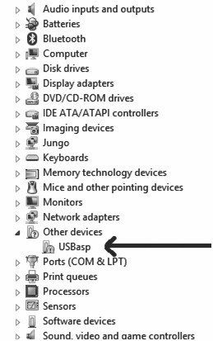

è Right click on the yellow marked USBasp, and then click on Update Driver.

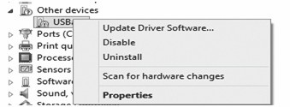

41 websit[e : **info@webteklabs.com**](http://www.i3indyatechnologies.com)

è Now update the driver using “Browse my computer for Driver Software”

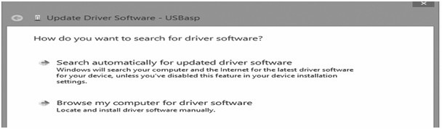

è Locate the location where the Driver for USBasp exists. (Refer to the CD provided.)

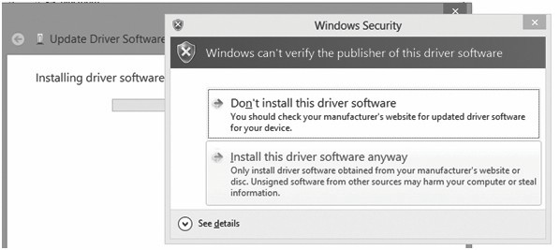

è elect “install this driver software anyway” option.

è After installation close the window.

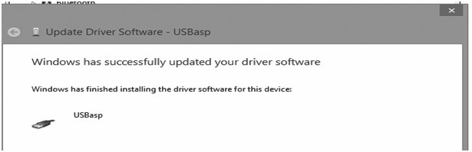

websit[e : **info@webteklabs.com**](http://www.i3indyatechnologies.com)42

**NOTE: How to install USBasp driver in Windows 8 ,8.1 & 10 as it shows device signature error.**

As it is by default device enforcement is enabled, so we have to forcefully disable it for external driver

installation such as USBasp.

**Step-1:** Open Change PC settings.

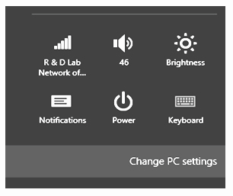

**Step-2:** Now for win8: select general settings in which you need to select advance startup and for win8.1

& 10 search advance startup. And click on **change advance startup options.**



43 websit[e : **info@webteklabs.com**](http://www.i3indyatechnologies.com)

**Step-2:** Now click on Restart Now.

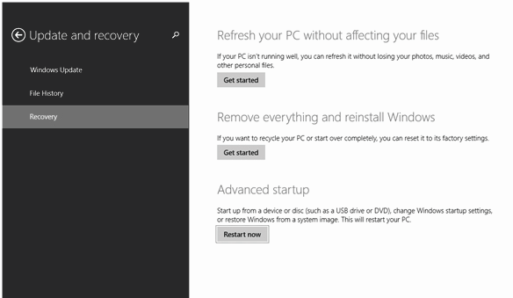

**Step-3:**Now you will get some options in which you need to select Troubleshoot.

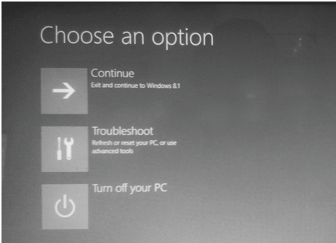

websit[e : **info@webteklabs.com**](http://www.i3indyatechnologies.com)

**Step-4:** After this, you need to select **Advanced Options.**

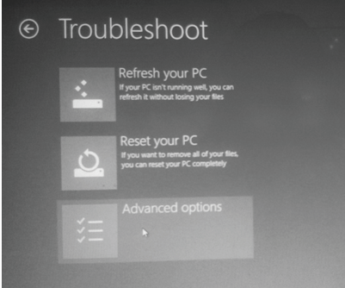

**Step-5:** Now, click on **Startup Settings.**

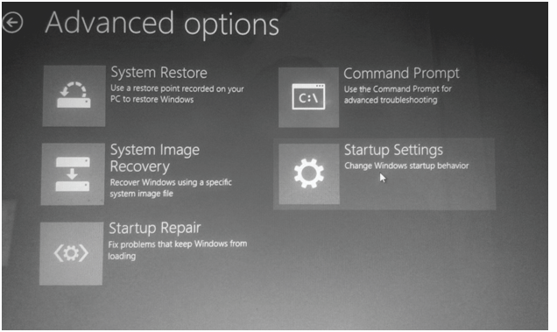

45 websit[e : **info@webteklabs.com**](http://www.i3indyatechnologies.com)

**Step-6:** Now, in startup setting you have click restart.

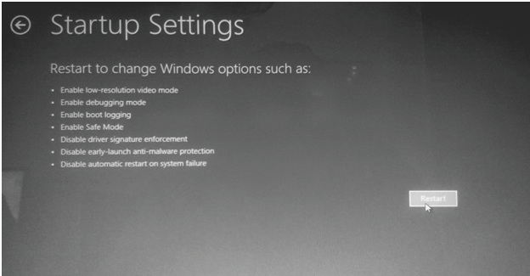

**Step-7:** After this step, you will get some options for making changes. **Press F7.**

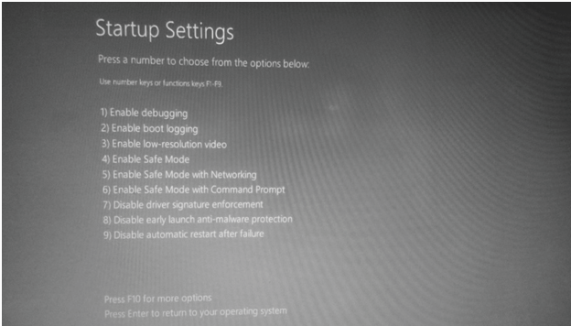

After selecting the '7) Disable driver signature enforcement' option restart and update the driver of USBasp as in usual way.

websit[e : **info@webteklabs.com**](http://www.i3indyatechnologies.com)46

**2. Installing the IDE(Integrated Development Environment) and Complier (AVRGCC)**

Install the software named **'WINAVR'** and then **AVRStudio 4.0** from the CD

**Installing WINAVR**

è**Locate the setup of “WINAVR” in the CD provided to you. Click on the icon to run the setup.**

è **Click “Next”**

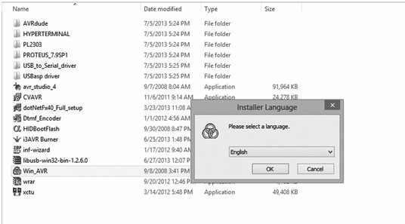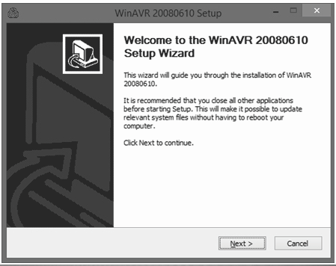

47 websit[e : **info@webteklabs.com**](http://www.i3indyatechnologies.com)

è **Click “I Agree”**

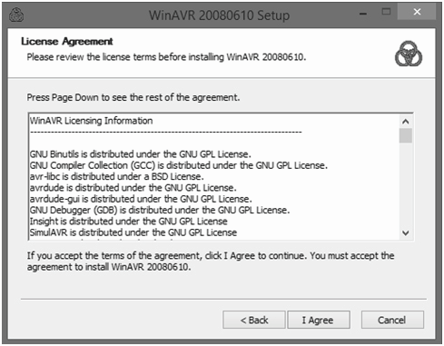

è **Click “Next”**

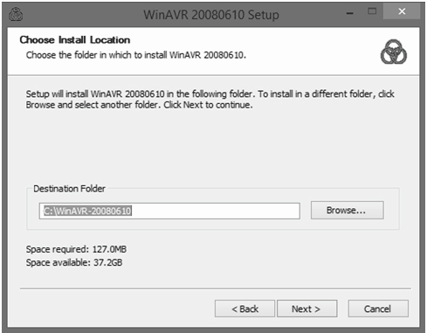

websit[e : **info@webteklabs.com**](http://www.i3indyatechnologies.com)48

è **Click “Install”**

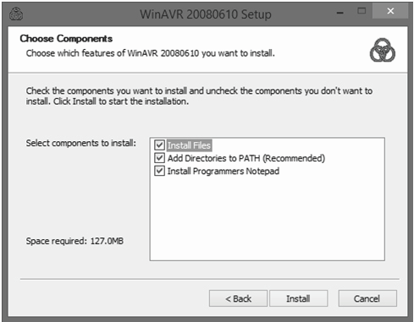

è **Click “Finish” to finish installation.**

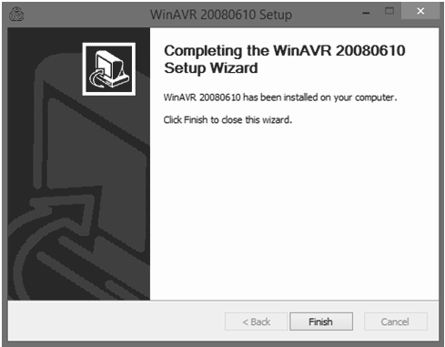

49 websit[e : **info@webteklabs.com**](http://www.i3indyatechnologies.com)

**Now InstallAVRStudio 4**

è **Locate the AVRStudio 4 setup file**

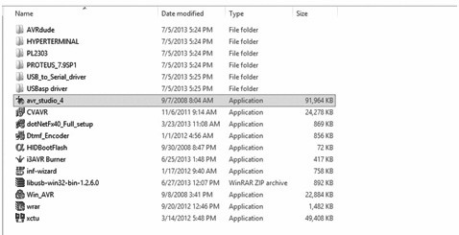

è **Click the setup file to install “AVRStudio 4.0”and click “Next”.**

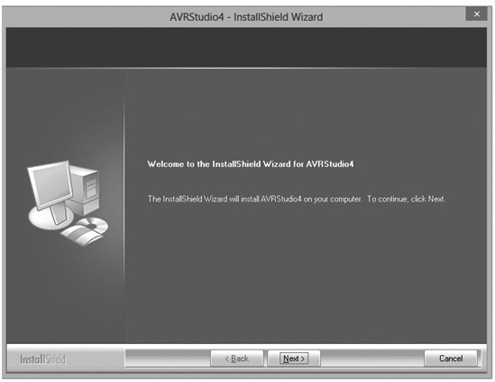

websit[e : **info@webteklabs.com**](http://www.i3indyatechnologies.com)50

è **Select “I accept the terms of license agreement” and click “Next”.**

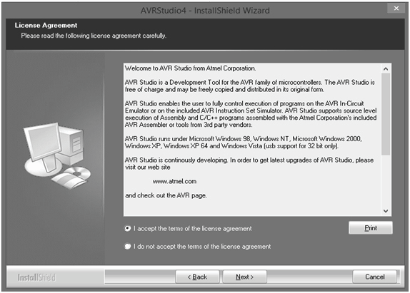

è **Click “Next”**

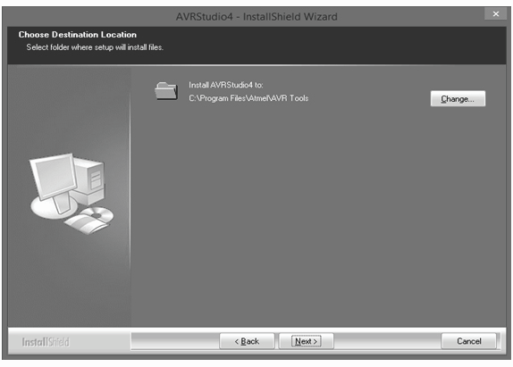

51 websit[e : **info@webteklabs.com**](http://www.i3indyatechnologies.com)

è **Click “Next”**

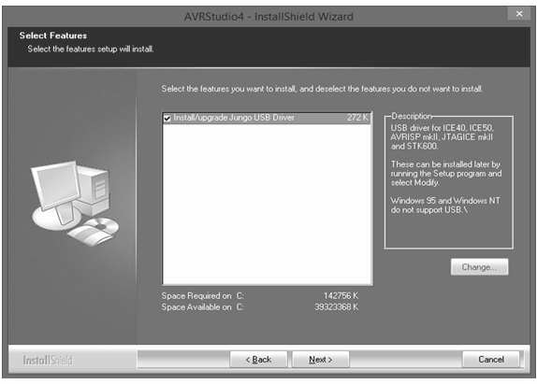

è **Click “Install”**

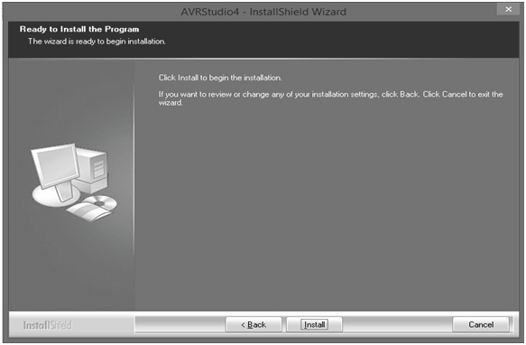

websit[e : **info@webteklabs.com**](http://www.i3indyatechnologies.com)52

è **Installation in progress.**

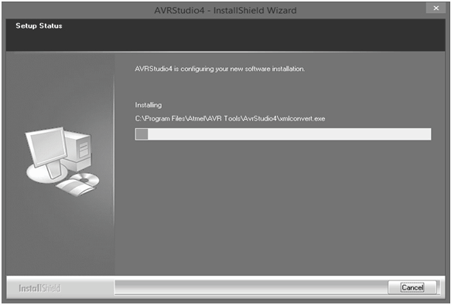

è **Click “Finish” to finish the installation of AVR studio 4.**

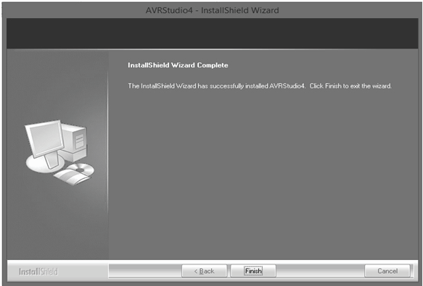

53 websit[e : **info@webteklabs.com**](http://www.i3indyatechnologies.com)

**3. Getting the microcontroller ready for programming**

Install the software named 'i3AVR Burner' from the CD as:

è Click on the icon of '**i3AVR Burner**'

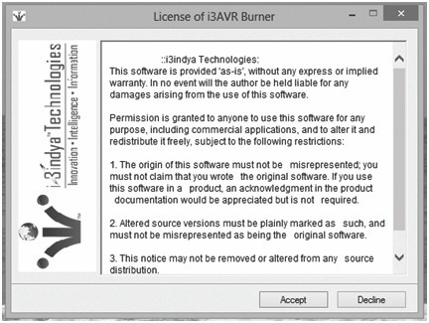

è Click 'Accept'

è Create a new folder in C:/, browse it and locate it & Click 'Install'

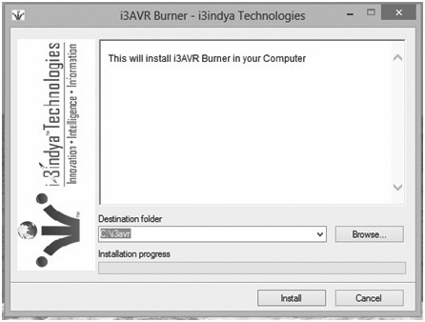

websit[e : **info@webteklabs.com**](http://www.i3indyatechnologies.com)5

è This will create an icon for 'i3AVR Burner' on your desktop, click on the icon and you will

get the following window:

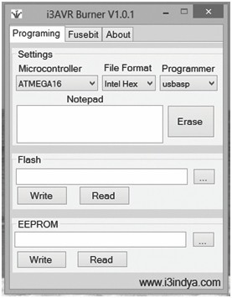

è Locate the .hex file of your program by clicking the browse button under the flash

category and click the write button. This will write your code onto the microcontroller

flash memory

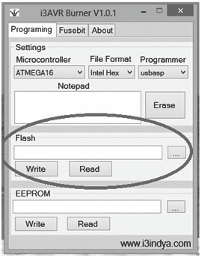

55 websit[e : **info@webteklabs.com**](http://www.i3indyatechnologies.com)

è**Writing your first code>>>**

è Open the installed AVR studio 4.



è **Click “New Project”.**

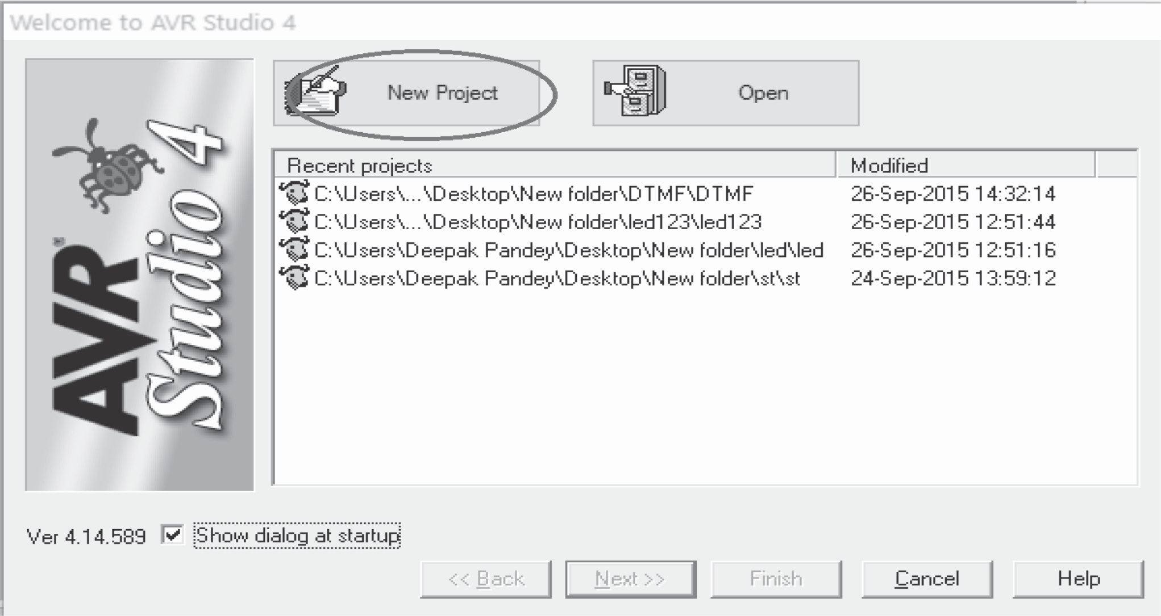

websit[e : **info@webteklabs.com**](http://www.i3indyatechnologies.com)56

è Select AVR GCC and name the project.

è Choose the location where you want to save your project.

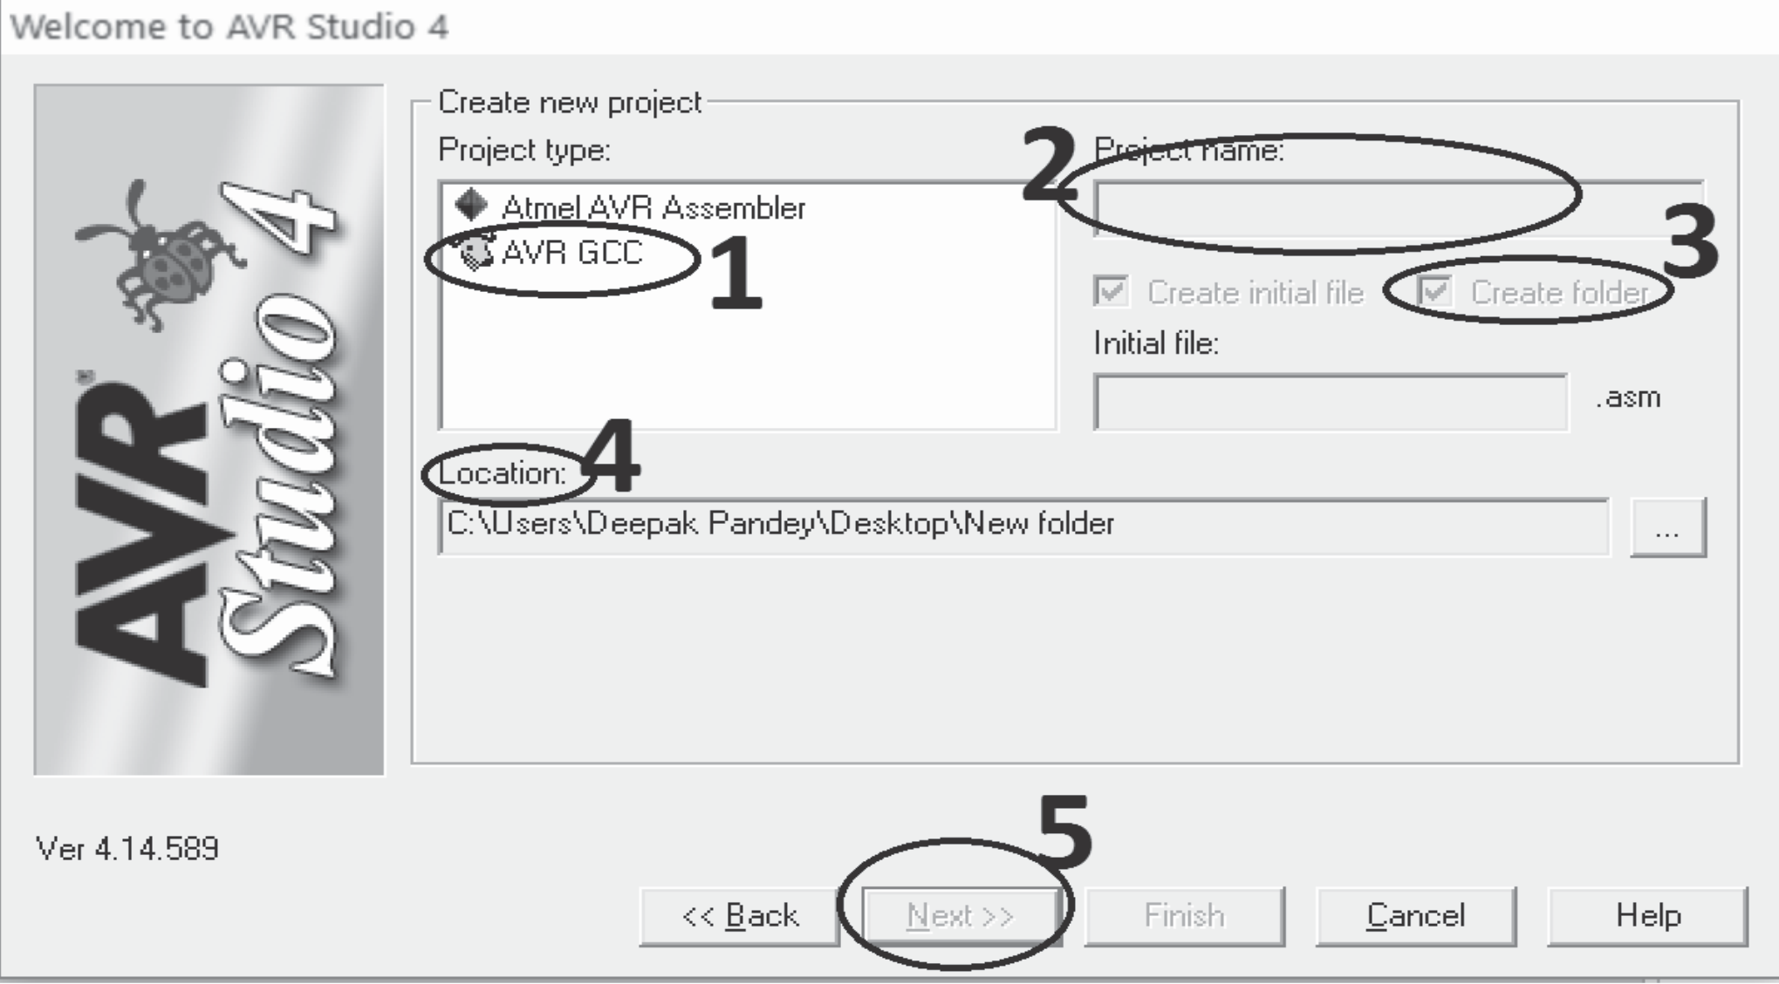

è select the simulator (AVR simulator in our case) and Atmega16 in device panel.

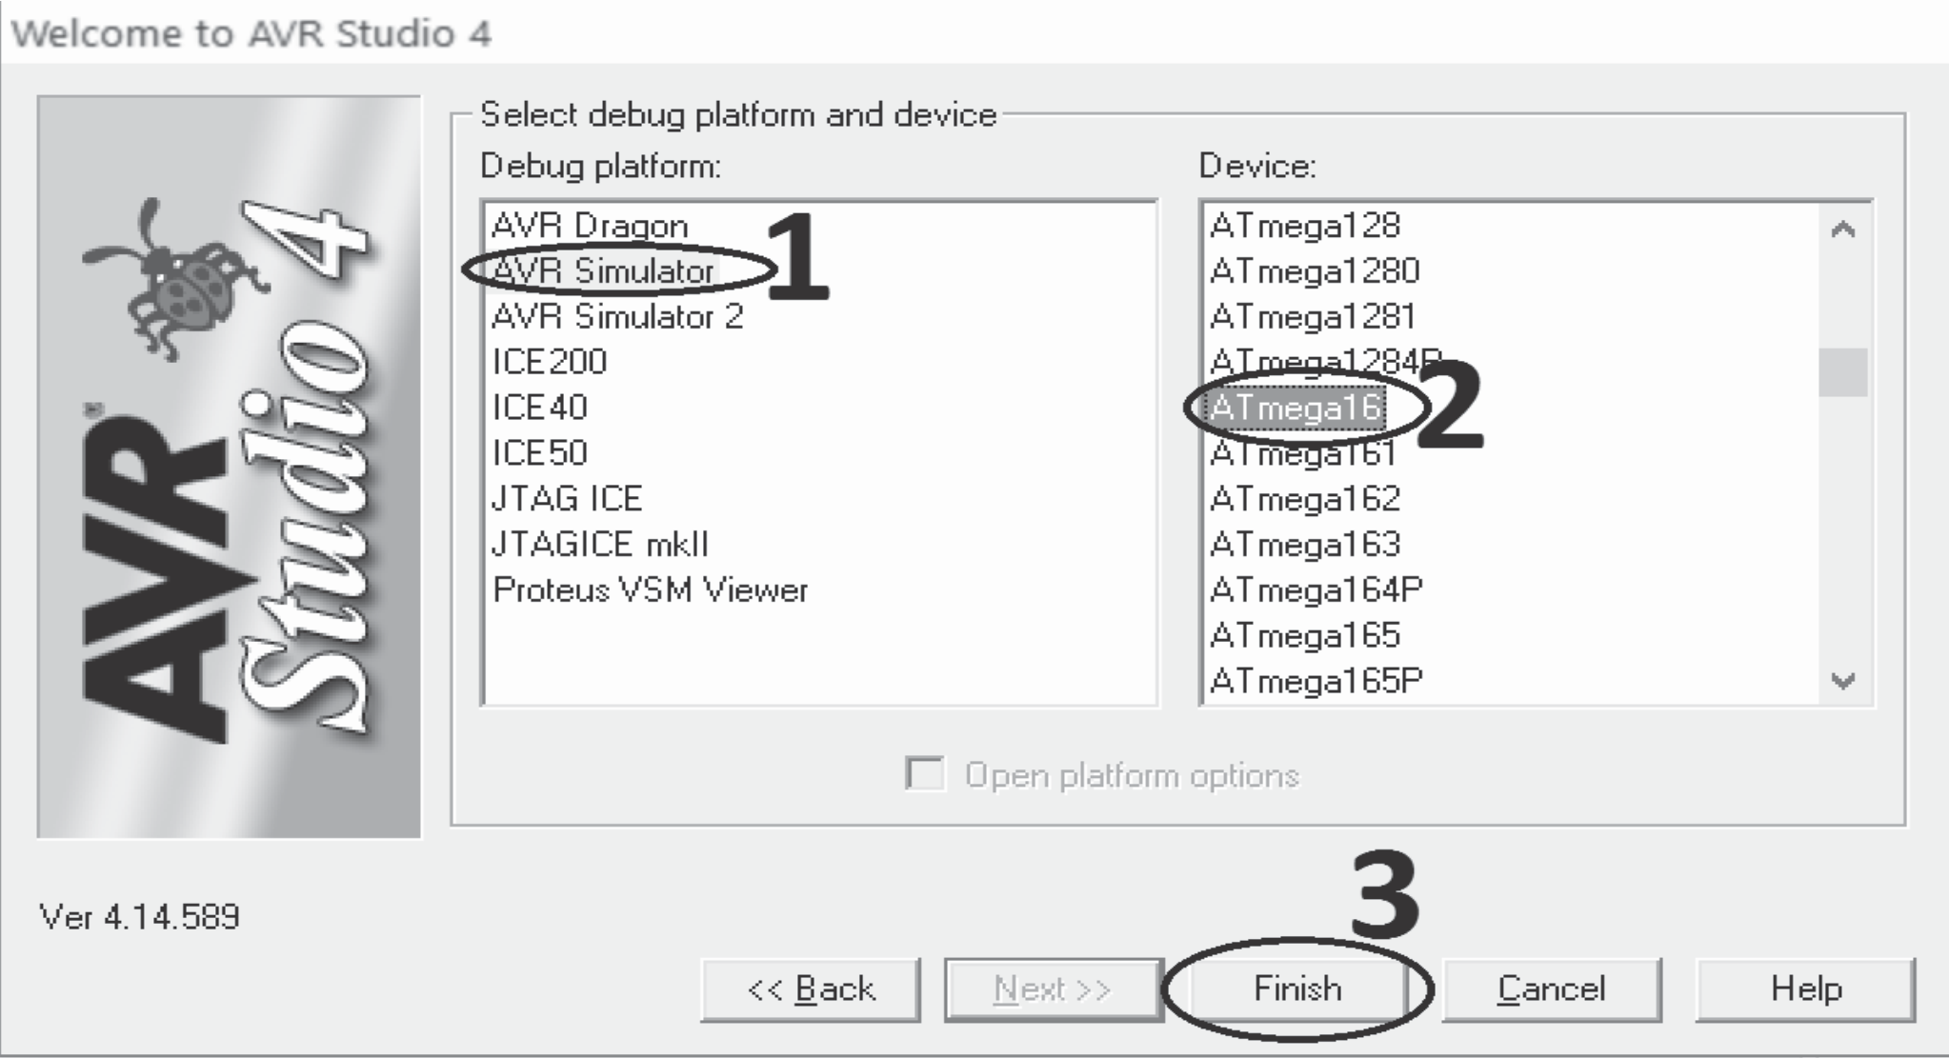

57 websit[e : **info@webteklabs.com**](http://www.i3indyatechnologies.com)

è Now start writing your code in the editer window

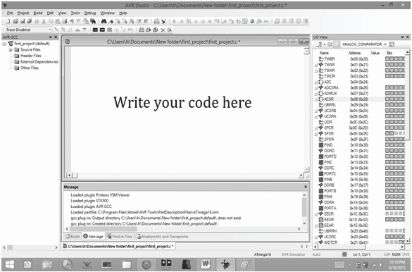

è

è After writing your code, click on “Build” option in the menu.

è After successful building operation select “Build and Run.”

è To Burn/feed the program inside theMicrocontroller, refer to “Getting the microcontroller

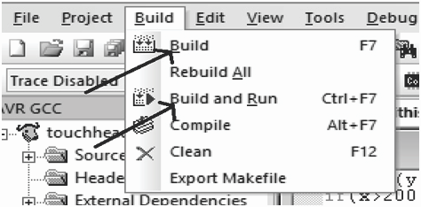

websit[e : **info@webteklabs.com**](http://www.i3indyatechnologies.com)58

2

-

DAY

TOPICS TO BE COVERED

è LED interfacing

è Seven Segment Display interfacing

è LED dot Matrix interfacing

PRACTICAL'S TO BE PERFORMED

è Glowing LEDs in the pattern of your choice

è Displaying digits on Seven Segment displays

è Generating Patterns on LED dot Matrix

è Displaying Alphabets on LED dot Matrix

**Description:**

In the 2nd day, you will learn about the working principle of LEDs and its interfacing with Atmega16 MCU. You have to design many patterns on LED as much possible. Here, you will also learn about the interfacing of SSD and 8x8 Led matrix interfacing with Atmega16 micro-controller.

**LED INTERFACING**



So, you probably wonder, why can't we program yet! Well, we still need to create a circuit that the program will control. It would be pointless to simply load a program into a microcontroller and run it without any devices connected to it. We wouldn't have much to look at! In fact you will soon see that many electronic components can be controlled by microcontrollers, however one of the easiest and basic devices to control is an LED.

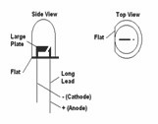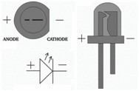

“LED" stands for Light Emitting Diode, and this component generally has two leads. Leads are the metal legs (wires) hanging off of the actual LED itself. These leads are the polar connections that allow current to flow into the LED from one lead (called the anode) and then out of the LED from the other lead (called the cathode).

One very important caution about powering and using LEDs is that the current running through the LED must be limited so it does not burn out the LED. LEDs have both a current rating, and a voltage rating. The current rating is the maximum current that the LED can handle,any higher current if passed through the LED will damage the LED; and a less current will result in a dimmer LED that does not emit light as brightly. So, we are faced with having to compute the optimum value for the resistor we will choose to connect to LED before we pass current through it. Note that if you don't want to do this calculation for some reason, it is generally safe to use a 1Kohm or 220 ohm resistor in series with the LED .In both the cases the light of intensity coming out of the LED will differ.

So to calculate the resistance needed, we will use Ohm's law which states that resistance (in Ohms) is

found by dividing the voltage by the current. The formula is:

**Resistance = volts/current**

This is typically written as **R = V / I.** But, how do we find the voltage and current values for the LED Typically, LEDs are rated at either 2 or 4 volts, and have either a 10 milliamp (mA) or 20mA current rating.

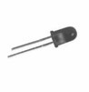

websit[e : **info@webteklabs.com**](http://www.i3indyatechnologies.com)59

My green LED has a 2 volt rating. White and blue LEDs have a voltage rating of 4 volts. I used the 10mA rating since it is safer to use this value as it results in the smallest denominator in the Ohm's law formula, and thus represents the largest resistance value for a given voltage. Therefore it can be considered the "worst case scenario," in terms of choosing resistor to insert into the circuit. Another aspect we will need to consider is the difference between the supply voltage (the voltage we are feeding into the system), and the rated voltage of the LED. Therefore the new formula becomes:-

**R = (Supply Voltage - LED Voltage) / I**

Therefore in the case of our green LED, R = (5v - 2v) / .01A = 300 ohms. Oh yeah, you need to convert the current to amps. Therefore we need to divide the 10mA number by 1000, as there are 1000 milliamps in one ampere. So now, what is this formula telling us? It's telling us that the resistance is equal to the remaining voltage after the LED is considered (i.e.; the voltage drop across the LED), divided by the desired current through the LED.What is that you say? We got a value of 300 out of that formula, but when I went to the store I couldn't find that number! I hate to tell this, but the money spent on petrol for that trip could have bought you 40 of the correct resistors! 300 Ohms is a resistance that is probably not available, but don't lose hope--you can always use a resistor of the next highest value. I have found this to be 330 Ohms in the mix of resistors I've collected from various thrown away appliances and electronics. And the best thing is that you don't have to be worry when “i3indya” is with you.

Hard part is behind us (the stuff above), so you can wipe your brow now! Let's use Pin 0 of PORT "B" on the MCU in this circuit, and that just so happens to correspond to the number 1 pin on the Atmega32 microcontroller I am using. So now we are going to programmatically turn on that pin to light up the LED.

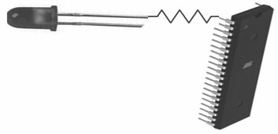

The steps to create the circuit go like this:

Connect the resistor to the pin number 1 (note that saying "PORTB0" is one way of referring to pin B0 of PORT B, but you'll learn other ways as well). Now connect the other end of the resistor to the positive side of the LED (i.e.; the anode side, or the lead that is the longest, or the lead opposite to the flat of the LED). Then we will connect the cathode side to the ground (GND) pin. The programmer will be connected too of course; which will allow the program to get transferred into the chip, and also provide power to the microcontroller. Finally, we can now apply the circuit to the breadboard. The videos demonstrate all the steps needed in this process. From the accompanying image, you can see that this is a very simple circuit.

60 websit[e : **info@webteklabs.com**](http://www.i3indyatechnologies.com)

Cautions: Check out the close-up of the resistor and the LED. Can you see how the wire is connected to the resistor and how the resistor is connected to the LED? We can start to program and make the LED light up. Excited? I am!

**(LED)(Connected to PORTB)**

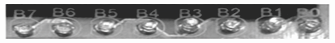

**Come to the programming part:-**

For the sake of simplification, let's categorize the function of the microcontroller into three categories:

v **Control,** v**Sensing and** v **Communication.**

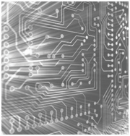

|  |  |  |  |
| --- | --- | --- | --- |
| We' l l l e ave t h e d e t a i l s o f h ow to d eve l o p e a c h o f t h e s e f u n c t i o n s , a n d d e lve i n to these details as we write the various programs. Note that there are many ways to program these functions. For the first program, we'll make the microcontroller "control" something. Now we'll be using an LED for this purpose. Basically, we will turn the LED on. Yes I know... boring, right? Well I need to start somewhere! As I take you through the experience of programming, I will add more complexity a little at a time so you are easily able to wrap your head around these important concepts.  So at this point you're probably asking...how do we make a program to control an LED? Well, it's really easy: We will simply tell Pin0 on PORTB to output 5 volts. Remember that this is the pin to which the positive lead (anode) is connected. The first key in this scenario is "output " and the next is "5 volts." There is a way we can tell a particular pin to be set to be an output from the MCU. Once a pin has been set to provide output, you will then be able to control that pin and make it either high (5 volts) or make it low (zero voltage). And since there are only two states for this pin in the output mode (5v or 0v), and only two states for the mode itself (input or output), you only need to set the value to either logical 1 or a 0. Note that, this must be accomplished for each pin we wish to use in our circuit. But before we get to plugging in a 1 or 0, let's talk about input versus output. When a pin is in input mode, it is listening for a voltage. When the pin is in output mode, it can be charged at 5v, or not charged at 0v. That's it! |  |  |  |
| There are many ways to do this. This is not to confuse you, but rather to make things simpler. I will be introducing you to one of the many ways to accomplish this task, and later I will explain some other methods while writing other programs. Note however that while this first method is great for introducing |  |  |  |

websit[e : **info@webteklabs.com**](http://www.i3indyatechnologies.com)61

vthe concept, it's probably not as good in practice. Therefore you will see other methods in future programs that will leave contextual pins (those pins on either side of the pin of interest) unaffected, as they may very well have been previously set in the program. But since we're writing a simple program, we won't worry about this complexity at this time.

To pick the output mode for a pin, you will use the Data Direction Register (DDR). Oh man! What is a register?!? Don't let this worry you. A register is simply a memory location that makes the microcontroller react in some way. We use a register to set a state for the microcontroller, or make the microcontroller do something. It's like reflexes, or tickles. When a person tickles another person, it invokes laughter. We can make the MCU do something by setting a specific value in a register. That's all you need to know at the moment. So when you use the DDR register, you are able to set the pin to either output data, or accept data input. But we said input or output, now you're saying data also. The term "data" used here simply just adds another dimension to this idea in the form of "time." If you make pin 5 volts, then zero volts, and then 5 volts again...you are actually sending 1s and 0s. To the pin, this is nothing more than a high (5 volts) state, and then a low (zero volts) state: The MCU sees this high/low logic. And you can also receive data in the same way. There are several ways to set pin0 for port B to output. One way to do this is to write:

*DDRB = 0b00000001;*

Let me explain. "DDRB" refers to the Data Direction Register for port B; "0b" is to tell the compiler that what follows is the binary expression of a number; and the "1" on the end denotes the pin 0 positions (the first pin in port B). Recall that there are 8 pins for port B; pins 0 though 7. There are also 8 digits in our line of code. So each digit represents a pin on the port, and we can use the individual digits to specifically refer to any one of the pins in port B. So the '1' at the end of our code statement refers to the first pin in port B, which in this case is pin 0. (Recall that C and C++ are zero-based languages, so the first index of a data structure refers to is the zero'th element; the second index refers to the first element, etc.) We really don't need to get any more complex at this point, as this will be covered in much more detail in future tutorials. However if you would like to know more about binary system, go to the bit operations in prerequisites chapter.

Now we need to apply 5v to the pin. This works just like the DDR code statement we used above. We will

use a binary number to put 5v on that pin (pin 0) using this statement:

PORTB = 0b00000001;

The only difference between this and the previous statement is that we are now using the PORT register. This register knows the pins of that specific port, and gives us access to specify the actual data value (logical 0 or 1) for these pins.

Now we need to talk a bit about the overall structure of our program. All programs need a specified place to start the execution. It's like giving someone a set of instructions on how to make a cake without telling them which step to start on. The "main" function is the place where all C/C++ programs start execution. So we will create a main function.

62 websit[e : **info@webteklabs.com**](http://www.i3indyatechnologies.com)

*int main(void)*

*{*

*return 0;*

*}*

In order for the program to understand the DDR and PORT register information and how these work within the microcontroller, an include statement must be added that contains all of the information about the AVR microcontrollers. This include statement will probably be in all of your programs.

*#include <avr/io.h>*

*intmain(void)*

*{*

*return 0;*

*}*

When the compilation process starts, the pre-processor portion of the compiler looks in the "avr" directory for the "io.h" file. The ".h" extension here indicates that this is a header file, and (as its name implies) the code within that file will be inserted at the beginning (head) of the source file you are creating. Now we can insert the DDR and PORT statements into our code, since the inclusion of the io.h header file has informed the compiler about them.

*#include <avr/io.h>*

*intmain(void)*

*{*

|  |  |  |
| --- | --- | --- |
|  |  |  |
|  |  |  |
|  |  |  |
|  | *}* |  |

*DDRB = 0b00000001; //Data Direction Register setting pin0 to output and the remaining pins as input*

*PORTB = 0b00000001; //Set pin0 to 5 volts*

*return 0;*

Now the direction of the pin0 is set to output, with a value set at 5v. But we are still not finished. Let's have a look how at the output, what you will see is that your LED does glow as accepted. Let's find out the reason why this happened? and let's correct it. Now go the Program you have written

*#include <avr/io.h>*

*int main(void)*

*{*

|  |  |  |
| --- | --- | --- |
|  |  |  |
|  |  |  |
|  |  |  |
|  | *}* |  |

*DDRB = 0b00000001; //Data Direction Register setting pin0 to output and the remaining pins as input*

*PORTB = 0b00000001; //Set pin0 to 5 volts*

*return 0;*

The controller operates at a frequency of 1 MHz, so it will take 1 microsecond to execute 1 line of code. So

the controller will finish this program in few microseconds and since our eyes can't detect this change, we

websit[e : **info@webteklabs.com**](http://www.i3indyatechnologies.com)6

won't be able to see whether our LED glowed or not. So what's the way out, we need to keep the microcontroller running indefinitely, so we need a routine to do this. This is called an endless (or infinite) loop. The infinite loop makes sure that the microcontroller does not stop performing its operations. I will explain this in more detail when we have stuff to do within this loop. There are several types of loops we can use for this purpose, but for this demonstration I will use the while loop. It means the same in English as it does in code: For instance, "while" I have my hand up, you should keep clapping.

So, the program syntax after involving the while loop is as follows:

*#include <avr/io.h>*

*int main(void)*

|  |  |  |
| --- | --- | --- |
|  |  |  |
|  |  |  |
|  |  |  |
|  |  |  |
|  |  |  |
|  |  |  |
|  |  |  |
|  | *}* |  |

*{ DDRB = 0b00000001; //Data Direction Register setting pin0 to output and the remaining pins as input*

*PORTB = 0b00000001; //Set pin0 to 5 volts*

*while(1)*

*{*

*//Code would be in here if it needed to execute over and over and over ... endlessly*

*}*

*return 0;*

Note that we use a '1' as the argument to the while loop, because anything other than '0' is a logical true. Therefore the while loop condition will never be anything other than logically true, and the program will continue to execute indefinitely (i.e.; I keep my hand raised).So, here is the fruit of our labor.Now Let's Put your code in the syntax and see whether the LED glows or not. So, the Program for glowing a single LED connected to pin0 of PORTB is as follows:

*#include <avr/io.h>*

*int main(void)*

|  |  |  |
| --- | --- | --- |
|  |  |  |
|  |  |  |
|  |  |  |
|  |  |  |
|  |  |  |
|  |  |  |
|  | *}* |  |

*{ DDRB = 0b00000001; //Data Direction Register setting pin0 to output and the remaining pins as input*

*PORTB = 0b00000001; //Set pin0 to 5 volts*

*while(1)*

*{ PORTB=0b00000001;*

*}*

*return 0;*

It was a long ride so far, but I promise, everything from here on will be gratifying and far less time consuming. In the next video and instruction, we will make the LED blink. The logic to blink a LED is to pass alternate 5V and 0V to the LED after some amount of delays, so that we can absorb the blink of the LED.

To put a delay in your program you need to a predefined function, *_delay_ms()* , but before using this function you need to include a header file available in *delay.h* header file in until folder of the complier. The program structure after including this header file will be as follows:

64 websit[e : **info@webteklabs.com**](http://www.i3indyatechnologies.com)

*#include <avr/io.h>*

*#include<util/delay.h>*

*int main(void)*

*{ DDRB = 0b00000001; //Data Direction Register setting pin0 to output*

*while(1)*

*{ PORTB = 0b00000001; //Set pin0 to 5 volts*

*}*

*return 0;*

*}*

Now you can easily use the *_delay_ms()* function to put delays in your program. So, Lets start working on it and develop a program for blinking a single LED connected to pin0 of PORTB. The program for the same is as follows:

*#include <avr/io.h>*

*#include<util/delay.h>*

*int main(void)*

*{ DDRB = 0b00000001; //Data Direction Register setting pin0 to output*

*while(1)*

*{ PORTB = 0b00000001; //Set pin0 to 5 volts*

*_delay_ms(1000); // a delay of 1 second*

*PORTB=0b00000000; //setting pin0 to 0 volts*

*_delay_ms(1000);// a delay of 1 second*

*}*

*return 0;*

*}*

Now let's investigate the output, the LED will glow for 1 second and will be OFF for 1 second. So feeling

happy after blinking a single LED. Now, use your logics and write program for the following:

**Assignment 1:**

1. Glowing All LEDs connected on MEGATron™ board.

2. Blinking all the LEDs connected on MEGATron™ board.

Now implement our ideas to different patterns of LED blinking… Remember Diwali…

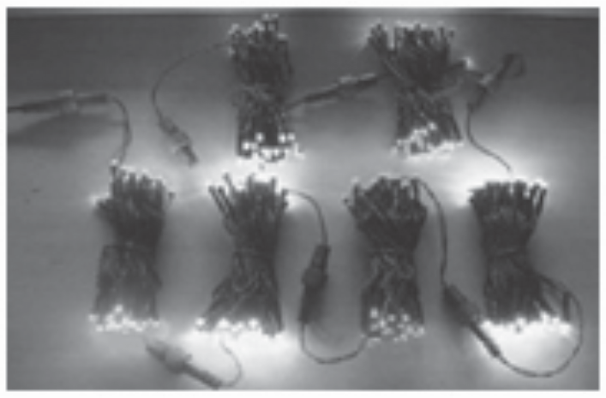

websit[e : **info@webteklabs.com**](http://www.i3indyatechnologies.com)65



**Practical 1: Glowing LEDs in different patterns**

**Description:** Eight LEDs are connected to each of your pin of PORTB you are supposed to light those LEDs

in patterns using DDR, PORT and delay

1) **Blinking the LEDs:** To make the LED blink

|  |  |  |
| --- | --- | --- |
|  |  |  |
|  |  |  |
|  |  |  |
|  |  |  |
|  |  |  |
|  |  |  |
|  | g. | Close the while loop |

a. Define the Port as Output

b. Start an infinite while loop

c. Make the Pin High

d. Add a delay

e. Make the Pin Low

f. Add a delay

**Flow Chart:**

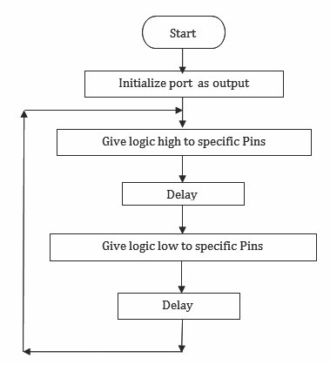

66 websit[e : **info@webteklabs.com**](http://www.i3indyatechnologies.com)

**Code:**

#include<avr/io.h> //Import the header files

#define F_CPU 16000000 //setting Oscillator frequency 16Mhz

#include<util/delay.h>

int main () //Start the main function

{

DDRB = 0b11111111; //Define port b as output port while(1) //Start an infinite while loop

{

PORTB = 0b11111111; //Make the pins high

_delay_ms(1000); //1 second delay. PORTB = 0b00000000; //Make the pins low

_delay_ms(1000); //1 second delay

}

return 0;

}

**Hardware Setup:**

Step1: Components Required

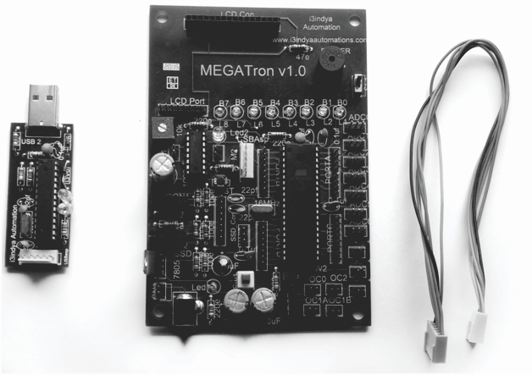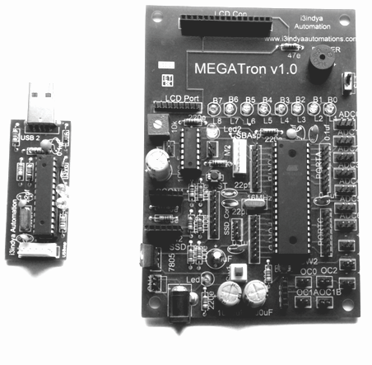

websit[e : **info@webteklabs.com**](http://www.i3indyatechnologies.com)

Step 2: Connecting the programmer with the development board.

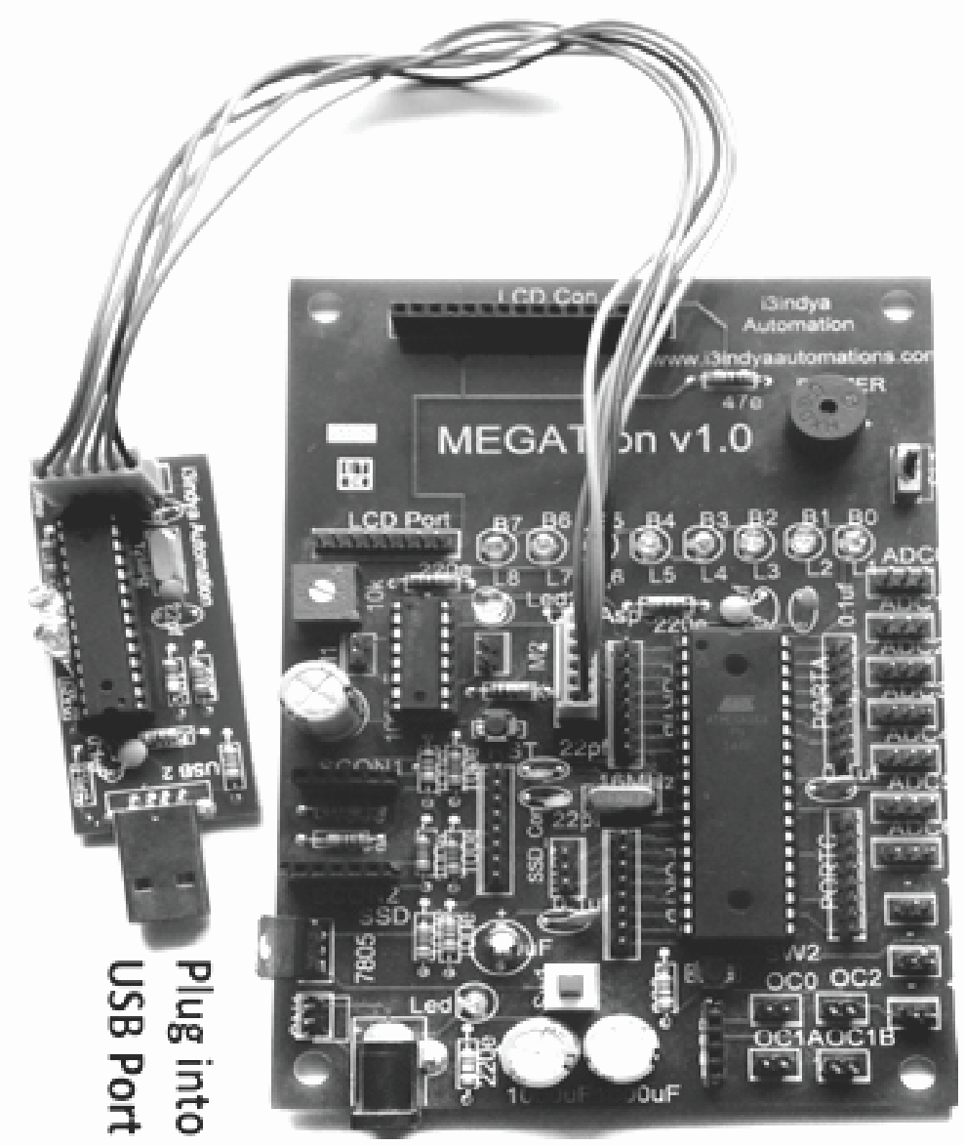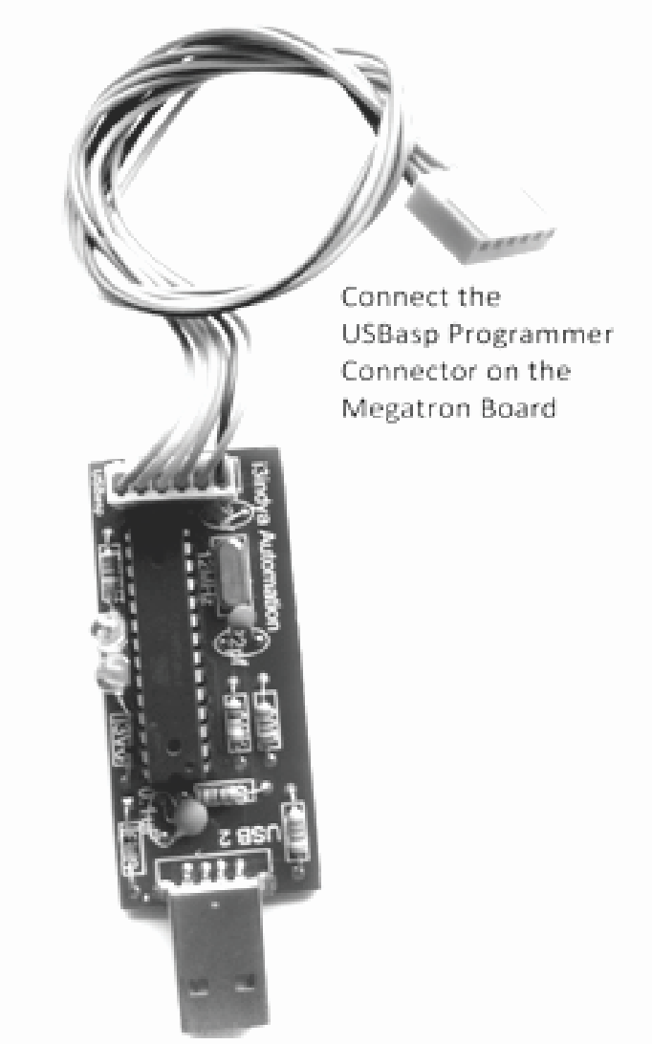

**Step 3:** Burn the hex file into the micro controller using I3AVR burner. Click on the icon and you will get the following window:

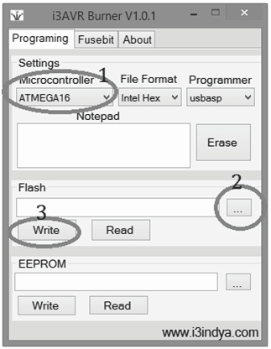

è Firstly, select the Microcontroller i.e. ATmega16. Then, locate the .hex file of your program by clicking the browse button under the flash category and click the write button. This will write your code onto the microcontroller flash memory

68 websit[e : **info@webteklabs.com**](http://www.i3indyatechnologies.com)

**Note:** Before **“Write”** click, make sure the USBasp Programmer is connected with the MEGATron™ Board (i.e. development board) and power must be turn ON.

**Result:** The LEDs will glow in the defined pattern.

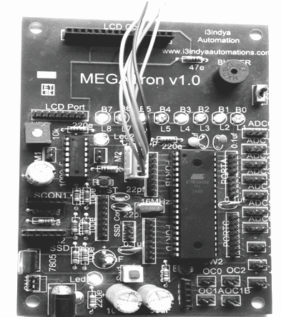

**NOTE: 8 LEDs are connected to PORTB in i3indya MEGATron™ board**

websit[e : **info@webteklabs.com**](http://www.i3indyatechnologies.com)6

**2. Right shifting of LEDs-**To make the LEDs right shift

a. Define the Port as Output

b. Start an infinite while loop

c. Light the first Led my making the first pin high d. Start a for loop

e. Right shift the high bit f. Add a delay

g. Close the for loop

h. Close the while loop

**Pattern required:**

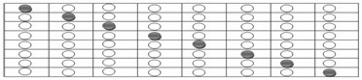

**Flow chart:**

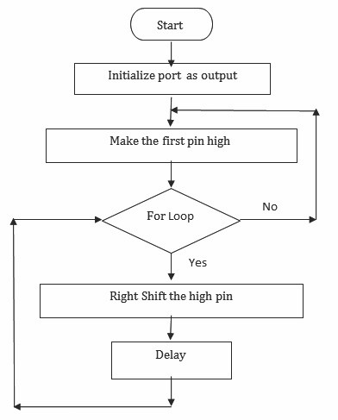

70 websit[e : **info@webteklabs.com**](http://www.i3indyatechnologies.com)

**Code:**

*#include<avr/io.h>*

*#define F_CPU 16000000*

*#include<util/delay.h>*

*int main()*

*{ DDRB=0XFF;*

*while(1)*

*{ PORTB=0X80; // You can use 0b10000000 or 128 as well. They all are same, just*

*the number system differs.//*

*_delay_ms(500);*

*for(inti=0;i<7;i++)*

*{ PORTB=PORTB>>1;*

*_delay_ms(1000);*

*}*

*}*

*return 0;*

*}*

**1) Left shift of LED**

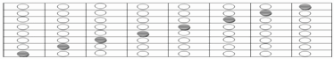

*#include<avr/io.h>*

*#define F_CPU 16000000*

*#include<util/delay.h>*

*int main()*

*{ DDRB=0XFF;*

*while(1)*

*{ PORTB=1;*

*_delay_ms(500);*

*for(inti=0;i<7;i++)*

*{ PORTB=PORTB<<1;*

*_delay_ms(500);*

*}*

*}*

*return 0;*

*}*

websit[e : **info@webteklabs.com**](http://www.i3indyatechnologies.com)71

**2) Convergence pattern on LED**

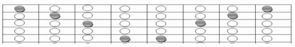

*#include<avr/io.h>*

*#define F_CPU 16000000*

*#include<util/delay.h> unsignedinti; unsignedint j;*

*int main()*

*{ DDRB=0xff;*

*while(1)*

*{ for(i=128,j=1;i>=16,j<=8;)*

*{ PORTB=i|j; // logical "OR" b/w i& j......*

*_delay_ms(300);*

*i=i/2;*

|  |  |  |  |
| --- | --- | --- | --- |
|  |  |  |  |
|  |  | *}* |  |

*j=j*2;*

**3) Divergence pattern on LED**

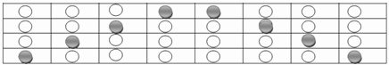

*#include<avr/io.h>*

*#define F_CPU 16000000*

*#include<util/delay.h> unsignedinti; unsignedint j;*

*int main()*

*{ DDRB=0xff;*

*while(1)*

*{ for(i=16,j=8;i<=128,j>0;)*

*{ PORTB=i|j;*

72 websit[e : **info@webteklabs.com**](http://www.i3indyatechnologies.com)

*i=i*2;*

*j=j/2;*

|  |  |  |  |
| --- | --- | --- | --- |
|  |  |  | *_delay_ms(300);* |
|  |  |  |  |
|  |  |  |  |
|  |  |  |  |
|  |  |  |  |

*}*

*}*

*return 0;*

*}*

**4) Sandglass pattern of LED blinking**

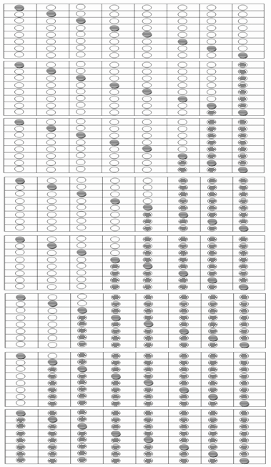

websit[e : **info@webteklabs.com**](http://www.i3indyatechnologies.com)7

**Code:**

*#include <avr/io.h>*

*#define F_CPU 16000000*

*#include <util/delay.h>*

*#define MRP 100 int main()*

*{ inti,j,k,num=8;*

*char a; DDRB=0xFF; PORTB=0x00; while (1)*

*{ // LED shifting left to right Ex:1 2 4 8 -- 9 10 12 -- 13 14 -- 15*

*PORTB=0x00;*

*a=0;*

*for(k=0;k<num;k++)*

*{ j=1;*

*for(i=num;i>k;i--)*

*{ PORTB=a|j;*

*j=(j<<1);*

*_delay_ms(MRP);*

*}*

*a=PORTB;*

*_delay_ms(1000);*

*}*

*// LED shifting right to left Ex:8 4 2 1 -- 9 5 3 -- 11 7 -- 15*

*PORTB=0x00;*

*a=0;*

*for(k=0;k<num;k++)*

*{ j=8;*

*for(i=num;i>k;i--)*

*{ PORTB=a|j;*

*j=(j>>1);*

*_delay_ms(MRP);*

*}*

*a=PORTB;*

*_delay_ms(1000);*

*}*

*}*

*return 0;*

*}*

74 websit[e : **info@webteklabs.com**](http://www.i3indyatechnologies.com)

Ø **Check your ability…**

**1. Glowing LEDs in a pattern of your choice.**

**2. Make your own Hardware to make frill LED and generate patterns.**

**3. Make 3X3X3, 4X4X4, 8X8X8 LED cube.**

**4. Make LED chaser LED spinning and decorate your room.**



websit[e : **info@webteklabs.com**](http://www.i3indyatechnologies.com)75

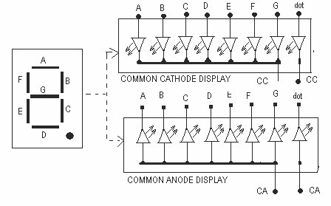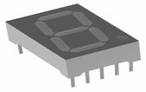

**I Interfacing Seven Segment Displays**

A seven-segment display (SSD) is well representation of 8 LED, or seven-segment indicator, is a form of electronic display device for displaying decimalnumerals that is an alternative to the more complex dot- matrix displays. Seven-segment displays are widely used in digital clocks, electronic meters, and other electronic devices for displaying numerical information.

Seven Segment display is of two types:

1. Common Anode

2. Common Cathode

**Common Anode:** In this type of SSD, the anode (positive end) of all the 8 LEDs in made common. Thus, to

select the LED you need to provide '0' to that LED.

**Common Cathode:** In this type of SSD, the cathode (negative end) of all the 8 LEDs in made common. Thus, to select the LED you need to provide '1' to that LED.

The seven LEDs in the seven segment display are labeled with the letters **A, B, C, D, E. F** and **G** as indicated in figure below. Some seven segment display may include 1 or 2 additional LEDs which are used as decimal point(s). Seven Segment Displays are mainly used to display numerical digits. The figure below shows which LEDs to turn **ON** to display the digits **1, 2, 3, 4, 5** and **6**. Other numbers can be displayed by turning ON the appropriate LEDs.

76 websit[e : **info@webteklabs.com**](http://www.i3indyatechnologies.com)

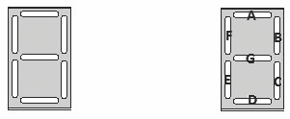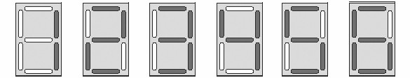

A Seven Segment Display can also be used to display certain letters of the alphabet. The figure below gives

the LEDs to turn ON to display **A, F, H, L** and **P.**

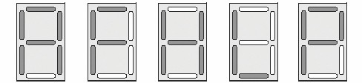

**SSD Pin Configuration:**

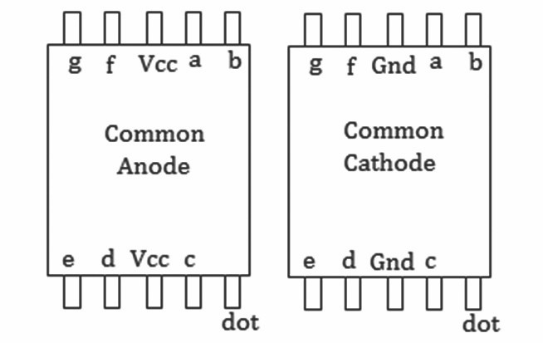

websit[e : **info@webteklabs.com**](http://www.i3indyatechnologies.com)7

**Binary Codes for Common cathode Seven Segment Displays**

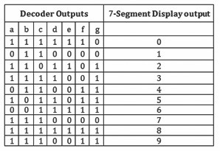

***Remember the LED interfacing logics…***

**We can use any PORT of ATmega16 to connect SSD Jack with 8 pin relimate.** Lets us consider our SSD is connected with PORTC with 8 pin relimate. Inside a SSD, we have 8 pins for the 8 LEDs, two pin for VCC supply (3 and 8 pin) in case of common cathode SSDs and vice-versa'. From the truth table we supply the logic '1' (VCC) and logic '0' to the corresponding SSD pin. You can display only single digit number on a single seven segment display at a time.

The program for displaying '0' on SSD is as follows:

#include<avr/io.h>

#define F_CPU 16000000

#include<util/delay.h>

int main ()

{ DDRD=0xFF; //PORTD as a out put



while(1)

{ PORTD=0b11000000; //To display 0

}

return 0;

}

***Hey come on… don't tell me to explain the above things, as you remember LED interfacings …… Some seven segment gifts for you….. :-***

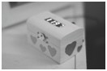

78 websit[e : **info@webteklabs.com**](http://www.i3indyatechnologies.com)



**DISPLAYING DIFFERENT DIGIT ON**

**ON SEVEN SEGMENT DISPLAY**

**Note: to connect a Seven segment, we will be using two ports of ATmega16, only 5 pins from each port will be utilized to glow the pattern on seven segment displays**

**Sample Program: To Display the digit 2 on Seven Segment Display**

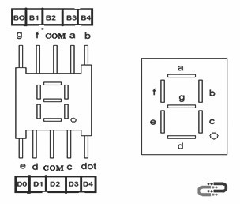

**Description:** Interface a Seven Segment Display to show various numbers

a. Declare required port as output port

b. Start infinite while loop

c. Make the required pins high to display a digit 2

d. Delay

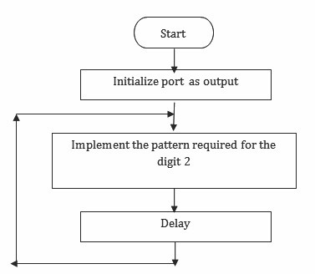

e. Change the pattern

**Flowchart:**

websit[e : **info@webteklabs.com**](http://www.i3indyatechnologies.com)7

**CODE:**

#include<avr/io.h>

#define F_CPU 16000000

#include<util/delay.h>

int main ()

{ DDRD=0xFF; //PORTD as a out put

while(1)

{ PORTD=0b10100100; //To display 2

}

return 0;

}

**Write your code**

è Open the installed AVR studio 4.



80 websit[e : **info@webteklabs.com**](http://www.i3indyatechnologies.com)

è Click **“New Project”.**

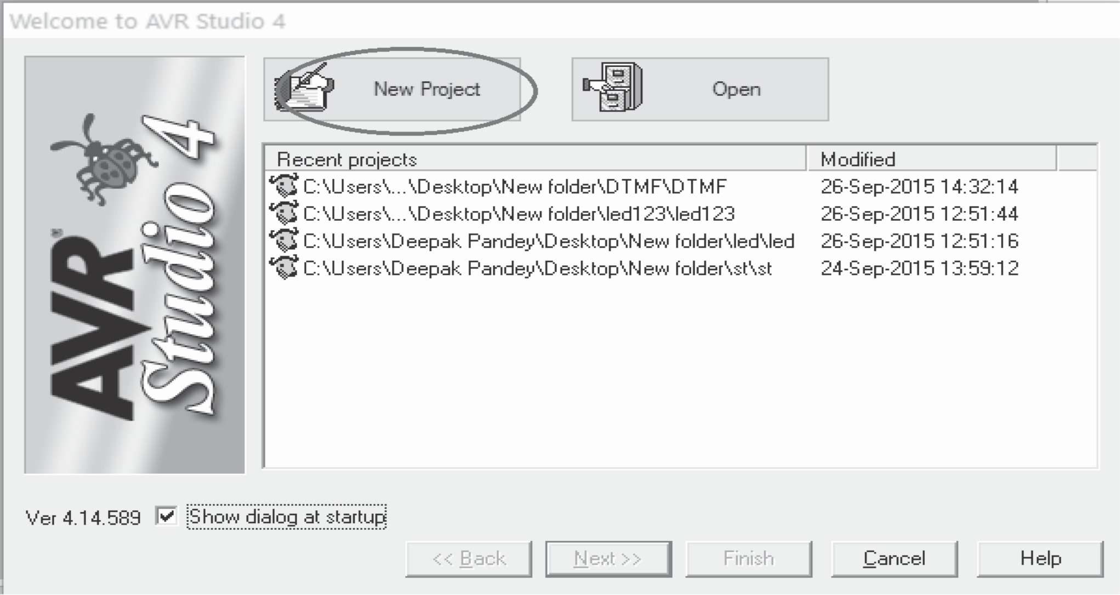

è Select AVR GCC and name the project.

è Choose the location where you want to save your project.

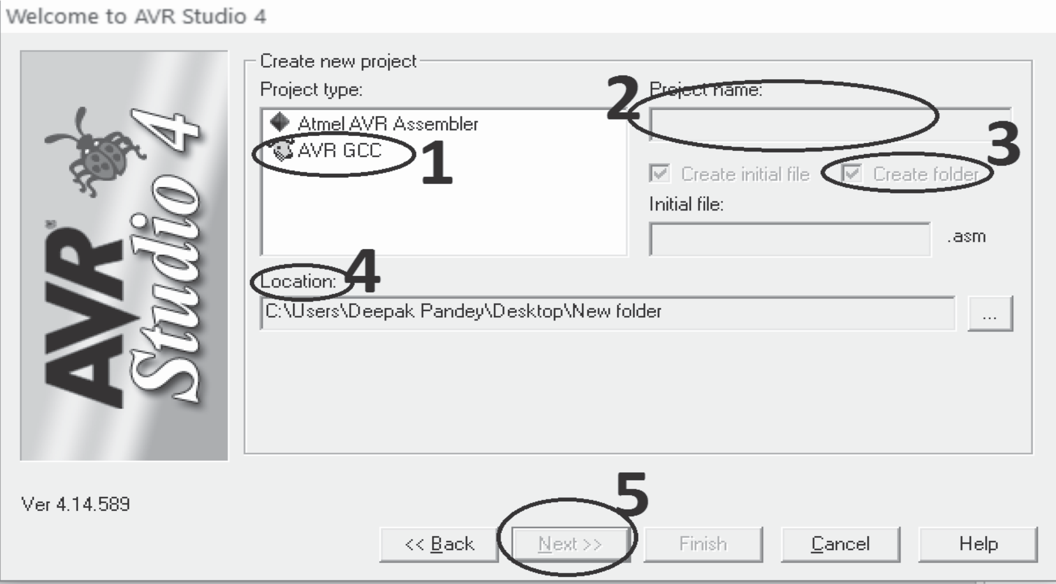

websit[e : **info@webteklabs.com**](http://www.i3indyatechnologies.com)8

è select the simulator (AVR simulator in our case) and Atmega16 in device panel.

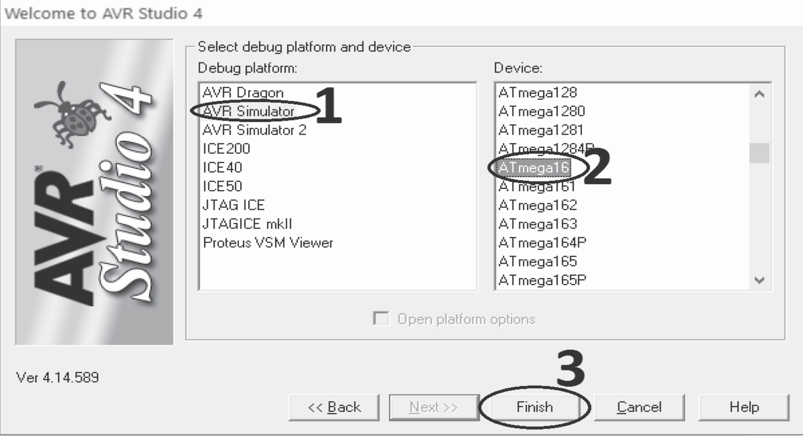

è Now start writing your code in the editer window

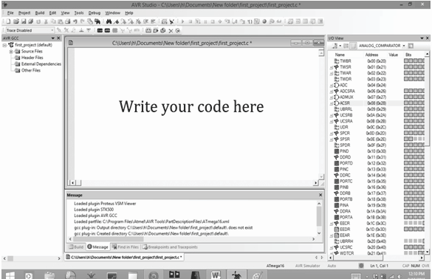

82 websit[e : **info@webteklabs.com**](http://www.i3indyatechnologies.com)

èAfter writing your code, click on “Build” option in the menu.

èAfter successful building operation select “Build and Run.”

èTo Burn/feed the program inside the Microcontroller, refer to “Getting the microcontroller

è Ready for programming” article.



**Hardware Setup:**

**Step1:** Components Required

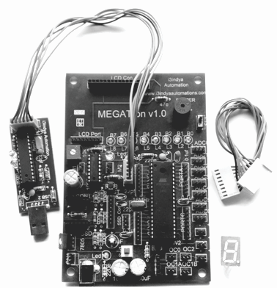

websit[e : **info@webteklabs.com**](http://www.i3indyatechnologies.com)8

**Step 2:** Connecting the programmer with the development board

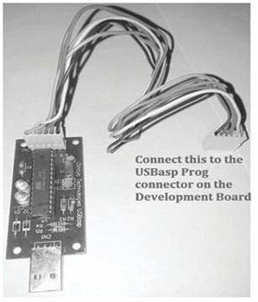

**Step 3:** Connect the seven segment display to its specified location and with PORTB using the

connecting wires.

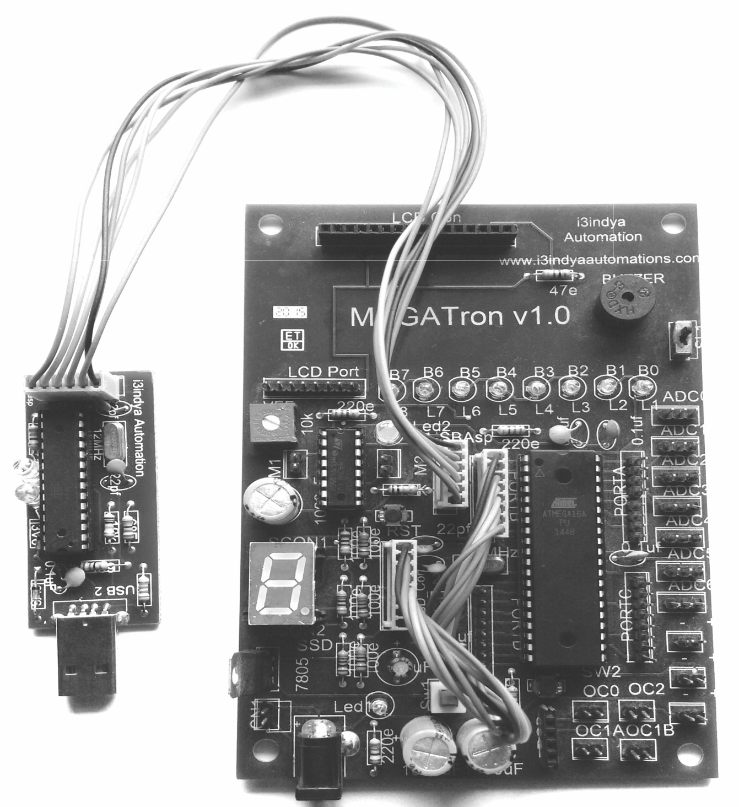

84 websit[e : **info@webteklabs.com**](http://www.i3indyatechnologies.com)

**Step 4:** Burn the hex file into the micro controller using I3AVR burner

è Click on the icon and you will get the following window:

èFirstly, select the Microcontroller i.e. ATmega16. Then, locate the .hex file of your program by clicking the browse button under the flash category and click the write button. This will write your code onto the microcontroller flash memory



**Note:** Before “Write” click, make sure the USBasp Programmer is connected with the MEGATron™ Board (i.e. development board) and power must be turn ON.

**Result:** The numbers will start being displayed on the

seven segment display after burning the code.

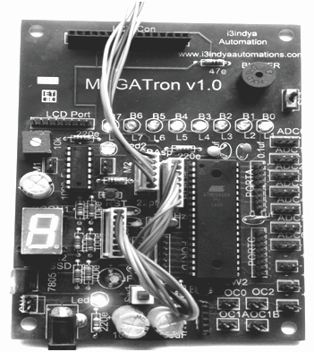

websit[e : **info@webteklabs.com**](http://www.i3indyatechnologies.com)8

**1) Display different numbers(digits) on seven segment display (SSD) (ANODE)**

#include<avr/io.h>

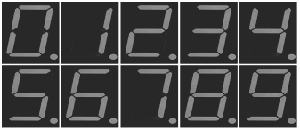

#define F_CPU 16000000

#include<util/delay.h>

int main()

{ DDRD=0xFF;

while(1)

{

PORTD=0b11000000; //0

_delay_ms(1000);

PORTD=0b11111001; //1

_delay_ms(1000);

PORTD=0b10100100;//2

_delay_ms(1000);

PORTD=0b10110000;//3

_delay_ms(1000);

PORTD=0b10011010;//4

_delay_ms(1000);

PORTD=0b10010010;//5

_delay_ms(1000);

PORTD=0b10000010;//6

_delay_ms(1000);

PORTD=0b11111000;//7

_delay_ms(1000);

_delay_ms(1000);

PORTD=0b10010000;//9

|  |  |  |
| --- | --- | --- |
|  |  | PORTD=0b10000000;//8 |
|  |  |  |
|  |  |  |
|  |  |  |
|  |  |  |
|  |  |  |
| } |  |  |

_delay_ms(1000);

}

86 websit[e : **info@webteklabs.com**](http://www.i3indyatechnologies.com)

**1) Try this time some alphabets also... (ANODE)**

#include<avr/io.h>

#define F_CPU 16000000

#include<util/delay.h>

int main()

{ DDRD=0xFF;

while(1)

{

PORTD=0b10001000;//A

_delay_ms(1000);

PORTD=0b10000000;//B

_delay_ms(1000);

PORTD=0b11000110;//C

_delay_ms(1000);

PORTD=0b11000000;//D

_delay_ms(1000);

PORTD=0b10000110;//E

_delay_ms(1000);

PORTD=0b10001110;//F

_delay_ms(1000);

}

}}

}

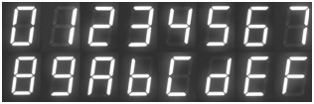

websit[e : **info@webteklabs.com**](http://www.i3indyatechnologies.com)8



è**Check your ability…**

è**1) Display all the numbers in cathode SSD.**

**2) Make SSD using 7 single LED.**

**3) Make Number Display Board using two or more SSD.**

**4) Make your Own Time Display Board (Digital Watch) which you see on Train Station.**

**5) Make your Own Voltage Meter using SSD.**

88 websit[e : **info@webteklabs.com**](http://www.i3indyatechnologies.com)



**LED DOT MATRIX**

LED dot matrices are very popular means of displaying information as it allows both static and animated text and images. Perhaps, you have encountered them at gas stations displaying the gas prices, or in the public places and alongside highways, displaying advertisements on large dot matrix panels.

In a dot matrix display, multiple LEDs are wired together in rows and columns. This is done to minimize the number of pins required to drive them. For example, an 8×8 matrix of LEDs (shown below) would need 64 I/O pins, one for each LED pixel. By wiring all the anodes together in rows (R1 through R8), and cathodes in columns (C1 through C8), the required number of I/O pins is reduced to 16. Each LED is addressed by its row and column number.

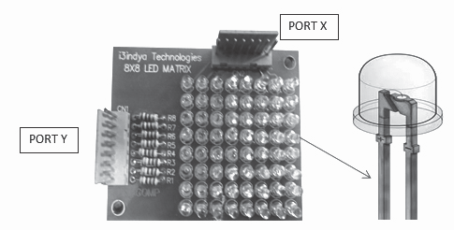

PORT X is the Negative port of the LED dot Matrix that means we need to pass logic '0' on th wires connected on this port, while PORT Y is the Positive port of the LED dot Matrix that means we need to pass logic '1' on th wires connected on this port.

**Interfacing LED Dot matrix display**

LED matrix which are available in market are either 4X4 or 8X8 matrix. If you buy an LED dot matrix from market, you may have problems interfacing it, because of their pin configuration. The correct Pin configuration of the manufactured LED dot matrix is shown above. But i3indya 8x8 LED dot matrix have 8 row pins and 8 column pins, just choose row no. and column no. for glowing the respective LED.

For interfacing we need two PORTs: one for row and one for column.

Ÿ The DDR registers of both the ports is to be made as output.

Ÿ For selecting a row we give '1' to that row pin and '0' for deselecting that row.

Ÿ For selecting a column we give '0' to that column pin and '1' for deselecting that column pin.

websit[e : **info@webteklabs.com**](http://www.i3indyatechnologies.com)89

Thus if we want to glow the LED in row 2 and column 5, we will write the code as:

DDRD=0xff; // declaring PORTA as output port for selecting rows

DDRA=0xff; // declaring PORTB as output port for selecting columns

while(1)

{ PORTA=0b00000010; //selecting row 2

PORTD=0b11101111; //selecting column 5

}

**Schematic for i3indya 8 X 8 LED dot Matix display**

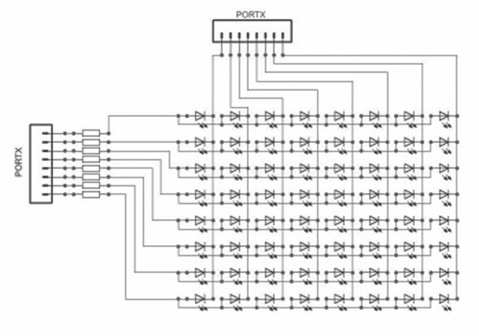

90 websit[e : **info@webteklabs.com**](http://www.i3indyatechnologies.com)

So for displaying a particular pattern you have to switch ON those LEDs which form the pattern, at a rate

that is undetectable by our eyes.

After burning above code what is the output you are getting????

Now, suppose you want to glow a single row, then the code would be as:

DDRD=0xff; // declaring PORTA as output port for selecting rows

DDRB=0xff; // declaring PORTB as output port for selecting columns

while(1)

{ PORTB=0b00010000; //selecting row 4

PORTD=0b00000000; //selecting all the columns

}

The following figure shows the effect of the above program on LED Dot Matrix

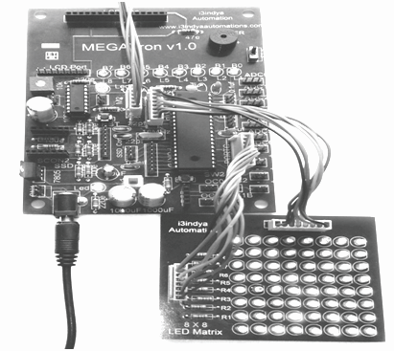

websit[e : **info@webteklabs.com**](http://www.i3indyatechnologies.com)9

Lets glow two rows one after the other after a small amount of delay and see the after effects. The code

would be same:

DDRD=0xff; // declaring PORTA as output port for selecting rows

DDRA=0xff; // declaring PORTB as output port for selecting columns

while(1)

{ PORTA=0b10000000; //selecting row 7

PORTD=0b00000000; //selecting all the columns

_delay_ms(50);

PORTA=0b01000000; //selecting row 6

PORTD=0b00000000; //selecting all the columns

_delay_ms(50);

}

What you will notice is that the two rows glow one by one, after one another. In the similar fashion if I glow

all the rows one by one by writing the code as:

DDRD=0xff; // declaring PORTA as output port for selecting rows

DDRA=0xff; // declaring PORTB as output port for selecting columns

while(1)

{ PORTA=0b10000000; //selecting row 7

PORTD=0b00000000; //selecting all the columns

_delay_ms(50);

PORTA=0b01000000; //selecting row 6

|  |  |  |  |
| --- | --- | --- | --- |
|  |  |  |  |
|  |  |  |  |
|  | | | |
|  |  |  |  |
|  |  |  |  |
|  | | | |
|  |  |  |  |
|  |  |  |  |
| } | | | |

PORTD=0b00000000; //selecting all the columns

_delay_ms(50);

PORTA=0b00100000; //selecting row 5

PORTD=0b00000000; //selecting all the columns

_delay_ms(50);

PORTA=0b00010000; //selecting row 4

PORTD=0b00000000; //selecting all the columns

_delay_ms(50);

You will find that the rows are moving from one side to the other, thus gives a logical way of shifting the

rows/column in the way you want.

92 websit[e : **info@webteklabs.com**](http://www.i3indyatechnologies.com)

**GENERATING DIFFERENT PATTERN ON LED DOT MATRIX**



***NOTE:*** *PORTD is connected to the positive port of the LED dot Matrix, while PORTB is connected to the*

*negative port of the LED dot Matrix in the following programs related to LED dot Matrix*

**Description:** Make a column glow on the matrix and shift it from right to left

|  |  |  |
| --- | --- | --- |
|  |  |  |
|  |  |  |
|  |  |  |
|  |  |  |
|  |  |  |
|  | 6. | Left Shift the PortB |

1. Declare required ports as output port

2. Start infinite while loop

3. Make the required pins on port connected to anode high

4. Make the required pins on port connected to cathode high

5. Delay

**Flowchart:**

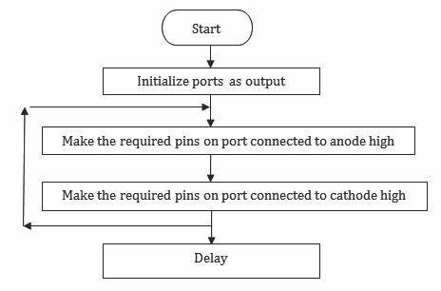

websit[e : **info@webteklabs.com**](http://www.i3indyatechnologies.com)9

**Code:**

#include<avr/io.h>

#include<util/delay.h>

int main()

{ DDRD=0xFF;

DDRB=0xFF;

while(1)

|  |  |  |  |  |  |  |
| --- | --- | --- | --- | --- | --- | --- |
|  |  |  |  |  |  |  |
|  |  |  |  |  |  |  |
|  |  |  |  |  |  |  |
|  |  |  |  |  |  |  |
|  |  |  |  |  |  |  |
|  |  |  |  |  |  |  |
|  |  |  |  |  |  |  |
|  |  |  |  |  |  |  |
|  |  |  |  |  |  |  |
|  |  |  |  |  |  |  |
|  |  |  |  |  |  |  |
|  |  |  |  |  |  |  |
|  |  |  |  |  |  |  |
|  |  |  |  |  |  |  |
|  |  |  |  |  |  |  |
|  |  |  |  |  |  |  |
|  |  |  |  |  |  |  |
|  |  |  |  |  |  |  |
|  |  |  |  | _delay_ms(2); |  |  |
|  |  |  |  | PORTD=0b00000100; |  | //select sixth column |
|  |  |  |  |  |  |  |
|  |  |  |  | _delay_ms(2); |  |  |
|  |  |  |  | PORTD=0b00000010; |  | //select seventh column |
|  |  |  |  |  |  |  |
|  |  |  |  | _delay_ms(2); |  |  |
|  |  |  |  | PORTD=0b00000001; |  | //select eigth column |
|  |  |  |  |  |  |  |
|  |  |  |  |  |  |  |
|  |  |  |  |  |  |  |
|  |  |  | | | | |
|  | } |  | | | | |

{ PORTD=0b10000000; //select first column;

PORTB=0b11111111;

_delay_ms(2);

PORTD=0b01000000; //Select second column

PORTB=0b11111111;

_delay_ms(2);

PORTD=0b00100000; //Select third column

PORTB=0b11111111;

_delay_ms(2);

PORTD=0b00010000; //select fourth column

PORTB=0b11111111;

_delay_ms(2);

PORTD=0b00001000; //select fifth column

PORTB=0b11111111;

PORTB=0b11111111;

PORTB=0b11111111;

PORTB=0b11111111;

_delay_ms(2);

}

return 0;

94 websit[e : **info@webteklabs.com**](http://www.i3indyatechnologies.com)

**Write your code**

è Open the installed AVR studio 4.



è Click **“New Project”.**



websit[e : **info@webteklabs.com**](http://www.i3indyatechnologies.com)9

è Select AVR GCC and name the project.

è Choose the location at which you want to save your project.



èSelect the simulator (AVR simulator in our case) and Atmega16 in device panel.



96 websit[e : **info@webteklabs.com**](http://www.i3indyatechnologies.com)

è Now start writing your code in the editor window

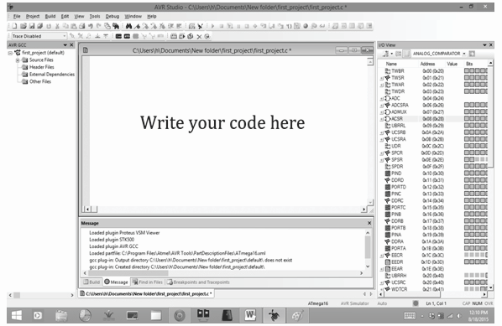

è After writing your code, click on “Build”. Option in the menu.

è After successful building operation select. “Build and Run.”

è To Burn/feed the program inside the Microcontroller, refer to “Getting the microcontroller

Ready for programming” article.

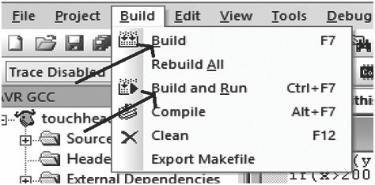

websit[e : **info@webteklabs.com**](http://www.i3indyatechnologies.com)97

**Hardware Setup:**

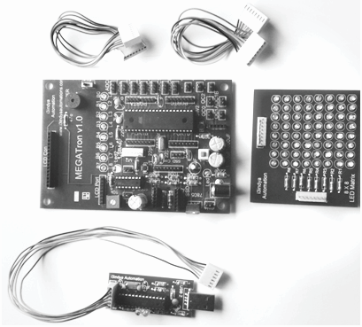

**Step1:** Components Required

**Step 2:** Connecting the programmer with the development board

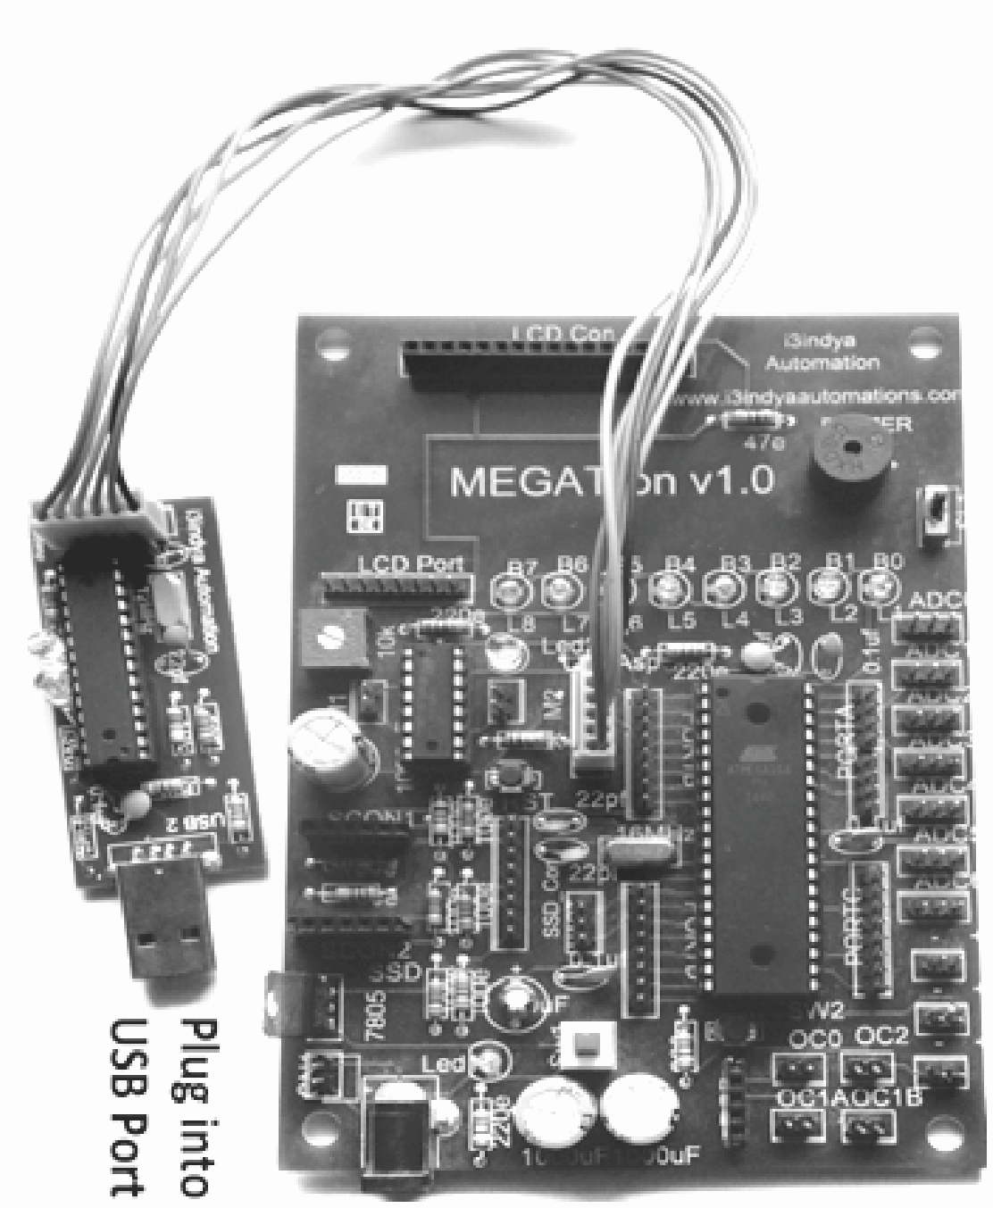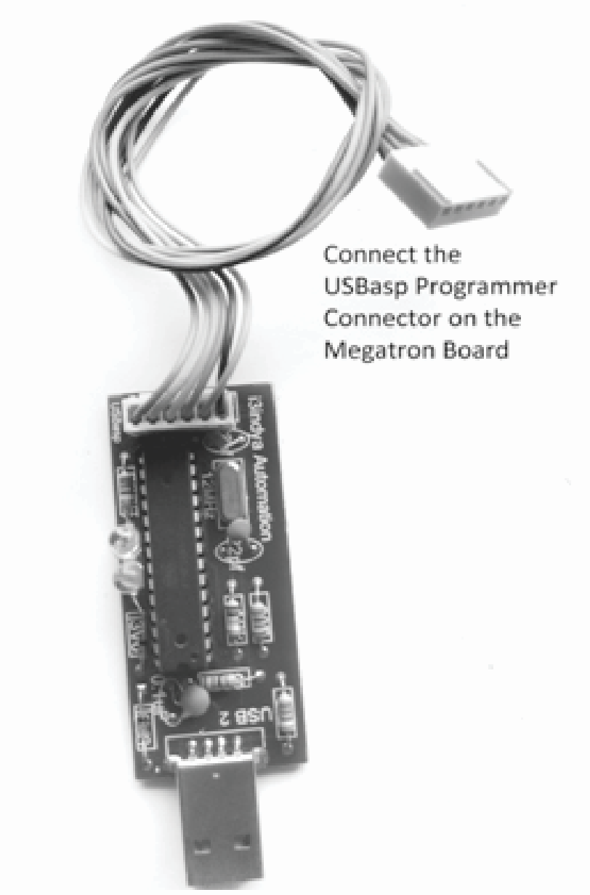

98 websit[e : **info@webteklabs.com**](http://www.i3indyatechnologies.com)

**Step 3:** Burn the hex file into the micro controller using I3AVR burner

è Click on the icon and you will get the following window:

èFirstly, select the Microcontroller i.e. ATmega16. Then, locate the .hex file of your program by clicking the browse button under the flash category and click the write button. This will write your code onto the microcontroller flash memory



**Note:** Before **“Write”** click, make sure the USBasp Programmer is connected with the MEGATron™ Board (i.e. development board) and power must be turn ON.

**Result:** : The pattern comes up on the led matrix after

burning the code.

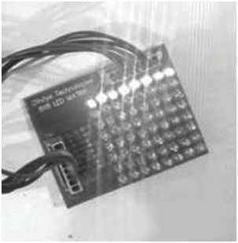

websit[e : **info@webteklabs.com**](http://www.i3indyatechnologies.com)9

**Shifting columns from Right to Left**

*#include<avr/io.h>*

*#define F_CPU 16000000*

*#include<util/delay.h>*

*int main()*

*{ DDRD=0xFF;*

|  |  |  |  |  |  |
| --- | --- | --- | --- | --- | --- |
|  |  |  | |  | |
|  |  |  | |
|  |  |  | |  |  |
|  |  |  |  |  | |
|  |  |  |  |  | |
|  |  |  |  |  | |
|  |  |  |  |  | |
|  |  |  |  |  | |
|  |  |  |  |  | |
|  |  |  |  |  | |
|  | | | | | |
|  |  |  |  |  | |
|  |  |  |  |  | |
|  |  |  |  |  | |
|  | | | | | |
|  |  |  |  |  | |
|  |  |  |  |  | |
|  |  |  |  |  | |
|  | | | | | |
|  |  |  |  |  | |
|  |  |  |  | *_delay_ms(2);* | |

*DDRB=0xFF;*

*while(1)*

*{ PORTD=0b10000000;//0x80;*

*PORTB=0b11111111;//0xff;*

*_delay_ms(2);*

*PORTD=0b01000000;//0x40;*

*PORTB=0b11111111;//0xff;*

*_delay_ms(2);*

*PORTD=0b00100000;//0x20;*

*PORTB=0b11111111;//0xff;*

*_delay_ms(2);*

*PORTD=0b00010000;//0x10;*

*PORTB=0b11111111;//0xff;*

*_delay_ms(2);*

*PORTD=0b00001000;//0x08;*

*PORTB=0b11111111;//0xff;*

*PORTD=0b00000100;//0x04;*

|  |  |  |  |  |
| --- | --- | --- | --- | --- |
|  |  |  |  |  |
|  |  |  |  | *_delay_ms(2);* |

*PORTB=0b11111111;//0xff;*

*PORTD=0b00000010;//0x02;*

|  |  |  |  |  |
| --- | --- | --- | --- | --- |
|  |  |  |  |  |
|  |  |  |  | *_delay_ms(2);* |

*PORTB=0b11111111;//0xff;*

*PORTD=0b00000001;//0x01;*

*PORTB=0b11111111;//0xff;*

*_delay_ms(2);*

*}*

*return 0;*

*}*

100 websit[e : **info@webteklabs.com**](http://www.i3indyatechnologies.com)

**Shifting columns from Left to Right**

*#include<avr/io.h>*

*#define F_CPU 16000000*

*#include<util/delay.h>*

*int main()*

*{ DDRD=0xFF;*

|  |  |  |  |
| --- | --- | --- | --- |
|  |  |  | |
|  |  |  | |
|  |  |  |  |
|  |  |  |  |
|  |  |  | *_delay_ms(2);* |

*DDRB=0xFF;*

*while(1)*

*{ PORTD=0b00000001;//0x01;*

*PORTB=0b11111111;//0xff;*

*PORTD=0b00000010;//0x02;*

|  |  |  |  |
| --- | --- | --- | --- |
|  |  |  |  |
|  |  |  | *_delay_ms(2);* |

*PORTB=0b11111111;//0xff;*

*PORTD=0b00000100;//0x04;*

|  |  |  |  |
| --- | --- | --- | --- |
|  |  |  |  |
|  |  |  | *_delay_ms(2);* |

*PORTB=0b11111111;//0xff;*

*PORTD=0b00001000;//0x08;*

*PORTB=0b11111111;//0xff;*

*_delay_ms(2);*

*PORTD=0b00010000;//0x10;*

|  |  |  |  |
| --- | --- | --- | --- |
|  |  |  |  |
|  |  |  | *_delay_ms(2);* |

*PORTB=0b11111111;//0xff;*

*PORTD=0b00100000;//0x20;*

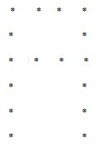

|  |  |  |  |
| --- | --- | --- | --- |
|  |  |  |  |
|  |  |  | *_delay_ms(2);* |

*PORTB=0b11111111;//0xff;*

*PORTD=0b01000000;//0x40;*

|  |  |  |  |
| --- | --- | --- | --- |
|  |  |  |  |
|  |  |  | *_delay_ms(2);* |

*PORTB=0b11111111;//0xff;*

*PORTD=0b10000000;//0x80;*

*PORTB=0b11111111;//0xff;*

*_delay_ms(2);*

*}*

*return 0;*

*}*

websit[e : **info@webteklabs.com**](http://www.i3indyatechnologies.com)

**Displaying alphabets on LED Dot Matrix**



**Description:** To display an alphabet on LED matrix using a combination of rows and columns

2. Start infinite while loop

3. Send the pattern for nth row on anode

4. Set the nth pin on cathode as low

|  |  |  |
| --- | --- | --- |
|  | 1. | Declare required ports as output |
|  |  |  |
|  |  |  |
|  |  |  |
|  |  |  |
|  | 6. | Do the same for n+1th element till last row |

5. Delay

**Flowchart:**

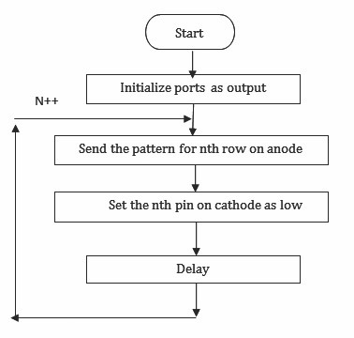

102 websit[e : **info@webteklabs.com**](http://www.i3indyatechnologies.com)

**Code:**

#include<avr/io.h>

#include<util/delay.h>

int main()

{ DDRD=0xFF;

DDRB=0xFF;

while(1)

{ for(int a=0;a<50;a++)

|  |  |  |  |  |  |  |
| --- | --- | --- | --- | --- | --- | --- |
|  |  |  |  |  |  |  |
|  |  |  |  |  |  |  |
|  |  |  |  |  |  |  |
|  |  |  |  |  |  |  |
|  |  |  |  |  |  |  |
|  |  |  |  |  |  |  |
|  |  |  |  |  |  |  |
|  |  |  |  |  |  |  |
|  |  |  |  |  |  |  |
|  |  |  |  |  |  |  |
|  |  |  |  |  |  |  |
|  |  |  |  |  |  |  |
|  |  |  |  |  |  |  |
|  |  |  |  |  |  |  |
|  |  |  |  |  |  |  |
|  |  |  |  |  |  |  |
|  |  |  |  |  |  |  |
|  |  |  |  |  |  |  |
|  |  |  |  |  |  |  |
|  |  |  |  |  |  |  |
|  |  |  |  | | | |
|  |  |  |  | | | |
|  |  |  |  | | | |
|  |  |  |  | | | |
|  |  |  | | | | |
|  | } |  | | | | |

{ PORTD=0b10000000; //0x80;

PORTB=0b00000001; //0x01;

_delay_ms(2);

PORTD=0b01000000; //0x40;

PORTB=0b11101101; //0xED;

_delay_ms(2);

PORTD=0b00100000; //0x20;

PORTB=0b11101101; //0xED;

_delay_ms(2);

PORTD=0x10;

PORTB=0b11101101; //0xED;

_delay_ms(2);

PORTD=0x08;

PORTB=0b00000001; //0x01;

_delay_ms(2);

}

PORTD=0X00;

PORTB=0X00;

_delay_ms(1000);

}

return 0;

websit[e : **info@webteklabs.com**](http://www.i3indyatechnologies.com)

10

**Write your code**

è Open the installed AVR studio 4.



è Click **“New Project”.**



104 websit[e : **info@webteklabs.com**](http://www.i3indyatechnologies.com)

è Select AVR GCC and name the project.

è Choose the location at which you want to save your project.



èSelect the simulator (AVR simulator in our case) and Atmega16 in device panel.



websit[e : **info@webteklabs.com**](http://www.i3indyatechnologies.com)

10

è Now start writing your code in the editor window



è After writing your code, click on “Build”. Option in the menu.

è After successful building operation select. “Build and Run.”

è To Burn/feed the program inside the Microcontroller, refer to “Getting the microcontroller

Ready for programming” article.



106 websit[e : **info@webteklabs.com**](http://www.i3indyatechnologies.com)

**Hardware Setup:**

**Step1:** Components Required

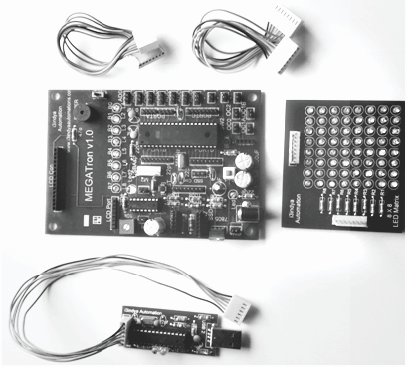

**Step 2:** Connecting the programmer with the development board

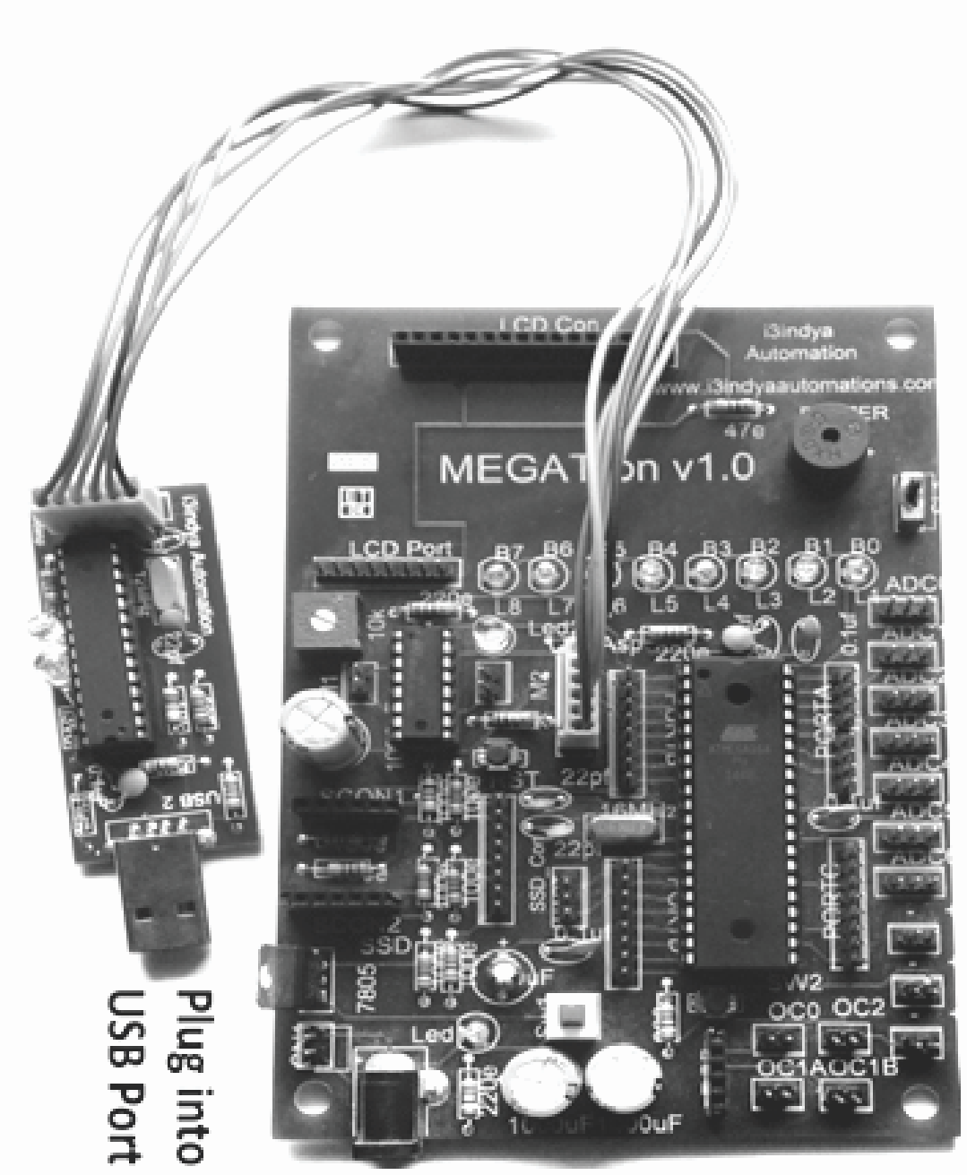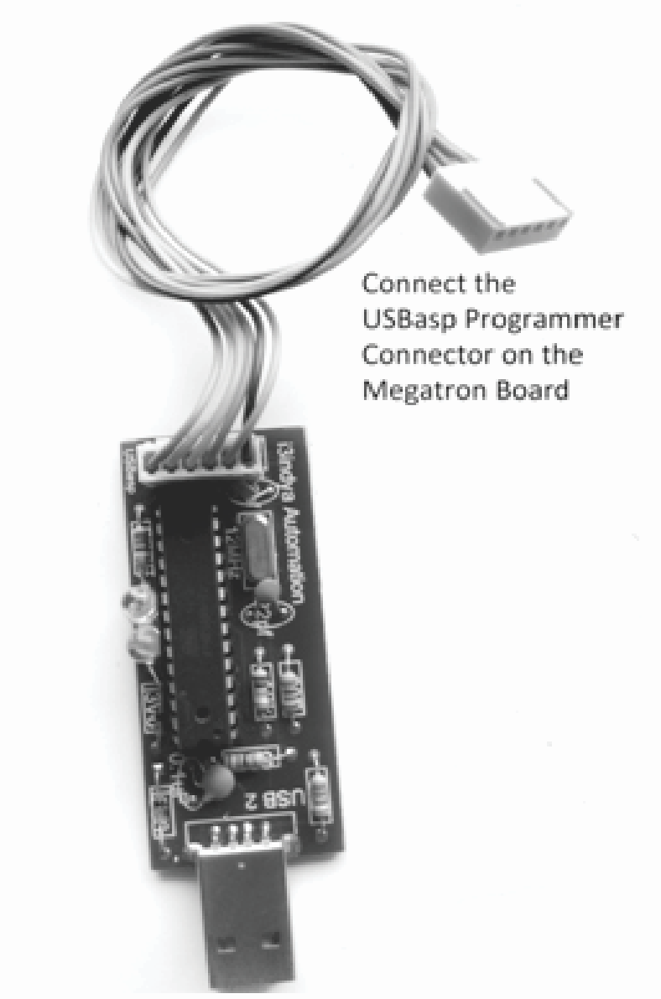

websit[e : **info@webteklabs.com**](http://www.i3indyatechnologies.com)

10

**Step 3:** Burn the hex file into the micro controller using I3AVR burner

è Click on the icon and you will get the following window:

èFirstly, select the Microcontroller i.e. ATmega16. Then, locate the .hex file of your program by clicking the browse button under the flash category and click the write button. This will write your code onto the microcontroller flash memory



**Note:** Before **“Write”** click, make sure the USBasp Programmer is connected with the MEGATron™ Board (i.e. development board) and power must be turn ON.

**Result:** : The pattern comes up on the led matrix after

burning the code.

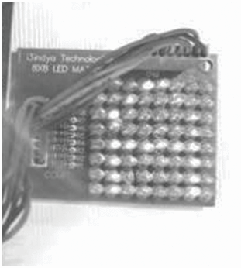

108 websit[e : **info@webteklabs.com**](http://www.i3indyatechnologies.com)

Ø **Check your ability…**

**1) Display all the alphabets on dot matrix.**

**2) Display all the numbers on dot matrix.**

**3) Display arrow on dot matrix.**

**4) Display a converging and diverging Heart in the LED dot matrix**

**5) Display a converging and diverging square in the LED dot matrix.**

**6) Scroll a single alphabet on the Led dot matrix**

**7) Scroll a string on the LED dot matrix**



websit[e : **info@webteklabs.com**](http://www.i3indyatechnologies.com)

109

3

-

DAY

TOPICS TO BE COVERED

è LCD interfacing with ATmega16

PRACTICAL'S TO BE PERFORMED

è Displaying Text on LCD

**Description:**

In 3rd day, you will learn about Liquid Crystal Display with its interfacing with Atmega16 MCU. There we have given the details of different modes of working along with the required function declaration. You will also design the code for Displaying text/name on LCD which has to be programmed in MCU and then you can observe the result

**LCD (LIQUID CRYSTAL DISPLAY)**



LCDs are all around us. Liquid crystal displays are so much in vogue these days; in fact most of people cannot get through their day without using one. This technology is utilized in television, digital clocks, microwave ovens, calculators, thermometers and even in stereos. There is no limit bar for the applications for liquid crystal displays. So, it would not be any surprise that this technology has revolutionized.

LCD stands for “Liquid Crystal Display”. As the name suggest that liquid crystal display, so it's a kind of display which is made by using liquid and crystal. Wonder 'Liquid Crystal'? It's basically a new state of matter 'Forth State', in which a type of crystal is melt up to a stage where it is at converting stage in liquid. This state of matter is quite useful for displaying values.

There are numerous types of liquid used for this purpose as pneumatic liquid and so on. Pneumatic liquid works on the concept of polarization which consists with twisted and untwisted pairs, means there'll be twisted and untwisted pair crystals of this pneumatic liquid, whenever any datum is to be printed onto display that time these twisted pair crystal turns to untwisted pair and then light will block which is continuously passing through backlight LED. As these crystal becomes untwisted that particular crystal block the light and that datum is printed on display.

Let's not confuse with this technology of polarization for displaying any data. As we are talking about embedded systems. So, we come directly on the topic. There are two types of LCD's used now a days for displaying data, even in Nokia display screens in 90's used.

|  |  |  |  |  |  |  |
| --- | --- | --- | --- | --- | --- | --- |
|  |  |  |  |  |  | 1. Alphanumeric LCD |
|  |  |  |  |  |  | 2. Graphic LCD |

Let's talk about alphanumeric LCD first. There are various models available for alphanumeric LCD in market now a day like 16*1, 16*2, 16*4 and so many. Let's see what their names tells about them, a 16*2 LCD means that there are 16 columns and two rows in which 16 characters can be printed in a single line and there are two lines. So, 32 characters are visible on this LCD at a time.

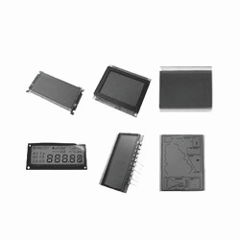

websit[e : **info@webteklabs.com**](http://www.i3indyatechnologies.com)

11

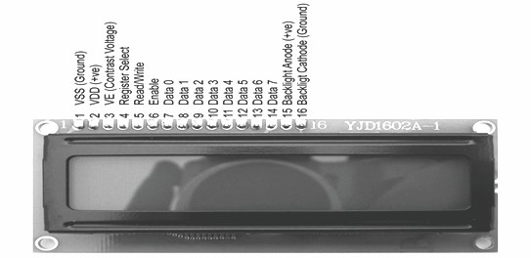

Fig (1): diagram for Alphanumeric LCD

The diagram shown above is for Alphanumeric LCD. There'll lines for displaying characters and at a time

only 16 characters can be displayed for 16*x series Alphanumeric LCD.

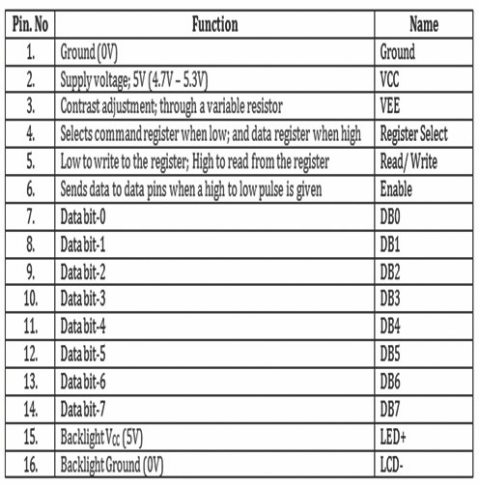

111 websit[e : **info@webteklabs.com**](http://www.i3indyatechnologies.com)

Before going to start interfacing part we should first know how characters can display on display screen and which type of characters can display. Actually there is a limitation on the characters that can be displayed, we can't display Urdu, Arabic, Punjabi characters and so on. English characters and numbers, arrow keys and some more character only can displayed. But if we want to display any special characters like: bell, any special figure, these can also be displayed but first we would be creating these special characters and then would be using same like we'll use other characters. Now we see that how this all is happening?

**Interfacing with Alphanumeric LCD**

Now let's play with display. As have learnt how to give '0' (gnd) and '1' (VCC) on the I/O pins of the microcontroller, it won't be difficult in interfacing LCD with a microcontroller. As we can see from LCD pin diagram there are 8 data pins means data can be transfer from these pins. There are two Hitachi microcontrollers named as HT44780 inside the 16*2 LCD. They control the entire event occurring inside the LCD and its complete working. The data from the microcontroller to microcontroller inside the LCD can be transferred in two ways; either data can travel using all data pins or using 4 data pins only. It's not a panic issue, now let's see how?

Ÿ 8 bit mode

Ÿ 4 bit mode

**8 BIT MODE OF OPERATION**



For better understanding of both the concepts let's take an example, as we can see there is a block diagram shown below. It shows the LCD attached to the microcontroller. There are four ports available in our microcontroller as I/O ports; any one of these can be used for connecting the LCD with the microcontroller. We have a maximum of 8 bit port available with us in microcontroller. So we'll be using two ports of our microcontroller (as we have three control pins (RS, R/W and EN) while 8 data pins, so a total of 11 pins if all the power pins are permanently connected in the system). It should be noted that all control bits and data bits, should be synchronized otherwise there might be any problem in displaying character.

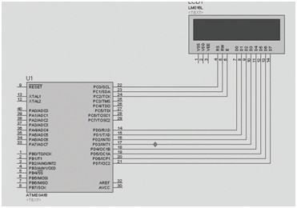

websit[e : **info@webteklabs.com**](http://www.i3indyatechnologies.com)

11

There are certain things which should be kept in mind whenever we interface LCD, such as meaning of each control pin and when to use them. There are three control pin in a LCD module (RS, R/W and EN), which we have to control through our programs. There are two things you should tell LCD's microcontroller before it displays a character. Thinking commands? Let's take an example;

when we start our talk with someone, the first thing we do is to say 'Hello'; this informs the other person that I want to share something with him/her. After this has been shared between the two persons, we then start sharing other things. In the similar manner, the two microcontrollers: our development board microcontroller and the microcontroller inside the LCD need to share some signals or command before they can actually start data transfer between each other. The information shared before starting any display includes:-

be used in different modes. So before displaying any character we need to tell the Hitachi's

microcontroller about the mode in which we want the microcontroller to operate the LCD.

Ÿ Whether we want the backlight 'ON' or 'OFF'.

|  |  |  |
| --- | --- | --- |
|  | Ÿ | A 16*4 LCD can be used in three modes: 16*1, 16*2 and 16*4. Similarly other LCD can also |
|  |  |  |
|  |  |  |
|  |  |  |
|  |  |  |
|  |  |  |
|  |  | first character. |

Ÿ The most important is the mode of data transfer: 8-bit mode or 4 bit mode.

Ÿ The starting location (as from home position means from 0x80 location), for displaying the

This sharing of signals between the two microcontroller is referred as LCD initialization and this is the

first step in interfacing a LCD with any microcontroller.

Once the LCD has been initialized, data sharing can start. So ours first work in interfacing is to create a

function for LCD initialization.

113 websit[e : **info@webteklabs.com**](http://www.i3indyatechnologies.com)

**Function for LCD initialization:**

*void LCD_init ()*

|  |  |  |
| --- | --- | --- |
|  |  |  |
|  |  |  |
|  |  |  |
|  |  |  |
|  | *}* |  |

*{ LCD_cmd (0x02); // Home position*

*LCD_cmd (0x38); // Set: 8-bit, 16*2 and 5*7 dots*

*LCD_cmd (0x06); // Entry mode*

*LCD_cmd (0x0c); // Display on cursor off*

Don't get confused with the codes (0x02, 0x38, 0x06, 0x0c) used in these lines, as these are the command inside the Hitachi's microcontroller for telling the microcontroller that we want him to put the LCD in the modes we desire. These are provided to us by the LCD manufacturer.

Notice, look at the functions (LCD_cmd) used inside the above function (LCD_init) for initialization, it consists of two parts: the name of the function and the value/argument in the brackets. The codes inside the brackets have already been explained in the above paragraph. The function used to pass these values has a definition as below:

**Sending a command:**

Now let's have a look how a command/data is transferred from the AVR microcontroller to the Hitachi microcontroller. The 'RS' pin stands for 'Register Select' pin, that simply means that it is used for selecting among the registers of the LCD.

The LCD has got two buffers named as

Ÿ Instruction Register

Ÿ Data Register

The binary numbers available to the Hitachi microcontroller on the data pins of the LCD are commands or data? This problem is solved by selecting the register where these binary codes will be stored. If the user selects IR (Instruction Register, RS =0), then the microcontroller understands it and treat the binary numbers as commands and vice versa if the user select the DR (Data Register). So the first task of the user is to select the register so that the microcontroller understands the data being fetched to it.

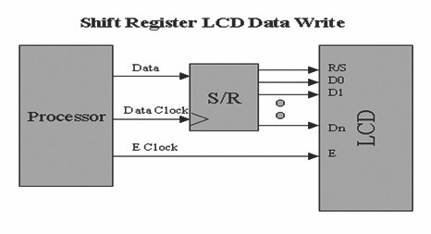

websit[e : **info@webteklabs.com**](http://www.i3indyatechnologies.com)

114

The second control signal is the RW pin. It is the Read/Write pin. If RW = 0, that means that the user wants to write on the LCD (which is the most obvious thing that we do with LCD. If RW = 1, that means that the user wants to read the LCD (this used when we want to read the busy flag inside the LCD, it is very rarely used).

The third control signal is the EN pin. It stands for 'Enable'. It acts as a lock at the entrance of the LCD. When enabled (EN =1), it allows the binary number own the data pins of the LCD to enter the buffers (IR or DR). So, when the user wants the data to enter the buffer, he/she provides a logic '1' on this pin otherwise it remains close (so that no garbage value can enter the LCD system).

Let's summarizes the entire step required in order to send a command/data from the AVR

microcontroller on the development board to the Hitachi's microcontroller inside the LCD.

Ÿ Select the register by the help of RS pin.

Ÿ Select the reading/writing mode by the help RW pin.

Ÿ Enable the EN for data to get into the buffers (IR/DR).

Ÿ Place the data on the data pins

Ÿ Disable the EN pin to prevent garbage value to enter the LCD system.

Let's have a look to the function one more time and try to understand the complete procedure in terms of

codes.

**NOTE: PORTD of ATmega16 is being used to communicate with the LCD.**

***Function for sending a command:***

*{ PORTD=abc; // Step 4*

*PORTD &=~(1<<rs); // Step 1, RS = 0 for sending a command*

*PORTD &=~(1<<rw); // Step 2, RW = 0 for writing operation on LCD*

*PORTD |=(1<<en); //Step 3,*

|  |  |  |  |
| --- | --- | --- | --- |
|  | *void LCD_cmd(unsigned char abc)* | |  |
|  |  | |  |
|  |  |  |  |
|  |  |  |  |
|  |  |  |  |
|  |  |  |  |
|  |  |  |  |
|  | *}* |  |  |

*_delay_ms(1); // delay for providing high to low pulse for getting data inside*

*PORTD &=~(1<<en); //Step 5,*

In the similar manner, the function for sending a data to the LCD in given below. The change is only at one place i.e. while selecting the register by using the RS pin of LCD. Otherwise the complete function is same as the function for sending a command.

115 websit[e : **info@webteklabs.com**](http://www.i3indyatechnologies.com)

***Function for writing data:***

*void LCD_data(unsigned char xyz)*

|  |  |  |
| --- | --- | --- |
|  |  |  |
|  |  |  |
|  |  |  |
|  |  |  |
|  |  |  |
|  |  |  |
|  | *}* |  |

*{ PORTD=xyz; // Step 4, xyz is a variable name*

*PORTD |=(1<<rs); //Step 1, RS =1 for DR*

*PORTD &=~(1<<rw); // Step 2, RW =0 for writing operation*

*PORTD |=(1<<en); //Step 3*

*_delay_ms(1); // delay for providing high to low pulse for getting data inside*

*PORTD &=~(1<<en); // Step 5*

**4 BIT MODE OF OPERATION**



Let's first understand the concept of 4 bit mode in LCD. Actually in 8 bit mode, we used a complete port of the AVR microcontroller for transferring the 8 bit data from the AVR microcontroller to the Hitachi's microcontroller, but what if I have lesser number of pins available to me to run the LCD. Here comes the 4 bit mode of operation of LCD to our remedies. Below is a diagram that shows how a LCD is connected in 4 bit mode of operation.

websit[e : **info@webteklabs.com**](http://www.i3indyatechnologies.com)

116

Notice, we have connected only higher 4 data pins (DB4, DB5, DB6 and DB7) this time and rest of the pins are made ground. See what happened? As we were using two ports of our microcontroller now this work can be done using any of a single port. So, we have saved our 4 pins. Thinking… how the data will be send?

Don't worry, we would break our data into two parts and will send it into two parts. As we know in any data MSB's (most significant bits) contribute more in data that's why we always prefer doing work with MSB bits first. We'll send higher 4 bits of the 8 bits data first and then the rest bits.

It is easy to send the upper nibble, because they are directly connected to the data pins of the LCD. To transfer the lower nibble, we'll left shift 8 bit data by 4 towards left, and make the lower bits as higher bits and will transfer them in the similar fashion as the higher nibble. Let's write the function for doing the same that is sending the 8 bits in the form of nibbles:

*Function for sending the command in 4-bit mode:*

*void disp_cmd(unsigned char abc)*

|  |  |  |  |  |
| --- | --- | --- | --- | --- |
|  |  |  |  | |
|  |  |  |  |  |
|  |  |  |  |  |
|  | | | | |
|  |  |  |  |  |
|  |  |  |  |  |
|  | *}* |  |  |  |

*{ char div1;*

*div1=abc& 0xF0; // block lower 4 bits extracted*

*LCD_cmd(div1); // function calling for sending the upper nibble to the LCD*

*div1=((abc<<4)&0xF0); // left shifted data by 4 and again block lower 4 bits.*

*LCD_cmd(div1); // again function calling for lower nibble to the LCD*

*_delay_ms(1); // providing sufficient delay for displaying data*

So before sending the data bits, we need to apply all the theory above to them. This is done by creating two

more function when working in 4 bit.

*Function for sending the command in 4-bit mode:*

*void disp_data(unsigned char abc)*

|  |  |  |  |  |
| --- | --- | --- | --- | --- |
|  |  |  |  | |
|  |  |  |  |  |
|  |  |  |  |  |
|  | | | | |
|  |  |  |  |  |
|  |  |  |  |  |
|  | *}* |  |  |  |

*{ char div1;*

*div1=abc& 0xF0; // block lower 4 bits extracted*

*LCD_data(div1); // function calling for sending the upper nibble to the LCD*

*div1=((abc<<4)&0xF0); // left shifted data by 4 and again block lower 4 bits.*

*LCD_data(div1); // again function calling for lower nibble to the LCD*

*_delay_ms(1); // providing sufficient delay for displaying data*

Not only that we need to tell the microcontroller that, we will be using it in 4 bit mode. So, we need to add

replace few lines in the LCD_init() function. The lines are:

*disp_cmd (0x28); // Set: 4-bit, 16*2 and 5*7 dots*

117 websit[e : **info@webteklabs.com**](http://www.i3indyatechnologies.com)

Let's have a look at the initialize function being used in 8-bit mode of operation and the initialize function

in 4-bit mode of operation:

**Function for LCD initialization in 4 bit mode of operation:**

*void LCD_init ()*

|  |  |  |
| --- | --- | --- |
|  |  |  |
|  |  |  |
|  |  |  |
|  |  |  |
|  | *}* |  |

*{ disp_cmd (0x02); // Home position*

*disp_cmd (0x28); // Set: 4-bit, 16*2 and 5*7 dots*

*disp_cmd (0x06); // Entry mode*

*disp_cmd (0x0c); // Display on cursor off*

**Function for LCD initialization in 8 bit mode of operation:**

*void LCD_init ()*

|  |  |  |
| --- | --- | --- |
|  |  |  |
|  |  |  |
|  |  |  |
|  |  |  |
|  | *}* |  |

*{ LCD_cmd (0x02); // Home position*

*LCD_cmd (0x38); // Set: 8-bit, 16*2 and 5*7 dots*

*LCD_cmd (0x06); // Entry mode*

*LCD_cmd (0x0c); // Display on cursor off*

You can have a look at the differences between the two functions.

Ÿ The first difference is the use of codes: 0x28 and 0x38 for configuring the LCD in 4 bit and 8

bit mode.

Ÿ The second difference is the use of the function being used to give the code values to the

LCD. We use dis_cmd() in case of 4 bit mode while LCD_cmd() in 8 bit mode. The dis_cmd()

function being used in 4 bit mode first send the upper nibble and then the lower nibble to

the LCD.

Always remember that while working in 8 bit mode we send command and data to the LCD by using LCD_cmd() and LCD_data(), while in 4 bit mode we use dis_cmd() and dis_data().

Let's summarize all the function being used in different modes of operation of LCD:

websit[e : **info@webteklabs.com**](http://www.i3indyatechnologies.com)

118

**Functions for 4 bit mode of operation**



***NOTE:*** *PORTD is being used for communicating with the LCD PD0 is connected to RS*

*PD1 is connected to RW PD2 is connected to EN*

**Function for LCD initialization:**

*void LCD_init ()*

|  |  |  |
| --- | --- | --- |
|  |  |  |
|  |  |  |
|  |  |  |
|  |  |  |
|  | *}* |  |

*{ disp_cmd (0x02); // Home position*

*disp_cmd (0x28); // Set: 4-bit, 16*2 and 5*7 dots*

*disp_cmd (0x06); // Entry mode*

*disp_cmd (0x0c); // Display on cursor off*

**Function for sending a command:**

*void LCD_cmd(unsigned char abc)*

|  |  |  |  |
| --- | --- | --- | --- |
|  |  |  |  |
|  |  |  |  |
|  |  |  |  |
|  |  |  |  |
|  |  |  |  |
|  |  |  |  |
|  | *}* |  |  |

*{ PORTD=abc;*

*PORTD &=~(1<<rs); // (Register select is set to 0)*

*PORTD &=~(1<<rw); // (Read/ Write is set to 0)*

*PORTD |=(1<<en); // (Enable is set to 1)*

*_delay_ms(1); // delay for providing high to low pulse for getting data inside*

*PORTD &=~(1<<en); // (Enable is set to 0)*

**Function for sending data:**

*void LCD_data(unsigned char xyz)*

|  |  |  |  |
| --- | --- | --- | --- |
|  |  |  |  |
|  |  |  |  |
|  |  |  |  |
|  |  |  |  |
|  |  |  |  |
|  |  |  |  |
|  | *}* |  |  |

*{ PORTD=xyz;*

*PORTD |=(1<<rs); // (Register select is set to 1)*

*PORTD &=~(1<<rw); // (Read/ Write is set to 0)*

*PORTD |=(1<<en); // (Enable is set to 1)*

*_delay_ms(1); // delay for providing high to low pulse for getting data inside*

*PORTD &=~(1<<en); // (Enable is set to 0)*

119 websit[e : **info@webteklabs.com**](http://www.i3indyatechnologies.com)

**Function for sending command in 4 bit mode:**

*void disp_cmd(unsigned char abc)*

*{ char div1;*

*div1=abc& 0xF0; // block lower 4 bits*

*LCD_cmd(div1); // function calling and displaying upper 4 bits*

*div1=((abc<<4)&0xF0); // left shifted data by 4 and again block lower 4 bits.*

|  |  |  |  |  |
| --- | --- | --- | --- | --- |
|  |  |  |  |  |
|  |  |  |  |  |
|  | *}* |  |  |  |

*LCD_cmd(div1); // again function calling for lower bits*

*_delay_ms(1); // providing sufficient delay for displaying data*

**Function for sending data in 4 bit mode:**

*void disp_data(unsigned char xyz)*

|  |  |  |  |  |
| --- | --- | --- | --- | --- |
|  |  |  |  | |
|  |  |  |  |  |
|  |  |  |  |  |
|  |  |  | |  |
|  |  |  |  |  |
|  |  |  |  |  |
|  | *}* |  |  |  |

*{ char div;*

*div=xyz& 0xF0; // block lower 4 bits*

*LCD_write(div); // function calling and displaying upper 4 bits*

*div=((xyz<<4)&0xF0); //left shifted data by 4 and again block lower 4 bits.*

*LCD_write(div); // again function calling for lower bits*

*_delay_ms(1); // providing sufficient delay for displaying data*

**FUNCTIONS FOR 8 BIT MODE OF OPERATION**



***NOTE:*** *PORTD & PORTC are being used for communicate with the LCD. PORTC is connected to data pins of the LCD, while*

*PORTD is connected to the control pins of the LCD PD0 is connected to RS*

*PD1 is connected to RW Pd2 is connected to EN*

**Function for LCD initialization:**

*voidLCD_init ()*

|  |  |  |
| --- | --- | --- |
|  |  |  |
|  |  |  |
|  |  |  |
|  |  |  |
|  | *}* |  |

*{ LCD_cmd (0x02); // Home position*

*LCD_cmd (0x38); // Set: 8-bit, 16*2 and 5*7 dots*

*LCD_cmd (0x06); // Entry mode*

*LCD_cmd (0x0c); // Display on cursor off*

websit[e : **info@webteklabs.com**](http://www.i3indyatechnologies.com)

120

**Function for sending a command:**

*void LCD_cmd(unsigned char abc)*

|  |  |  |  |
| --- | --- | --- | --- |
|  |  |  |  |
|  |  |  |  |
|  |  |  |  |
|  |  |  |  |
|  |  |  |  |
|  |  |  |  |
|  | *}* |  |  |

*{ PORTC=abc;*

*PORTD &=~(1<<rs); // (Register select is set to 0)*

*PORTD &=~(1<<rw); // (Read/ Write is set to 0)*

*PORTD |=(1<<en); // (Enable is set to 1)*

*_delay_ms(1); // delay for providing high to low pulse for getting data inside*

*PORTD &=~(1<<en); // (Enable is set to 0)*

**Function for sending data:**

void LCD_data(unsigned char xyz)

|  |  |  |  |
| --- | --- | --- | --- |
|  |  |  |  |
|  |  |  |  |
|  |  |  |  |
|  |  |  |  |
|  |  |  |  |
|  |  |  |  |
|  | } |  |  |

{ PORTC=xyz;

PORTD |=(1<<rs); // (Register select is set to 1)

PORTD &=~(1<<rw); // (Read/ Write is set to 0)

PORTD |=(1<<en); // (Enable is set to 1)

_delay_ms(1); // delay for providing high to low pulse for getting data inside

PORTD &=~(1<<en); // (Enable is set to 0)

These are the functions which are used for displaying an alphanumeric characters in 4 bit and 8 bit

mode.

**LCD connections on i3indya Development Board:**

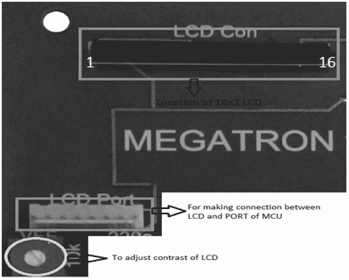

121 websit[e : **info@webteklabs.com**](http://www.i3indyatechnologies.com)

Match the number written on i3indya Developemnt Board and back of the LCD while connecting LCD on the development Board. The PORT for connecting LCD is shown in the above figure. The LCD is Plug N Play in our development Board that means you can communicate with the LCD using any PORT of ATmega16. It uses a single PORT for its operation that means 4 bit mode of LCD can only used while working on i3indya development board, so remember to program the LCD in 4 bit mode while working with i3indya development board.

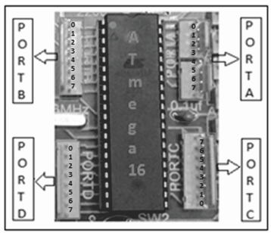

**SAMPLE PROGRAM: Display characters and string on LCD in 8bit mode**



**NOTE:** *PORTC & PORTB are being used to communicate with the LCD. PORTC is connected to the data pins of*

*the LCD, while PORTB is connected to the control pins of the LCD.*

*PC0 is connected to RS pin*

*PC1 is connected to RW pin*

*PC2 is connected toEN pin*

This sample program cannot be run on i3indyadevelopement board as the LCD will be requiring11 pins for communication while the LCD on i3indya Development board requires 7 pins for its communication. If you want to test this program you need to connect the LCD externally with the corresponding pins as shown in the diagram below.

websit[e : **info@webteklabs.com**](http://www.i3indyatechnologies.com)

122

**Connection diagram:**

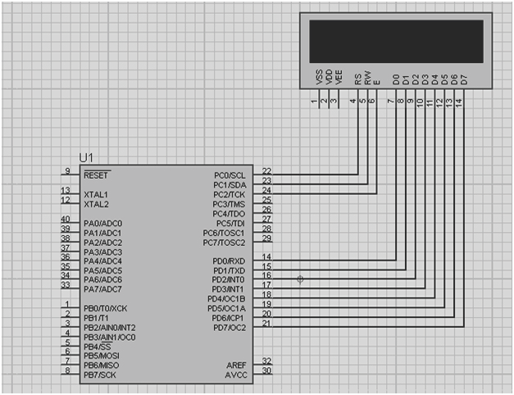

**Code:**

#define F_CPU 16000000

#include<avr/io.h>

#include<util/delay.h>

#define LCD_DATA_cntrl PORTC

#define en PC2

#define rw PC1

#define rs PC0

void LCD_cmd(unsigned char cmd); void LCD_data(unsigned char data); void LCD_init();

void LCD_clear();

void LCD_string(unsigned char *str);

123

websit[e : **info@webteklabs.com**](http://www.i3indyatechnologies.com)

int main()

{ DDRC=0xff;

DDRD=0xff;

LCD_init();

while(1)

{ LCD_cmd(0x80);

LCD_string("8 bit mode!");

LCD_cmd(0xC0);

LCD_data('A');

_delay_ms(8000);

LCD_clear();

}

return 0;

}

void LCD_init()

{ LCD_cmd(0x02);

LCD_cmd(0x38);

LCD_cmd(0x06);

LCD_cmd(0x0c);

}

void LCD_cmd(unsigned char abc)

{ LCD_DATA_cntrl=abc;

PORTC&=~(1<<rs);

PORTC&=~(1<<rw);

PORTC |=(1<<en);

_delay_ms(1);

PORTC&=~(1<<en);

}

void LCD_data(unsigned char xyz)

{ LCD_DATA_cntrl=xyz;

PORTC |=(1<<rs);

PORTC&=~(1<<rw);

PORTC |=(1<<en);

_delay_ms(1);

PORTC&=~(1<<en);

}

void LCD_clear()

{ LCD_cmd(0x01);

_delay_ms(200);

}

websit[e : **info@webteklabs.com**](http://www.i3indyatechnologies.com)

124

void LCD_string(unsigned char *str)

{ int i=0;

while(str[i]!='\0')

|  |  |  |
| --- | --- | --- |
|  |  |  |
|  |  |  |
|  | } |  |

{ LCD_data(str[i]);

i++;

**SAMPLE PROGRAM: Display any character on LCD in**

**4bit mode**



**NOTE:** *PORTC is being used to communicate with the LCD.lower nibble of the PORT will be used to give the control signals while higher nibble of the PORT will be used to give the data to the LCD after breaking the data into higher and lower nibble*

*PC0 is connected to RS*

*PC1 is connected to RW*

*PC2 is connected to EN*

*PC3 is not connected to any pin*

*PC4 is connected to D4 of LCD*

*PC5 is connected to D5 of LCD*

*PC6 is connected to D6 of LCD*

*PC7 is connected to D7 of LCD*

*You can test this code on i3indya development board as LCD in i3indya development board utilizes 1 PORT*

*for connecting LC D with ATmega16*

**Flow chart:**

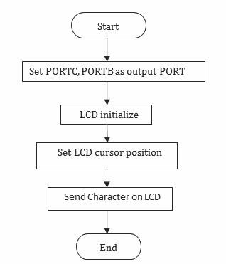

125

websit[e : **info@webteklabs.com**](http://www.i3indyatechnologies.com)

**Connection diagram:**

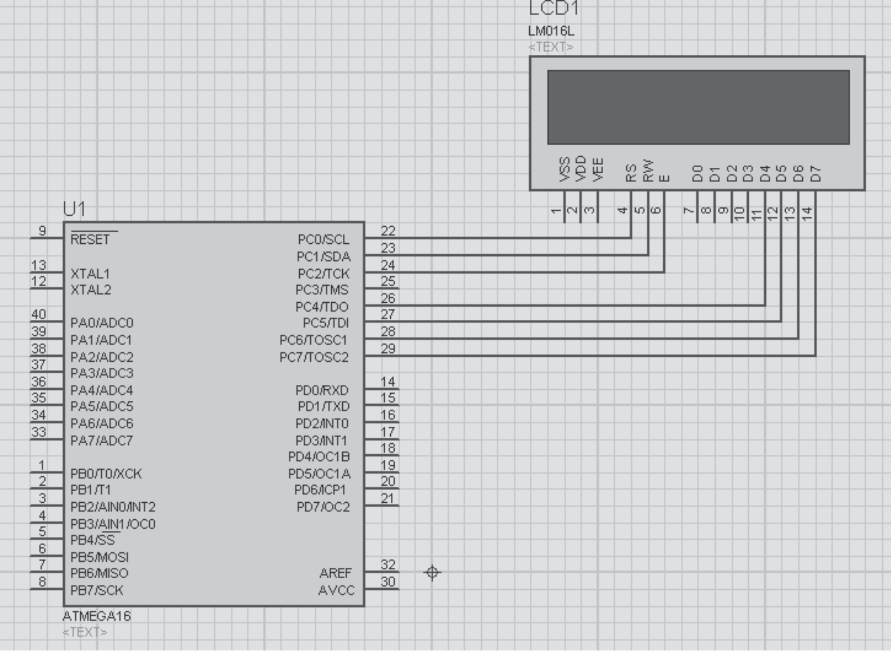

**Code:**

#define F_CPU 16000000

#include<avr/io.h>

#include<util/delay.h>

#define LCD_DATA_cntrl PORTC

#define en PC2

#define rw PC1

#define rs PC0

void LCD_cmd(unsigned char cmd); void LCD_data(unsigned char data); void LCD_init();

void disp_cmd(unsigned char c); void disp_data(unsigned char d); void LCD_clear();

void LCD_string(unsigned char *str);

websit[e : **info@webteklabs.com**](http://www.i3indyatechnologies.com)

126

void disp_data(unsigned char d);

void LCD_clear();

void LCD_string(unsigned char *str);

int main()

{ DDRC=0xff; //I/O Port declared as output, as LCD will be connected

LCD_init();

while(1)

{ LCD_clear();

disp_cmd(0x85);

disp_data('A');

_delay_ms(100);

}

return 0;

}

void LCD_init()

{ disp_cmd(0x02);

disp_cmd(0x28);

disp_cmd(0x06);

disp_cmd(0x0c);

}

void LCD_cmd(unsigned char abc)

{ PORTC=abc;

PORTC &=~(1<<rs);

PORTC &=~(1<<rw);

PORTC |=(1<<en);

_delay_ms(1);

PORTC &=~(1<<en);

}

void LCD_data(unsigned char xyz)

{ PORTC=xyz; PORTC |=(1<<rs);

PORTC &=~(1<<rw);

PORTC |=(1<<en);

_delay_ms(1);

PORTC &=~(1<<en);

}

127

websit[e : **info@webteklabs.com**](http://www.i3indyatechnologies.com)

void disp_cmd(unsigned char abc)

{ char div1;

div1=abc & 0xF0;

LCD_cmd(div1);

div1=((abc<<4)&0xF0);

LCD_cmd(div1);

_delay_ms(100);

}

void disp_data(unsigned char xyz)

{ char div;

div=xyz & 0xF0;

LCD_data(div);

div=((xyz<<4)&0xF0);

LCD_data(div);

_delay_ms(100);

}

void LCD_clear()

{ disp_cmd(0x01);

_delay_ms(200);

}

**Write your code**

è Open the installed AVR studio 4.



websit[e : **info@webteklabs.com**](http://www.i3indyatechnologies.com)

128

è Click **“New Project”.**



è Select AVR GCC and name the project.

è Choose the location at which you want to save your project.



129

websit[e : **info@webteklabs.com**](http://www.i3indyatechnologies.com)

èSelect the simulator (AVR simulator in our case) and Atmega16 in device panel.



è Now start writing your code in the editor window



websit[e : **info@webteklabs.com**](http://www.i3indyatechnologies.com)

130

è After writing your code, click on “Build”. Option in the menu.

è After successful building operation select. “Build and Run.”

è To Burn/feed the program inside the Microcontroller, refer to “Getting the microcontroller

Ready for programming” article.



**Hardware Setup:**

**Step1:** Components Required

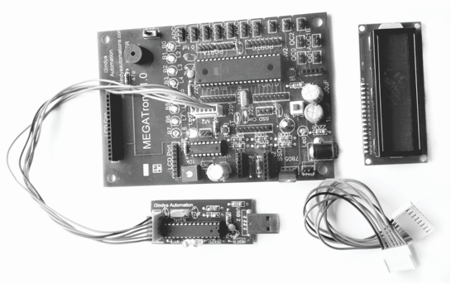

131

websit[e : **info@webteklabs.com**](http://www.i3indyatechnologies.com)

**Step 2:** Connecting the programmer with the development board

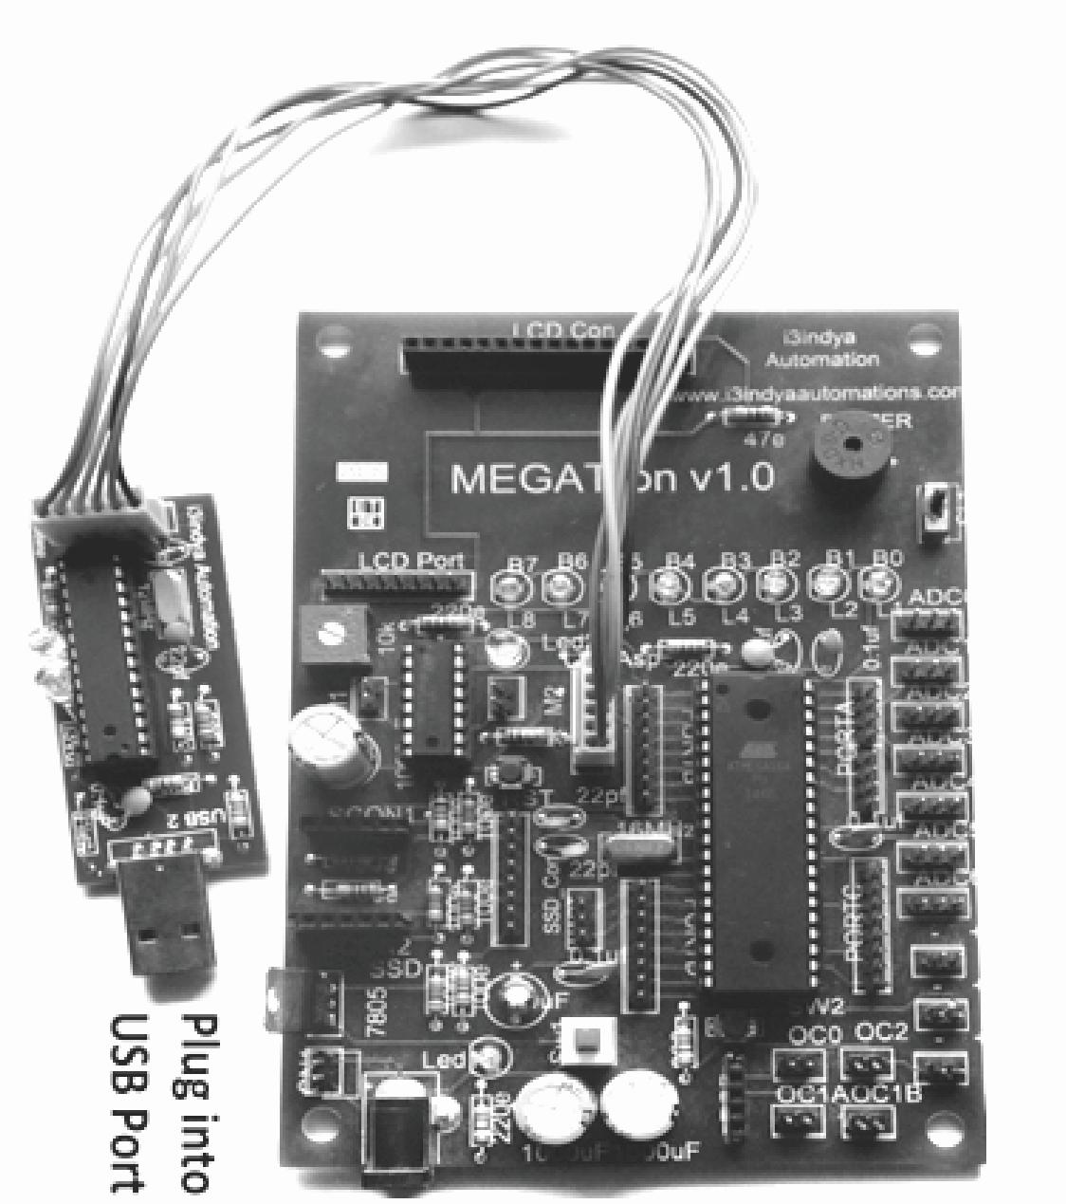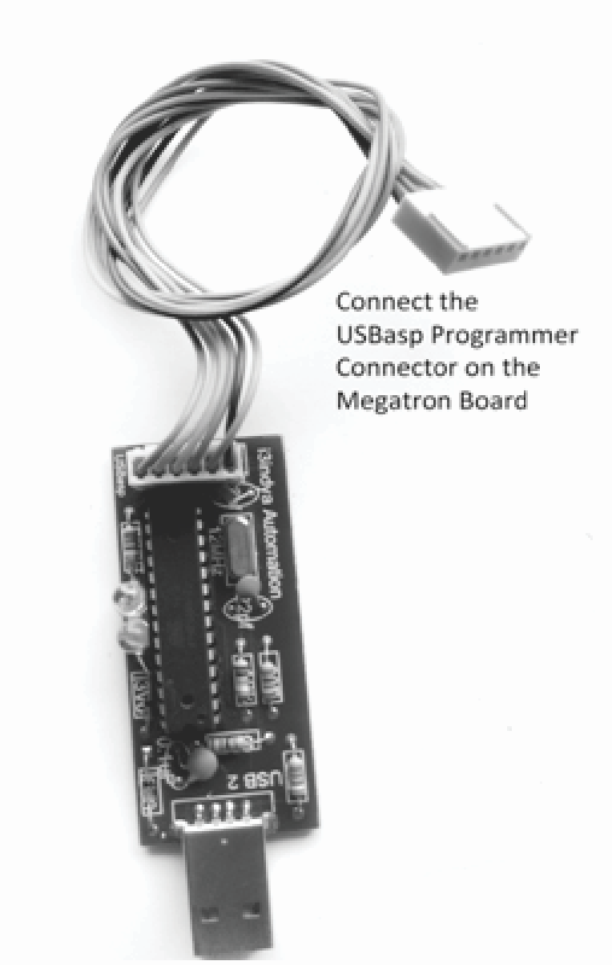

**Step3:** Connect the 8 Pin connector at PORTC and at LCD port and connect LCD.

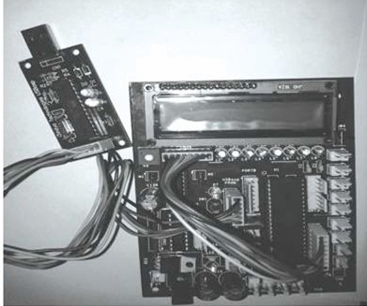

websit[e : **info@webteklabs.com**](http://www.i3indyatechnologies.com)

132

**Step 4:** Burn the hex file into the micro controller using I3AVR burner

è Click on the icon and you will get the following window:

èFirstly, select the Microcontroller i.e. ATmega16. Then, locate the .hex file of your program by clicking the browse button under the flash category and click the write button. This will write your code onto the microcontroller flash memory



**Note:** Before “Write” click, make sure the USBasp Programmer is connected with the MEGATron™ Board (i.e. development board) and power must be turn ON.

**Result:** Character will show on LCD.

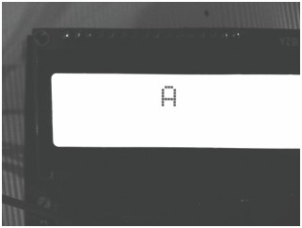

So, till now you have only learnt about displaying a single character on the LCD using both the modes of LCD, but if you want to display a string, then what?

*What will be the output of the following line of code:*

*disp_data('i3indya RoboChamps'); ?*

*You will notice that only 's' is displayed on the LCD, why not others, try it yourself first?*

133

websit[e : **info@webteklabs.com**](http://www.i3indyatechnologies.com)

Let's see how a string can be displayed on LCD, you will create a function for the same as:

**Function for a string:**

void LCD_string(unsigned char *str)

|  |  |  |  |  |  |
| --- | --- | --- | --- | --- | --- |
|  |  |  |  | | |
|  |  |  |  | | |
|  |  |  |  |  |  |
|  |  |  |  |  |  |
|  |  |  |  |  |  |
|  | } |  |  |  |  |

{ int i=0;

while(str[i]!='\0')

{ disp_data(str[i]); //4 bit mode function for data

i++;

}

**Explanation:** In the first line, we have created function and passed a string type of argument to it. We have taken an integer type variable and initialized it with zero for using it till the end of the string doesn't meet. Every string ends with 'NULL' character. So, we'll check condition in while loop. Until the 'NULL' is found, keep on displaying the character on the LCD. In 4 bit mode, we have used disp_data() function for sending a data to the LCD while in 8 bit mode we use LCD_data() function for sending data to the LCD. So, if you want to display the string in 8 bit mode, please make the corresponding change (replace the function disp_data(str[i]) by LCD_data(str[i])). Whenever this null character is found, this loop terminates.

What about multidigitnumbers ?

Let's create a function for the same as well:

**Function for displaying any number:**

*void number_LCD(unsigned intabc)*

|  |  |  |  |
| --- | --- | --- | --- |
|  |  |  |  |
|  |  |  |  |
|  |  |  |  |
|  |  |  |  |
|  |  |  |  |
|  |  |  |  |
|  |  |  |  |
|  |  |  |  |
|  | *}* |  |  |

*{ disp_cmd(0x04); // auto decrement mode*

*unsigned int d=0;*

*while(abc!=0)*

*{ d=abc%10;*

*disp_write(d+48); // display digit*

*abc=abc/10;*

*}*

*disp_cmd(0x06); //auto increment mode*

**Explanation:** Let's understand this function with an example.

websit[e : **info@webteklabs.com**](http://www.i3indyatechnologies.com)

134

If Number=1534; then it will be copied to abc(variable, see in function) and now will work with this new variable. The loop first check whether the number enter in zero or not. As usual, the answer is 'NO', so the loop continues to the next instruction inside the loop. We have taken a new variable d and for d=abc%10 (1534%10=4) means d=4, now let's display it on the LCD. We did d+48 because '48' is the ASCII code for

'0' (zero). Now, d means 4+48=52 and this 52 is an ASCII value for number 4. It will display on specified

location given by us. After that abc=abc/10; means 1534/10=153, this is the new value of the variable

'abc'. This loop will again check whether this variable is equal to zero or not. If the result is 'No', then the

process is repeated again.

As it has already been stated that we can display only limited character on the LCD. This is because we can display only those characters on the LCD whose patterns are available in the memory of the LCD. To understand the complete concept and learn how we can display our own created pattern on the LCD, let's have a look at the memory mapping of LCD.

**SAMPLE PROGRAM: DISPLAY ANY NUMBER ON LCD IN 4 BIT MODE**



**Practical: Display any number on LCD**

**Description:**Displaying any number on LCD

**NOTE:** PORTC is being used to communicate with the LCD. Lower nibble of the PORTC will be used to give the control signals while higher nibble of the PORTC will be used to give the data to the LCD after breaking the data into higher and lower nibble

PC0 is connected to RS

PC1 is connected to RW

PC2 is connected to EN

PC3 is not connectedto any pin

PC4 is connected to D4 of LCD

PC5 is connected to D5 of LCD

PC6 is connected to D6 of LCD

PC7 is connected to D7 of LCD

You can test this code on i3indya development board as LCD in i3indya development board utilizes 1 PORT for connecting LC D with ATmega16

135

websit[e : **info@webteklabs.com**](http://www.i3indyatechnologies.com)

**Flow chart:**

**Connection diagram:**

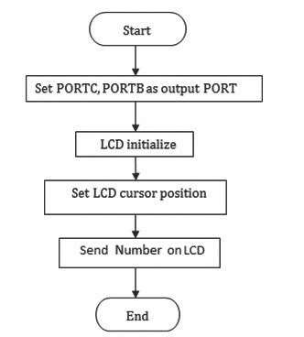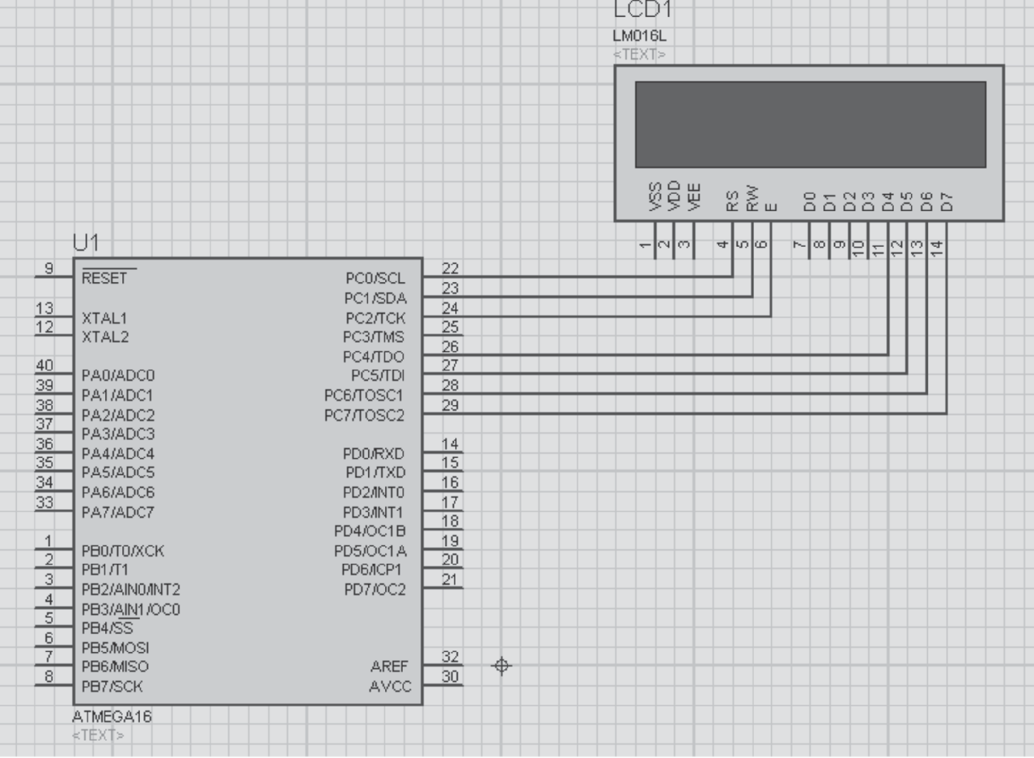

websit[e : **info@webteklabs.com**](http://www.i3indyatechnologies.com)

136

**Code:**

#define F_CPU 16000000

#include<avr/io.h>

#include<util/delay.h>

#define LCD_DATA_cntrl PORTC

#define en PC2

#define rw PC1

#define rs PC0

void LCD_cmd(unsigned char cmd); void LCD_data(unsigned char data); void LCD_init();

void disp_cmd(unsigned char c); void disp_data(unsigned char d); void LCD_clear();

void LCD_string(unsigned char *str); void number_LCD(unsigned int num); *int main()*

*{ DDRC=0xff;*

*DDRB=0xff;*

*LCD_init();*

*unsigned int i=1234;*

*while(1)*

*{ disp_cmd(0x83);*

*number_LCD(i);*

*_delay_ms(200);*

*}*

*return 0;*

*}*

*void LCD_init()*

*{ disp_cmd(0x02);*

*disp_cmd(0x28);*

*disp_cmd(0x06);*

*disp_cmd(0x0c);*

*}*

*void LCD_cmd(unsigned char abc)*

*{ PORTC=abc;*

*PORTC &=~(1<<rs);*

*PORTC &=~(1<<rw);*

*PORTC |=(1<<en);*

*_delay_ms(1);*

*PORTC &=~(1<<en);*

*_delay_ms(5);*

*}*

137

websit[e : **info@webteklabs.com**](http://www.i3indyatechnologies.com)

*void LCD_data(unsigned char abcabh)*

*{ PORTC=abcabh;*

*PORTC |=(1<<rs);*

*PORTC &=~(1<<rw);*

*PORTC |=(1<<en);*

*_delay_ms(1);*

*PORTC &=~(1<<en);*

*}*

PORTC&=~(1<<en);

}

void disp_cmd(unsigned char abc)

{ char div1;

div1=abc & 0xF0;

LCD_cmd(div1);

div1=((abc<<4)&0xF0);

LCD_cmd(div1);

_delay_ms(5);

}

void disp_data(unsigned char xyz)

{ char div;

div=xyz & 0xF0;

LCD_data(div);

div=((xyz<<4)&0xF0);

LCD_write(div);

}

void LCD_string(unsigned char *str)

{ int i=0;

while(str[i]!='\0')

|  |  |  |
| --- | --- | --- |
|  |  |  |
|  |  |  |
|  |  |  |
| } |  |  |

{ disp_data(str[i]);

i++;

}

void number_LCD(unsigned int abc) ///// number in a string function //////

{ disp_cmd(0x04);

unsigned int d=0;

while(abc!=0)

{ d=abc%10;

disp_data(d+48);

abc=abc/10;

}

disp_cmd(0x06);

}

websit[e : **info@webteklabs.com**](http://www.i3indyatechnologies.com)

138

**Write your code**

è Open the installed AVR studio 4.



è Click **“New Project”.**



139

websit[e : **info@webteklabs.com**](http://www.i3indyatechnologies.com)

è Select AVR GCC and name the project.

è Choose the location at which you want to save your project.



èSelect the simulator (AVR simulator in our case) and Atmega16 in device panel.



websit[e : **info@webteklabs.com**](http://www.i3indyatechnologies.com)

1407

è Now start writing your code in the editor window



è After writing your code, click on “Build” Option in the menu.

è After successful building operation select. “Build and Run.”

è To Burn/feed the program inside the Microcontroller, refer to “Getting the microcontroller

Ready for programming” article.



141

websit[e : **info@webteklabs.com**](http://www.i3indyatechnologies.com)

**Hardware Setup:**

**Step1:** Components Required

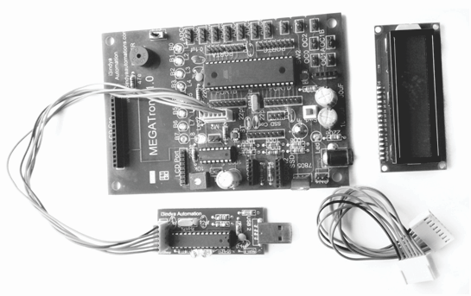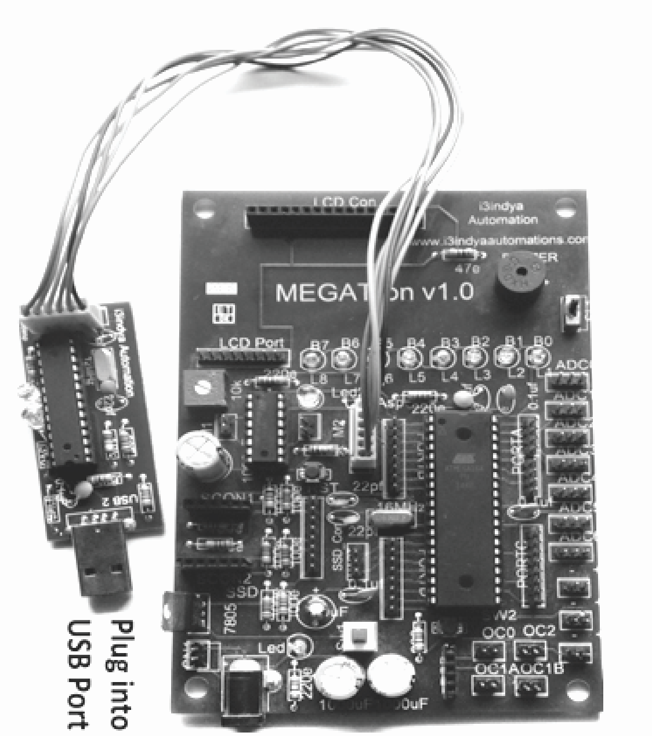

**Step 2:** Connecting the programmer with the development board

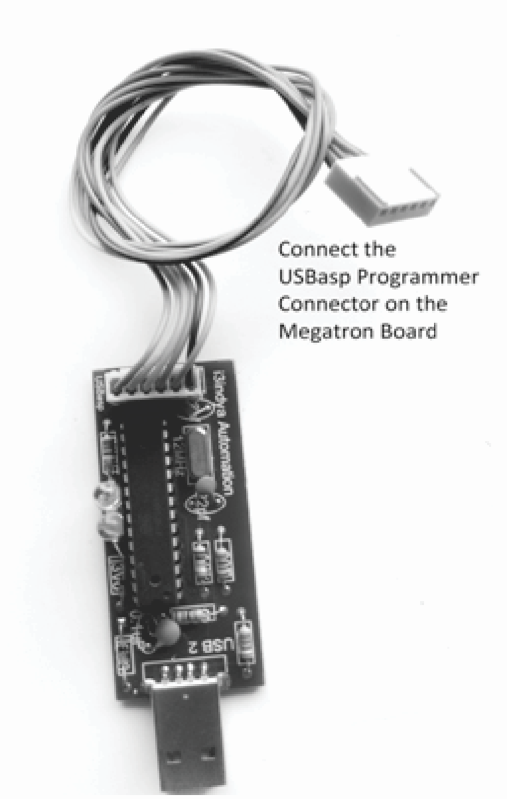

websit[e : **info@webteklabs.com**](http://www.i3indyatechnologies.com)

142

**Step3:** Connect the 8 Pin connector at PORTC and at LCD port and connect LCD.

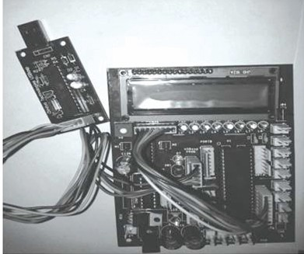

**Step 4:** Burn the hex file into the micro controller using I3AVR burner

è Click on the icon and you will get the following window:

èFirstly, select the Microcontroller i.e. ATmega16. Then, locate the .hex file of your program by clicking the browse button under the flash category and click the write button. This will write your code onto the microcontroller flash memory

**Note:** Before “Write” click, make sure the USBasp Programmer is connected with the MEGATron™ Board (i.e. development board) and power must be turn ON.

143



websit[e : **info@webteklabs.com**](http://www.i3indyatechnologies.com)

**Result:** Number will show on LCD

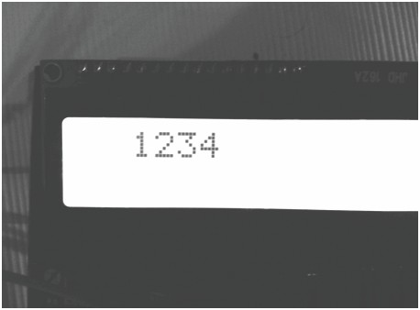

**PRACTICAL 4: DISPLAYING A TEXT ON LCD**

**NOTE:** PORTC is being used to communicate with the LCD.lower nibble of the PORTC will be used to give the control signals while higher nibble of the PORTC will be used to give the data to the LCD after breaking the data into higher and lower nibble

PC0 is connected to RS

PC1 is connected to RW

PC2 is connected to EN

PC3 is not connectedto any pin

PC4 is connected to D4 of LCD

PC5 is connected to D5 of LCD

PC6 is connected to D6 of LCD

PC7 is connected to D7 of LCD

You can test this code on i3indya development board as LCD in i3indya development board utilizes 1 PORT for connecting LC D with ATmega16

websit[e : **info@webteklabs.com**](http://www.i3indyatechnologies.com)

144

**Flow chart:**

***Code:***

*#define F_CPU 16000000*

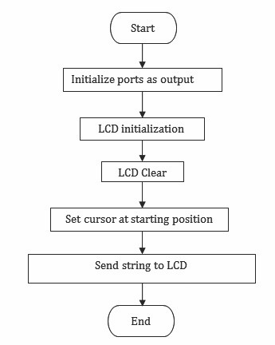

*#include<avr/io.h>*

*#include<util/delay.h>*

#define LCD_DATA_cntrl PORTC

#define en PC2

#define rw PC1

#define rs PC0

*void LCD_cmd(unsigned char cmd); void LCD_data(unsigned char data); void LCD_init();*

*void disp_cmd(unsigned char c); void disp_data(unsigned char d); void LCD_clear();*

*void LCD_string(unsigned char *str);*

*int main()*

*{ DDRC=0xff;*

*DDRB=0xff;*

*LCD_init();*

*while(1)*

*{ LCD_clear();*

*disp_cmd(0x80);*

*LCD_string("i3indya Tech");*

*_delay_ms(100);*

*}*

*return 0;*

*}*

145

websit[e : **info@webteklabs.com**](http://www.i3indyatechnologies.com)

*void LCD_init()*

*{ disp_cmd(0x02);*

*disp_cmd(0x28);*

*disp_cmd(0x06);*

*disp_cmd(0x0c);*

*}*

*void LCD_cmd(unsigned char abc)*

*{ PORTC=abc;*

*PORTC&=~(1<<rs);*

*PORTC&=~(1<<rw);*

*PORTC |=(1<<en);*

*_delay_ms(1);*

*PORTC&=~(1<<en);*

*}*

*void LCD_data(unsigned char xyz)*

*{ PORTC=xyz;*

*PORTC |=(1<<rs);*

*PORTC&=~(1<<rw);*

*PORTC |=(1<<en);*

*_delay_ms(1);*

*PORTC&=~(1<<en);*

*}*

*void disp_cmd(unsigned char abc)*

*{ char div1;*

*div1=abc & 0xF0;*

*LCD_cmd(div1);*

*div1=((abc<<4)&0xF0);*

*LCD_cmd(div1);*

*_delay_ms(100);*

*}*

*void disp_data(unsigned char xyz)*

*{ char div;*

*div=xyz & 0xF0;*

*LCD_data(div);*

*div=((xyz<<4)&0xF0);*

*LCD_data(div);*

*_delay_ms(100);*

*}*

websit[e : **info@webteklabs.com**](http://www.i3indyatechnologies.com)

146

*void disp_data(unsigned char xyz)*

*{ char div;*

*div=xyz & 0xF0;*

*LCD_data(div);*

*div=((xyz<<4)&0xF0);*

*LCD_data(div);*

*_delay_ms(100);*

*}*

*void LCD_clear()*

*{ disp_cmd(0x01);*

*_delay_ms(200);*

*}*

*void LCD_string(unsigned char *str)*

*{ int i=0;*

*while(str[i]!='\0')*

**Write your code**

è Open the installed AVR studio 4.



147

websit[e : **info@webteklabs.com**](http://www.i3indyatechnologies.com)

è Click **“New Project”.**



è Select AVR GCC and name the project.

è Choose the location at which you want to save your project.



websit[e : **info@webteklabs.com**](http://www.i3indyatechnologies.com)

148

èSelect the simulator (AVR simulator in our case) and Atmega16 in device panel.



è Now start writing your code in the editor window



149

websit[e : **info@webteklabs.com**](http://www.i3indyatechnologies.com)

è After writing your code, click on “Build”. Option in the menu.

è After successful building operation select. “Build and Run.”

è To Burn/feed the program inside the Microcontroller, refer to “Getting the microcontroller

Ready for programming” article.

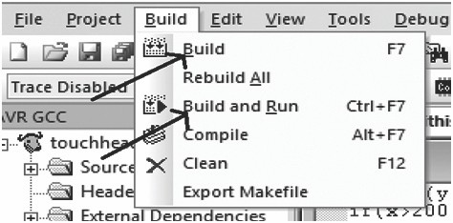

**Hardware Setup:**

**Step1:** Components Required

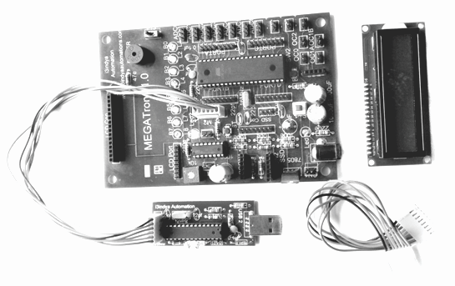

websit[e : **info@webteklabs.com**](http://www.i3indyatechnologies.com)

150

**Step 2:** Connecting the programmer with the development board

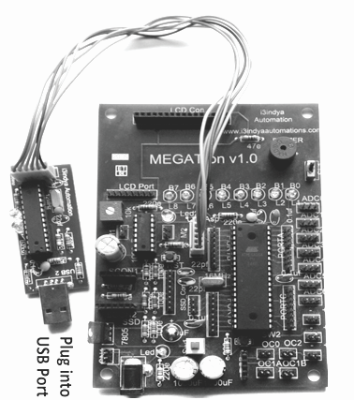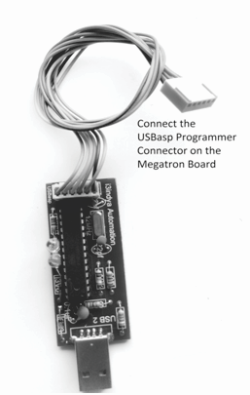

**Step3:** Connect the 8 Pin connector at PORTC and at LCD port and connect LCD.



151

websit[e : **info@webteklabs.com**](http://www.i3indyatechnologies.com)

**Step 4:** Burn the hex file into the micro controller using I3AVR burner

è Click on the icon and you will get the following window:



**Result:** Text will show on LCD.

èFirstly, select the Microcontroller i.e. ATmega16. Then, locate the .hex file of your program by clicking the browse button under the flash category and click the write button. This will write your code onto the microcontroller flash memory

**Note:** Before “Write” click, make sure the USBasp Programmer is connected with the MEGATron™ Board (i.e. development board) and power must be turn ON.

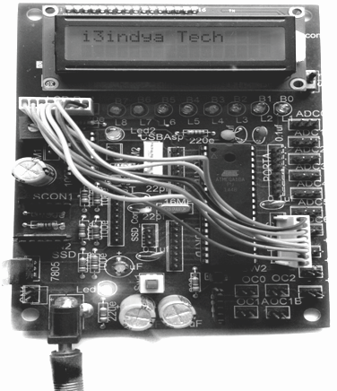

websit[e : **info@webteklabs.com**](http://www.i3indyatechnologies.com)

152

4

-

DAY

TOPICS TO BE COVERED

è LCD interfacing continues…..

PRACTICAL'S TO BE PERFORMED

è Scrolling text on LCD

è Creating simple animations on LCD

Projects To Be Completed

è Digital Clock

**Description:**

In 4th day, you will learn about the different memory types of LCD. After this you will write the program for scrolling any text on LCD. One of the great feature of LCD is, you can also design your own custom character on LCD which can be animated on LCD too. Here, You will implement your 1st project which is Digital Clock.

**Designing commands to be used with LCD**

The following table illustrates the way you can design your own commands even if you don't remember

all the LCD commands:

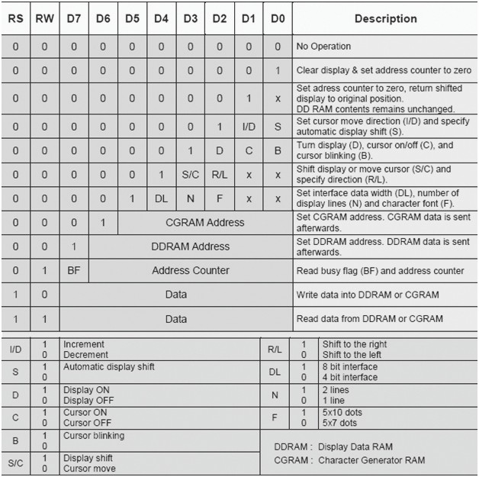

From the table it can found that the command for shifting the entire display of LCD towards left is 0x18. So, if you want to scroll the content of LCD towards left then just pass the command 0x18 after displaying the complete string on the LCD.

153

websit[e : **info@webteklabs.com**](http://www.i3indyatechnologies.com)

**PRACTICAL 6: SCROLLING TEXT ON LCD**



**NOTE:** PORTC is being used to communicate with the LCD. Lower nibble of the PORTC will be used to give the control signals while higher nibble of the PORTC will be used to give the data to the LCD after breaking the data into higher and lower nibble

PC0 is connected to RS

PC1 is connected to RW PC2 is connected to EN

PC3 is not connected to any pin PC4 is connected to D4 of LCD PC5 is connected to D5 of LCD PC6 is connected to D6 of LCD PC7 is connected to D7 of LCD

**Flow chart:-**

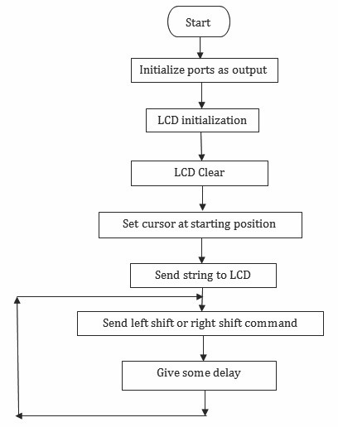

websit[e : **info@webteklabs.com**](http://www.i3indyatechnologies.com)

154

***Code:***

*#define F_CPU 16000000*

*#include<avr/io.h>*

*#include<util/delay.h>*

#define LCD_DATA_cntrl PORTC

#define en PC2

#define rw PC1

#define rs PC0

*void LCD_cmd(unsigned char cmd); void LCD_data(unsigned char data); void LCD_init();*

*void disp_cmd(unsigned char c); void disp_data(unsigned char d); void LCD_clear();*

*void LCD_string(unsigned char *str);*

*int main()*

|  |  |  |
| --- | --- | --- |
|  |  |  |
|  |  |
|  |  |
|  |  |
|  |  |
|  |  |
|  |  |
|  |  |  |
|  |  |  |
|  |  |  |
|  |  |  |
| *}* |  |  |

*{ DDRC=0xff;*

*DDRB=0xff;*

*LCD_init();*

*while(1)*

*{ LCD_clear();*

*disp_cmd(0x80);*

*LCD_string("Welcome i3indya");*

*disp_cmd(0x18); //LCD command 0x18 is for Left shifting the display*

*_delay_ms(100);*

*}*

*return 0;*

*void LCD_init()*

*{ disp_cmd(0x02);*

*disp_cmd(0x28);*

*disp_cmd(0x06);*

*disp_cmd(0x0c);*

*}*

*void LCD_cmd(unsigned char abc)*

*{ PORTC=abc;*

*PORTC&=~(1<<rs);*

*PORTC&=~(1<<rw);*

155

websit[e : **info@webteklabs.com**](http://www.i3indyatechnologies.com)

*PORTC |=(1<<en);*

*_delay_ms(1);*

*PORTC&=~(1<<en);*

*}*

*void LCD_data(unsigned char xyz)*

*{ PORTC=xyz;*

*PORTC |=(1<<rs);*

*PORTC&=~(1<<rw);*

*PORTC |=(1<<en);*

*_delay_ms(1);*

*PORTC&=~(1<<en);*

*}*

*void disp_cmd(unsigned char abc)*

*{ char div1;*

*div1=abc & 0xF0;*

*LCD_cmd(div1);*

*div1=((abc<<4)&0xF0);*

*LCD_cmd(div1);*

*_delay_ms(100);*

*}*

*void disp_data(unsigned char xyz)*

*{ char div;*

*div=xyz & 0xF0;*

*LCD_data(div);*

*div=((xyz<<4)&0xF0);*

*LCD_data(div);*

*_delay_ms(100);*

*}*

*void LCD_clear()*

*{ disp_cmd(0x01);*

*_delay_ms(200);*

*}*

*void LCD_string(unsigned char *str)*

*{ int i=0;*

*while(str[i]!='\0')*

|  |  |  |
| --- | --- | --- |
|  |  |  |
|  |  |  |
|  |  |  |
| *}* |  |  |

*{ disp_data(str[i]);*

*i++;*

*}*

websit[e : **info@webteklabs.com**](http://www.i3indyatechnologies.com)

156

**Write your code**

è Open the installed AVR studio 4.



è Click **“New Project”.**

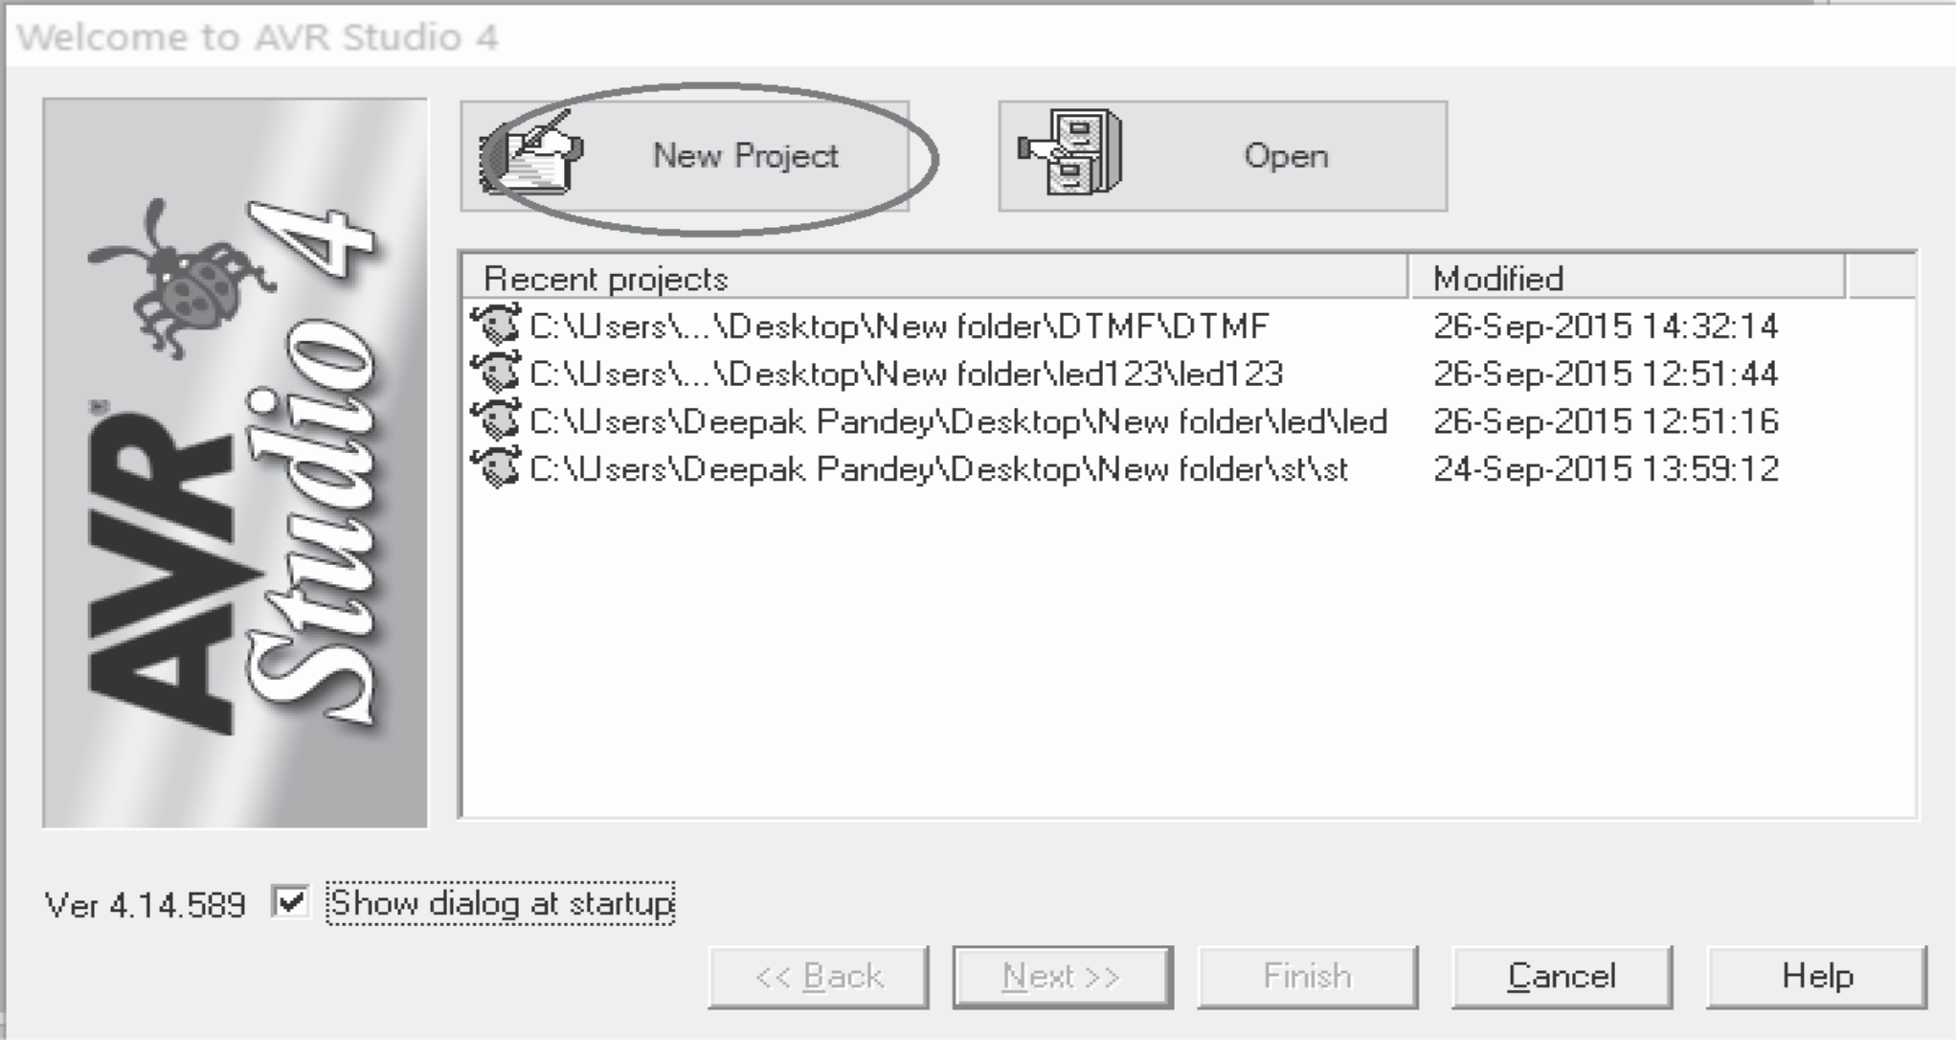

157

websit[e : **info@webteklabs.com**](http://www.i3indyatechnologies.com)

è Select AVR GCC and name the project.

è Choose the location at which you want to save your project.



èSelect the simulator (AVR simulator in our case) and Atmega16 in device panel.



websit[e : **info@webteklabs.com**](http://www.i3indyatechnologies.com)

158

è Now start writing your code in the editor window



è After writing your code, click on “Build”. Option in the menu.

è After successful building operation select. “Build and Run.”

è To Burn/feed the program inside the Microcontroller, refer to “Getting the microcontroller

Ready for programming” article.



159

websit[e : **info@webteklabs.com**](http://www.i3indyatechnologies.com)

**Hardware Setup:**

**Step1:** Components Required

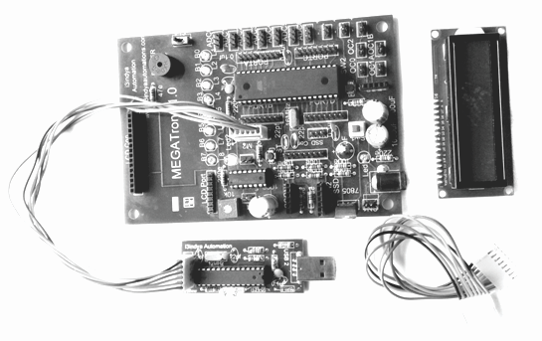

**Step 2:** Connecting the programmer with the development board

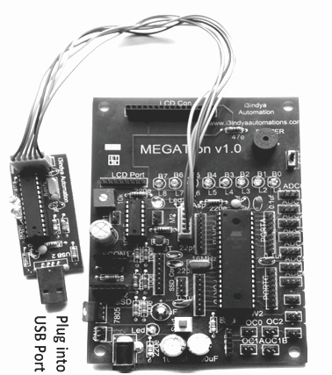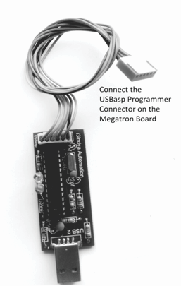

websit[e : **info@webteklabs.com**](http://www.i3indyatechnologies.com)

160

**Step3:** Connect the 8 Pin connector at PORTC and at LCD port and connect LCD.

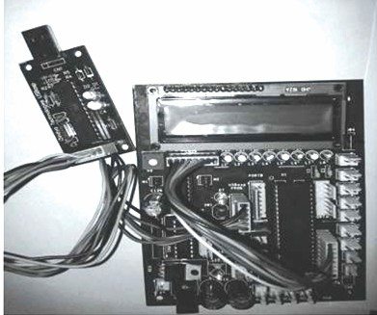

**Step 4:** Burn the hex file into the micro controller using I3AVR burner

è Click on the icon and you will get the following window:

èFirstly, select the Microcontroller i.e. ATmega16. Then, locate the .hex file of your program by clicking the browse button under the flash category and click the write button. This will write your code onto the microcontroller flash memory

**Note:** Before “Write” click, make sure the USBasp Programmer is connected with the MEGATron™ Board (i.e. development board) and power must be turn ON.

161



websit[e : **info@webteklabs.com**](http://www.i3indyatechnologies.com)

**Result:** Scrolling text will show on LCD.

**MEMORY MAPPING IN 16*2 LCD**

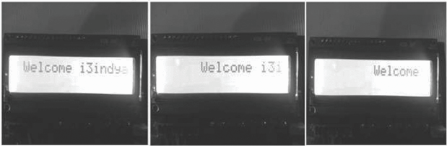

The memory of a LCD is divided into three regions. They are:

**1. DDRAM (Display data random access memory)**

**2. CGRAM (Character generation random access memory)**

**3. CGROM (Character generation read only memory)** Let's have a look on these memories one by one. **DDRAM: (Display data RAM)**

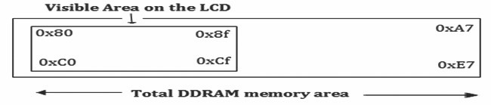

Display Data RAM (DDRAM) is the memory area used for displaying character. This is memory area associated with the display area on the LCD. A maximum of 80 characters can be stored in this memory out of which only 32 characters are visible at a time on LCD screen. These 32 characters are displayed as

16 characters in one row and rest 16 in other row. It means that in each line of LCD there are 40 character

spaces available out of which only starting 16 characters are visible on LCD screen. To display any

websit[e : **info@webteklabs.com**](http://www.i3indyatechnologies.com)

162

character on the LCD, we pass the display location (DDRAM address) to the Hitachi's microcontroller and then the character to be displayed. DDRAM memory address starts from 0x80 to 0xA7 in the first row and from 0xC0 to 0xE7 in the second row. Out of these characters displayed on memory areas from 0x80 to

0x8f are visible on the first row, while characters displayed on memory areas from 0xC0 to 0xCf are

visible on the second row.

**CGROM (Character generation ROM)**

This is the memory area where all the predefined patterns are stored. The patterns are drawn in this memory area at the time of LCD manufacturing. The patterns are stored such that their memory address is equivalent to the ASCII code for that pattern. e.g. A pattern in the form of 'A' is located at the 65th memory location in CGROM memory area. So when you pass 65 to the Hitachi's microcontroller to print

'A' on the LCD, actually the controller don't know what is 'A' or 'B' or any other character. It just takes the binary value of 65 from DR, passes this value to CGROM, CGROM them check what's there on the 65th memory location and prints the pattern on the given DDRAM address. Now, let's have a look on the characters stored in this memory.

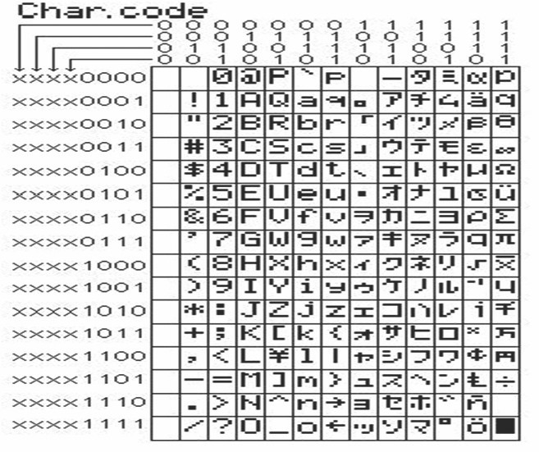

163

websit[e : **info@webteklabs.com**](http://www.i3indyatechnologies.com)

**CGRAM (Character Generator RAM)**

This area of the LCD memory is used when the user wants to create its own character like a Bell shape, a heart shape or something else. As we can see in the memory diagram, we have blank locations from 0 to 7 (a total of 8 locations). These locations are used for accessing the user defined characters created in CGRAM memory area.

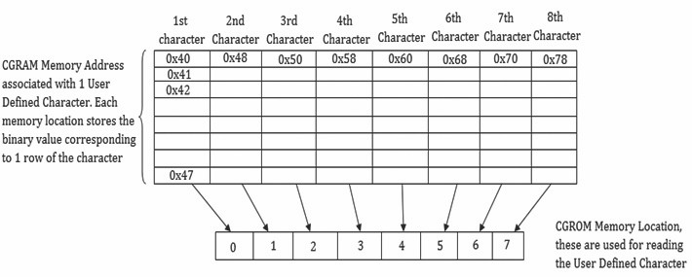

**Creating User defied Characters:**

Each pattern/character is designed in 5*7 dots matrix that means you have to design your desired character in a matrix of 5 columns and 8 rows. Each CGRAM memory location is associated with onerow of the matrix. So to store a pattern/character we consume 8 locations of CGRAM. Thus we have a total of

64 memory location of CGRAM, with the help of which we can create a maximum of 8 user defined characters. The first location of CGRAM has a memory address of 0x40 followed by 63 continuous CGRAM memory locations. Thus the first row of the user defined character is written at 0x40, the second row at

0x41, then at 0x42 till 0x47. The second character starts from 0x48, the third character at 0x50 and so on. The last character is starts at 0x77 and ends at 0x7f.

**Example:**

Let's generate “Heart” on LCD. For generating it we'll create a heart in 5*8 matrixes, and calculate the

corresponding binary value for each row to stores in each CGRAM memory location.

websit[e : **info@webteklabs.com**](http://www.i3indyatechnologies.com)

164

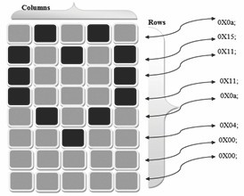

**Function for creating custom character:**

*void custom_char()*

|  |  |  |  |
| --- | --- | --- | --- |
|  |  |  |  |
|  |  |  |  |
|  |  |  |  |
|  |  |  |  |
|  |  |  |  |
|  |  |  |  |
|  |  |  |  |
|  |  |  |  |
|  |  |  |  |
|  | *}* |  |  |

*{ disp_write(0x40); // starting location of CGRAM, where I want to create the character*

*disp_data(0x0a); // for the very first row in 5*8 dots.*

*disp_data(0x15);*

*disp_data(0x11);*

*disp_data(0x11);*

*disp_data(0x0a);*

*disp_data(0x04);*

*disp_data(0x00);*

*disp_data(0x00); // code for last row in 5*8 dots.*

If this function is called in main function for displaying Heart (custom character) for a specified location then Heart would be displaying on that exact position. To read this character, you need to call the 0th memory location of CGROM.

**PRACTICAL 7: CREATING SIMPLE ANIMATION ON LCD**



**Description:**In this practical we have to display a custom character on LCD.

**NOTE:** PORTC is being used to communicate with the LCD. Lower nibble of the PORTC will be used to give the control signals while higher nibble of the PORTC will be used to give the data to the LCD after breaking the data into higher and lower nibble

165

websit[e : **info@webteklabs.com**](http://www.i3indyatechnologies.com)

PC0 is connected to RS

PC1 is connected to RW

PC2 is connected to EN

PC3 is not connected to any pin

PC4 is connected to D4 of LCD

PC5 is connected to D5 of LCD

PC6 is connected to D6 of LCD

Pc7 is connected to D7 of LCD

You can test this code on i3indya development board as LCD in i3indya development board utilizes 1 PORT for connecting LC D with ATmega16

**Flow chart:-**

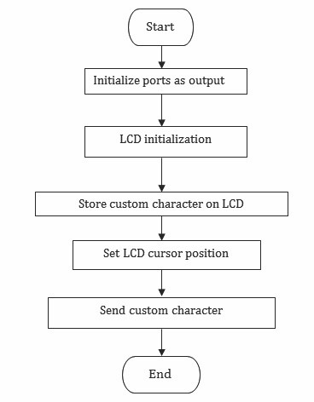

websit[e : **info@webteklabs.com**](http://www.i3indyatechnologies.com)

166

***Code:***

*#define F_CPU 16000000*

*#include<avr/io.h>*

*#include<util/delay.h>*

#define LCD_DATA_cntrl PORTC

#define en PC2

#define rw PC1

#define rs PC0

*void LCD_cmd(unsigned char cmd);*

*void LCD_data(unsigned char data);*

*void LCD_init();*

*void disp_cmd(unsigned char c);*

*void disp_data(unsigned char d);*

*void LCD_clear();*

*void LCD_string(unsigned char *str);*

*int main()*

*{ DDRC=0xff;*

*LCD_init();*

*disp_cmd(0x40);*

*disp_data(0x04);*

*disp_data(0x0e);*

*disp_data(0x0e);*

*disp_data(0x0e);*

*disp_data(0x1f );*

*disp_data(0x00);*

*disp_data(0x04);*

*disp_data(0x00);*

*while(1)*

*{ disp_cmd(0xc5);*

*disp_data(0);*

*}*

*return 0;*

*}*

*void LCD_init()*

*{ disp_cmd(0x02);*

*disp_cmd(0x28);*

*disp_cmd(0x06);*

*disp_cmd(0x0c);*

*}*

*void LCD_cmd(unsigned char abc)*

|  |  |  |
| --- | --- | --- |
|  |  |  |
|  |  |  |
|  |  | *PORTC &=~(1<<rw);* |

*{ PORTC=abc;*

*PORTC &=~(1<<rs);*

167 websit[e : **info@webteklabs.com**](http://www.i3indyatechnologies.com)

*_delay_ms(1);*

*PORTC &=~(1<<en);*

*}*

*{ PORTC=xyz;*

*PORTC |=(1<<rs);*

*PORTC &=~(1<<rw);*

*PORTC |=(1<<en);*

*_delay_ms(1);*

*PORTC &=~(1<<en);*

*}*

*{ char div1;*

*div1=abc & 0xF0;*

*LCD_cmd(div1);*

*div1=((abc<<4)&0xF0);*

*LCD_cmd(div1);*

*_delay_ms(100);*

*}*

|  |  |  |  |
| --- | --- | --- | --- |
|  |  | *PORTC |=(1<<en);* | |
|  |  |  | |
|  |  |  | |
|  |  |  | |
| *void LCD_data(unsigned char xyz)* | | | |
|  |  |  | |
|  |  |  | |
|  |  |  | |
|  |  |  | |
|  |  |  | |
|  |  |  | |
|  |  |  | |
| *void disp_cmd(unsigned char abc)* | | | |
|  |  |  | |
|  |  |  | |
|  |  |  | |
|  |  |  | |
|  |  |  | |
|  |  |  | |
|  |  |  | |
| *void disp_data(unsigned char xyz)* | | | |
|  |  |  | |
|  |  |  | |
|  |  |  | |
|  |  |  | |
|  |  |  | |
|  |  |  | |
|  |  |  | |
| *void LCD_clear()* | | | |
|  |  |  | |
|  |  |  | |
|  |  |  | |
| *void LCD_string(unsigned char *str)* | | | |
|  |  |  | |
|  |  |  | |
|  |  |  |  |
|  |  |  |  |
|  |  |  |  |
|  | *}* |  |  |

*{ char div;*

*div=xyz & 0xF0;*

*LCD_data(div);*

*div=((xyz<<4)&0xF0);*

*LCD_data(div);*

*_delay_ms(100);*

*}*

*{ disp_cmd(0x01);*

*_delay_ms(200);*

*}*

*{ int i=0;*

*while(str[i]!='\0')*

*{ disp_data(str[i]);*

*i++;*

*}*

websit[e : **info@webteklabs.com**](http://www.i3indyatechnologies.com)

168

**Write your code**

è Open the installed AVR studio 4.



è Click **“New Project”.**



169

websit[e : **info@webteklabs.com**](http://www.i3indyatechnologies.com)

è Select AVR GCC and name the project.

è Choose the location at which you want to save your project.



èSelect the simulator (AVR simulator in our case) and Atmega16 in device panel.



websit[e : **info@webteklabs.com**](http://www.i3indyatechnologies.com)

170

è Now start writing your code in the editor window



è After writing your code, click on “Build”. Option in the menu.

è After successful building operation select. “Build and Run.”

è To Burn/feed the program inside the Microcontroller, refer to “Getting the microcontroller

Ready for programming” article.



171

websit[e : **info@webteklabs.com**](http://www.i3indyatechnologies.com)

**Hardware Setup:**

**Step1:** Components Required

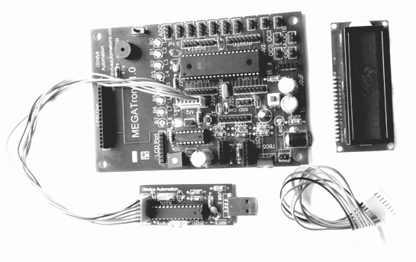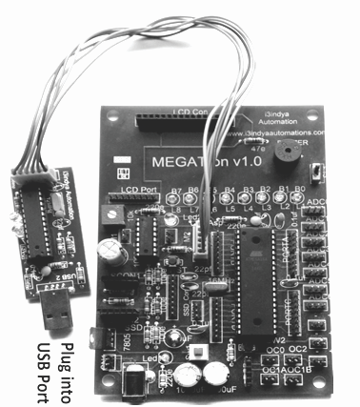

**Step 2:** Connecting the programmer with the development board

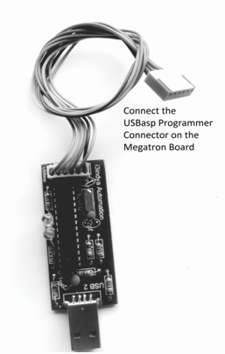

websit[e : **info@webteklabs.com**](http://www.i3indyatechnologies.com)

172

**Step3:** Connect the 8 Pin connector at PORTC and at LCD port and connect LCD.

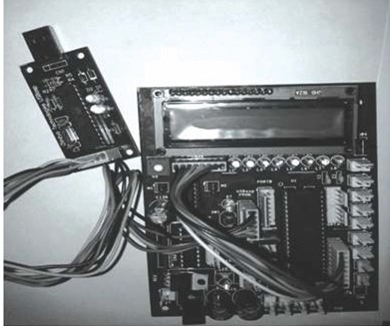

**Step 4:** Burn the hex file into the micro controller using I3AVR burner

è Click on the icon and you will get the following window:

è F i r s t ly, s e l e c t t h e M i c ro c o n t ro l l e r i . e . ATmega16. Then, locate the .hex file of your program by clicking the browse button under the flash category and click the write button. This will write your code onto the microcontroller flash memory

**Note:** Before “Write” click, make sure the USBasp Programmer is connected with the MEGATron™ Board (i.e. development board) and power must be turn ON.

173



websit[e : **info@webteklabs.com**](http://www.i3indyatechnologies.com)

**Result:** Custom character will show on LCD.

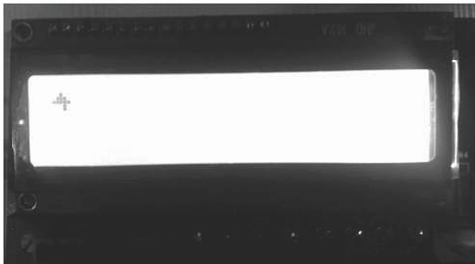

**Let's mix up what we learnt till now and develop a Digital Clock of our own**

**PROJECT 1: DIGITAL CLOCK**



**NOTE:** PORTC is being used to communicate with the LCD.lower nibble of the PORTC will be used to give the control signals while higher nibble of the PORTC will be used to give the data to the LCD after breaking the data into higher and lower nibble

PC0 is connected to RS

PC1 is connected to RW

PC2 is connected to EN

PC3 is not connectedto any pin

PC4 is connected to D4 of LCD

PC5 is connected to D5 of LCD

PC6 is connected to D6 of LCD

PC7 is connected to D7 of LCD

You can test this code on i3indya development board as LCD in i3indya development board utilizes 1 PORT for connecting LC D with ATmega16

websit[e : **info@webteklabs.com**](http://www.i3indyatechnologies.com)

174

***Code:***

*#define F_CPU 16000000*

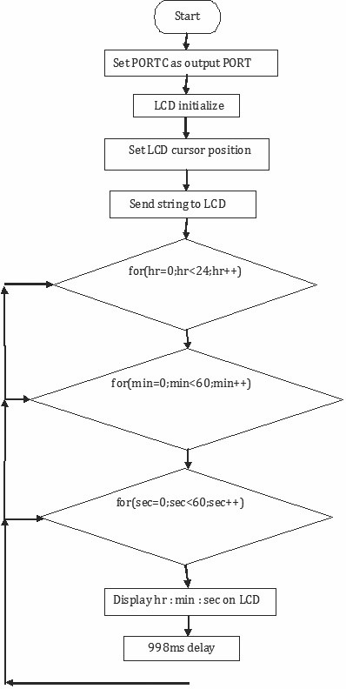

*#include<avr/io.h>*

*#include<util/delay.h>*

*#define LCD_DATA_cntrl PORTC*

*#define en PC2*

*#define rw PC1*

*#define rs PC0*

*void LCD_cmd(unsigned char cmd); void LCD_data(unsigned char data); void LCD_init();*

*void disp_cmd(unsigned char c); void disp_data(unsigned char d); void LCD_clear();*

*void LCD_string(unsigned char *str);*

*void lcd_number(unsigned int value);*

*int main()*

*{ unsigned char d,i;*

*unsigned char hr,min,sec;*

*DDRC = 0XFF;*

*lcd_init();*

*lcd_command(0x81);*

*lcd_string("Digital clock");*

*while(1)*

*{ for(hr=0;hr<24;hr++)*

*{ for(min=0;min<60;min++)*

*{ for(sec=0;sec<60;sec++)*

*{ disp_cmd(0xc4);*

*lcd_number(hr);*

*disp_cmd(0xc5);*

*disp_data(':');*

*disp_cmd(0xc7);*

*lcd_number(min);*

*disp_cmd(0xc8);*

*disp_data(':');*

*disp_cmd(0xca);*

*lcd_number(sec);*

*_delay_ms(998);*

*}*

*}*

*}*

*}*

*return 0;*

*}*

**Flow chart:**

175

websit[e : **info@webteklabs.com**](http://www.i3indyatechnologies.com)

*void LCD_init()*

*{ disp_cmd(0x02);*

*disp_cmd(0x28);*

*disp_cmd(0x06);*

*disp_cmd(0x0c);*

*}*

*void LCD_cmd(unsigned char abc)*

*{ PORTC=abc;*

*PORTC &=~(1<<rs);*

*PORTC &=~(1<<rw);*

*PORTC |=(1<<en);*

*_delay_ms(1);*

*PORTC &=~(1<<en);*

*}*

*void LCD_data(unsigned char xyz)*

*{ PORTC=xyz;*

*PORTC |=(1<<rs);*

*PORTC &=~(1<<rw);*

*PORTC |=(1<<en);*

*_delay_ms(1);*

*PORTC &=~(1<<en);*

*}*

*void disp_cmd(unsigned char abc)*

*{ char div1;*

*div1=abc & 0xF0;*

*LCD_cmd(div1);*

*div1=((abc<<4)&0xF0);*

*LCD_cmd(div1);*

*_delay_ms(100);*

*}*

*void disp_data(unsigned char xyz)*

*{ char div;*

*div=xyz & 0xF0;*

*LCD_data(div);*

*div=((xyz<<4)&0xF0);*

*LCD_data(div);*

*_delay_ms(100);*

*}*

*void LCD_clear()*

*{ disp_cmd(0x01);*

*_delay_ms(200);*

*}*

websit[e : **info@webteklabs.com**](http://www.i3indyatechnologies.com)

176

void LCD_string(unsigned char *str)

{ int i=0;

while(str[i]!='\0')

{ disp_data(str[i]);

i++;

}

}

void lcd_number(unsigned int value)

|  |  |  |
| --- | --- | --- |
|  |  |  |
|  |  |  |
|  |  |  |
|  |  |  |
|  |  |  |
|  |  |  |
|  |  |  |
|  |  |  |
|  |  |  |
| } |  |  |

{ unsigned int d=0;

disp_cmd(0x04); //auto decrement mode

d=value%10;

disp_data(d+48);

value=value/10;

d=value%10;

disp_data(d+48);

disp_cmd(0x06); //auto increment mode

**Write your code**

è Open the installed AVR studio 4.



177

websit[e : **info@webteklabs.com**](http://www.i3indyatechnologies.com)

è Click **“New Project”.**



è Select AVR GCC and name the project.

è Choose the location at which you want to save your project.



websit[e : **info@webteklabs.com**](http://www.i3indyatechnologies.com)

178

èSelect the simulator (AVR simulator in our case) and Atmega16 in device panel.



è Now start writing your code in the editor window



179

websit[e : **info@webteklabs.com**](http://www.i3indyatechnologies.com)

è After writing your code, click on “Build”. Option in the menu.

è After successful building operation select. “Build and Run.”

è To Burn/feed the program inside the Microcontroller, refer to “Getting the microcontroller

Ready for programming” article.



**Hardware Setup:**

**Step1:** Components Required

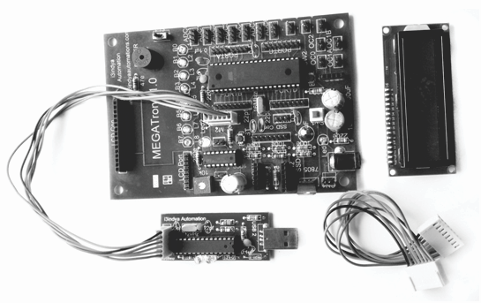

websit[e : **info@webteklabs.com**](http://www.i3indyatechnologies.com)

180

**Step 2:** Connecting the programmer with the development board

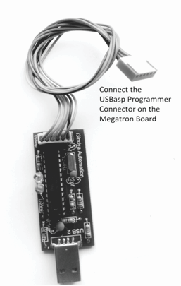

**Step3:** Connect the 8 Pin connector at PORTC and at LCD port and connect LCD.

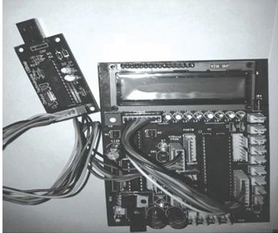

181

websit[e : **info@webteklabs.com**](http://www.i3indyatechnologies.com)

**Step 4:** Burn the hex file into the micro controller using I3AVR burner

è Click on the icon and you will get the following window:



**Result:** Digital clock will show on LCD.

èFirstly, select the Microcontroller i.e. ATmega16. Then, locate the .hex file of your program by clicking the browse button under the flash category and click the write button. This will write your code onto the microcontroller flash memory

**Note:** Before “Write” click, make sure the USBasp Programmer is connected with the MEGATron™ Board (i.e. development board) and power must be turn ON.

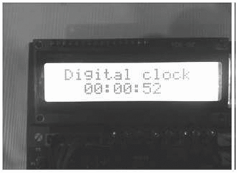

websit[e : **info@webteklabs.com**](http://www.i3indyatechnologies.com)

182

Ø **Check your ability…**

**1. WAP to scroll the string from left to right.**

**2. WAP to scroll the string from right to left.**

**3. WAP to display strings at both the rows and clear it after sometime.**

**4. WAP to display any number on the LCD.**

**5. WAP to make Ringing BELL application on LCD.**

183

websit[e : **info@webteklabs.com**](http://www.i3indyatechnologies.com)

TOPICS TO BE COVERED

5

-

DAY

è Interfacing DC Motors with Atmega1

è IC L293D and its need

è Interfacing Stepper Motor with ATmega16

PRACTICAL'S TO BE COVERED

è Learning interfacing of DC motors with

LED and LCD

è Controlling the direction of rotation of motion of the DC motors

è Rotation in forward and backward direction

è Controlling the speed of the stepper motor

è Rotating the stepper motor at/to a given angle/distance

**Description:**

In 5th day, you will learn about the working of different types of motors/actuators.You will learn about the motors drivers L293D, ULN2803 with the explanation of H-bridge which is used to control the direction of rotation of motors. Here you will learn about DC and Stepper motor and about its programming with Atmega16.

**DC MOTOR INTERFACING**



An electric motor is an electromechanical device that converts electrical energy into mechanical energy. Most electric motors operate through the interaction of magnetic fields and current-carrying conductors to generate force. These are the different types of motors available:

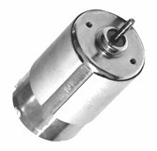

Ÿ DC motor

Ÿ Stepper motor

Ÿ Servo motor

Ÿ Universal motor

**DC motor:**

A DC motor is an electric motor that runs on direct current (DC) electricity. DC motor has simply two wires coming out of the mechanical chassis (covering). These two wires are used to provide the DC supply to the DC motor.

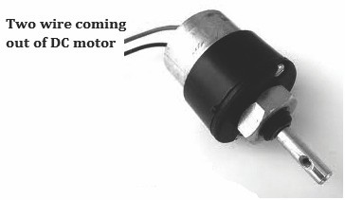

The DC motor is a non-polar device i.e. that the polarity of the DC motor is not fixed. You can provide any polarity on these wires. When you apply a DC supply, it will rotate in one direction and its direction can be changed by changing the polarity of the DC supply. DC motors can operate directly from rechargeable batteries, which provided the motive power for the first electric vehicles.

***Principle of operation-***

Ÿ The internal configuration of a DC motor is designed to harness the magnetic interaction

between a current-carrying conductor and an external magnetic field to generate

|  |  |  |
| --- | --- | --- |
|  | Ÿ | In any electric motor, operation is based on simple electromagnetism. |
|  |  |
|  |  |  |
|  |  | rotational motion. |

184

websit[e : **info@webteklabs.com**](http://www.i3indyatechnologies.com)

We don't connect DC motor with microcontroller directly because the amount of current output from the microcontroller pin , when the pin is declared as output and a logic '1' is provided on that pin is not sufficient enough to generate a magnetic field which can rotate the shaft. Thus we need to amplify the current coming out from the pin of the microcontroller. So to connect a motor with a microcontroller we need an interfacing IC which is also called driver IC. There are different types of driver IC available depending upon the current and voltage ratings like L293D, L298D, ULN2803 and so many…. So choose the driver IC depending upon your usage and use motors in your projects.

***We use L293D as a driver IC to interface motors with microcontrollers-***

The L293D is ideal for controlling the forward/reverse/brake motions of small DC motors controlled by a microcontroller such as an AVR, 8051 microcontroller. The L293D is a quadruple push-pull 4 channel driver capable of delivering 600mA per channel. One l293D is capable of driving two DC motor at a time. Features-

Ÿ 600mA output current capability per driver.

Ÿ Wide supply voltage range 4.5 volt to 36 volt.

Ÿ Separate input-logic supply. **How the IC amplifies the current????? , Let's investigate it. The IC L293D actually consists of two H-bridges. What is H-Bridge??????**

**H-Bridge:** It is a simple electronics circuit used for switching a bi-stable device (a device with two stable states is referred as bi-stable device e.g motor with two directions of rotation, clockwise and anti- clockwise) between its states.

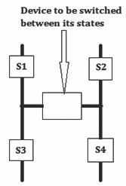

websit[e : **info@webteklabs.com**](http://www.i3indyatechnologies.com)

185

**The switches S1, S2, S3 and S4 are Darlington pairs which are being operated as switch. Darlington Pair:** It is a pair of transistors connected back to back to amplify the current.

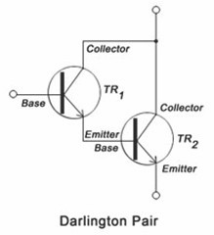

Now let's have a look how a DC motor is operated using a H-Bridge………

We develop the make the following connection shown in the diagram below. The switches S3 and S4 are grounded while the direction of motion of the motor will now depend upon the values available at Input 1 and Input 2.

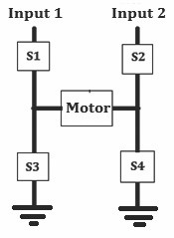

186

websit[e : **info@webteklabs.com**](http://www.i3indyatechnologies.com)

**There are four cases with two inputs. Let's provide each input pair and have a look at the output.**

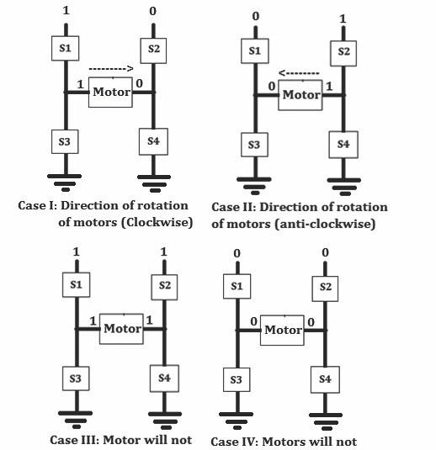

So we can confer from the above discussion that the motor will only rotate if there is a difference in the

inputs at the two terminals i.e. 1 on input 1 while 0 on input 2 and vice versa.

The functioning is implemented in the H-bridges available in IC L293D. So lets' have a look at the pin

diagram of IC L293D.

websit[e : **info@webteklabs.com**](http://www.i3indyatechnologies.com)

187

**PIN diagram-** It is a 16 pin IC withfour input pins and four output pins. This single IC has a property to

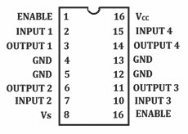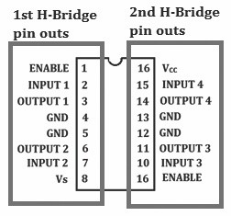

drive two DC motors at a time.

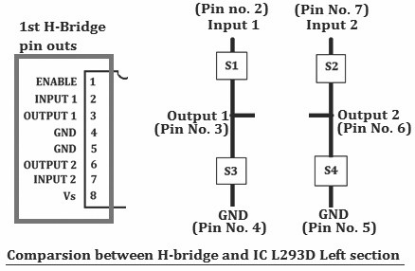

188

websit[e : **info@webteklabs.com**](http://www.i3indyatechnologies.com)

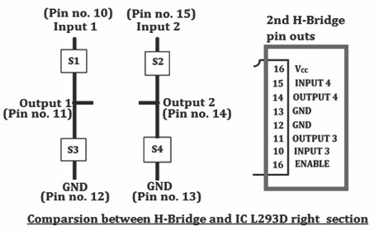

The two pins ENABLE 1 and ENABLE 2 at pin nos. 1 and 16 of L293D are for enabling the two H-bridges if you want to use these two H-bridge otherwise enable only that section that you want to use. They are enabled by connecting these pins to 5V

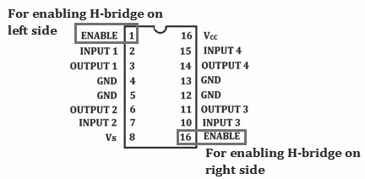

websit[e : **info@webteklabs.com**](http://www.i3indyatechnologies.com)

189

So only two more pins are left unused in the complete IC, let's have a look at them.

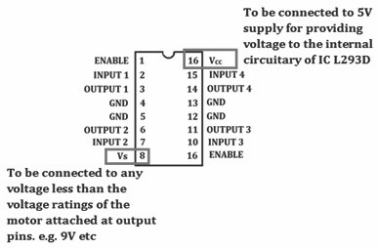

Let's summaries the complete L293D circuit with motor attached at its place.

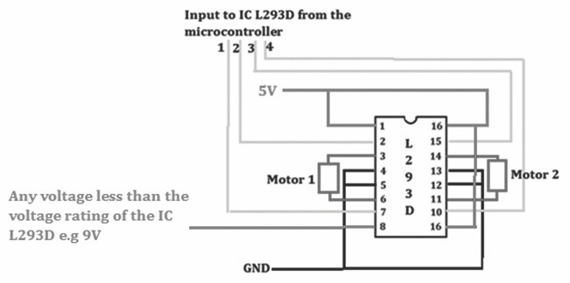

Before developing our own robots, let's have a look at the way the robot will move.

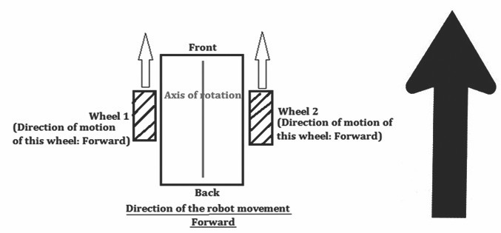

190

websit[e : **info@webteklabs.com**](http://www.i3indyatechnologies.com)

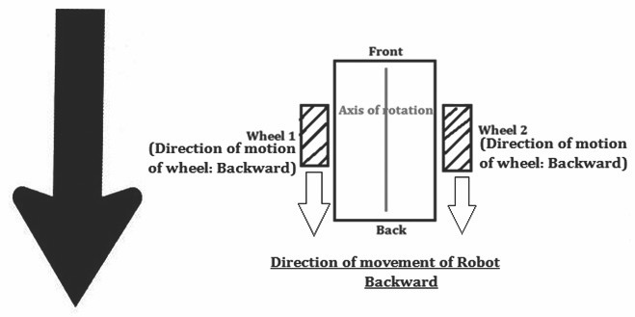

Now, thinking of how to turn the robot towards either of the side. The solution is the use of Differential Drive Mechanism

**Differential Drive Mechanism**

This is a driving mechanism used for turning the robots. This mechanism utilizes the difference of speed between the two rotating wheels. The robot can turn to either left or right. It can be implemented in three ways. Let's have a look at each of the ways one by one.

**CASE I: Move one forward while the other Backward**

In this the wheel which moves backward decides the direction of movement of the robot.

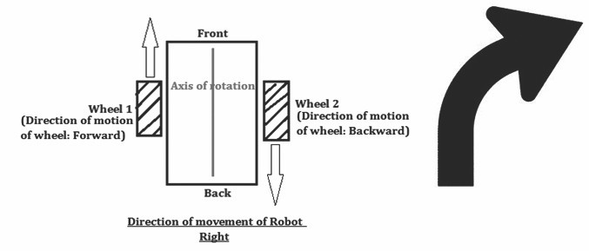

websit[e : **info@webteklabs.com**](http://www.i3indyatechnologies.com)

191

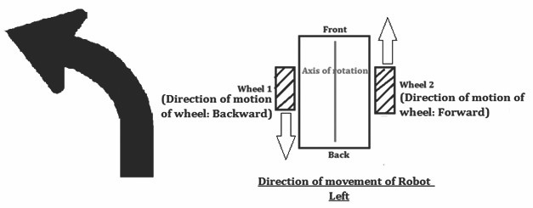

**CASE II: Move one while stop the other**

In this, the wheel which is not moving decides the direction of movement of the robot.

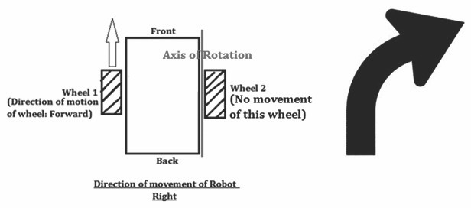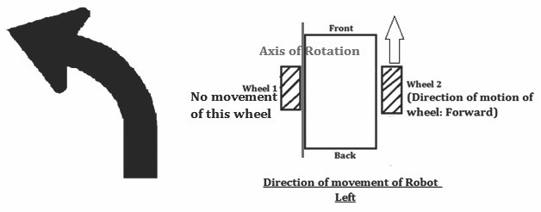

192

websit[e : **info@webteklabs.com**](http://www.i3indyatechnologies.com)

**CASE III: Move one faster than the other**

In this, the wheel which moves slower decides the direction of movement of the robot.

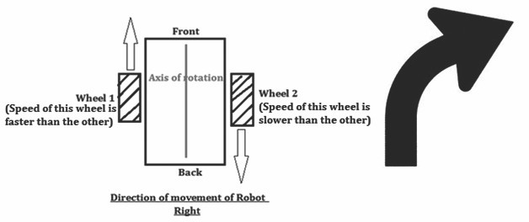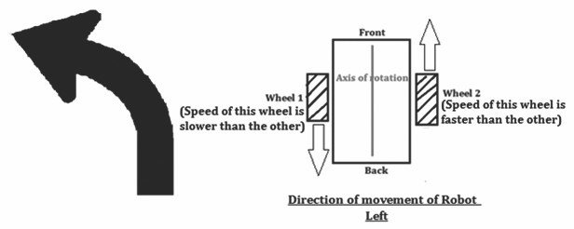

websit[e : **info@webteklabs.com**](http://www.i3indyatechnologies.com)

193

**MOTORS ON**



**i3indya DEVELOPMENT BOARD**

*The 4 input pins of the IC L293D are connected to PB0, PB1, PB2& PB3 on Atmega16. M1 (Motor 1) is connected between PB0 & PB1, while M2(Motor 2) is connected between PB2 & PB3. In order to run the motors you need to declare PORTB as output and give your signals accordingly.*

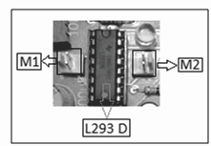

**PRACTICAL 8: Learning interfacing of DC motors with LEDs and LCD**

**Connection Diagram with ATmega16**

**NOTE:** *PORTD is being used to communicate with the LCD.lower nibble of the PORTD will be used to give the control signals while higher nibble of the PORTD will be used to give the data to the LCD after breaking the data into higher and lower nibble*

*PD0 is connected to RS*

*PD1 is connected to RW*

*PD2 is connected to EN*

*PD3 is not connectedto any pin*

*PD4 is connected to D4 of LCD*

*PD5 is connected to D5 of LCD*

*PD6 is connected to D6 of LCD*

*PD7 is connected to D7 of LCD*

194

websit[e : **info@webteklabs.com**](http://www.i3indyatechnologies.com)

*The motors are connected on PB0, PB1, PB2 & PB3, also the LEDs are connected on PORTB*

*You can test this code on i3indya development board as LCD in i3indya development board*

*utilizes 1 PORT for connecting LC D with ATmega16*

**Connection Diagram:**

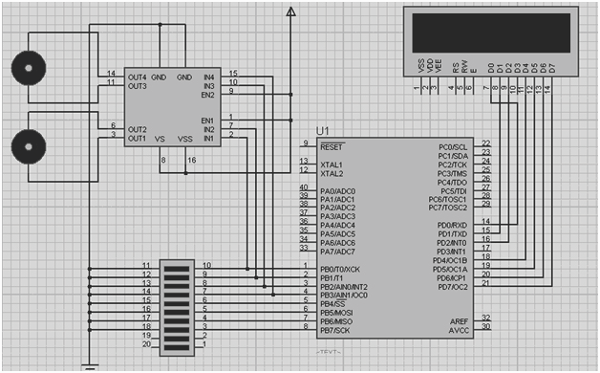

websit[e : **info@webteklabs.com**](http://www.i3indyatechnologies.com)

195

**Flowchart:**

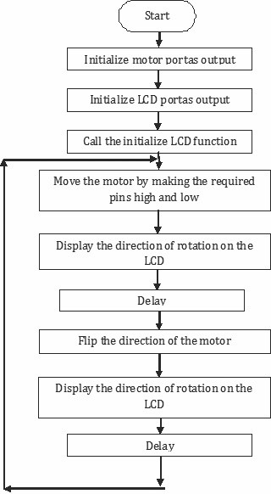

196 websit[e : **info@webteklabs.com**](http://www.i3indyatechnologies.com)

***Code:***

*#include<avr/io.h>*

*#include<util/delay.h>*

*#define LCD_DATA_cntrl PORTD*

*#define en PD2*

*#define rw PD1*

*#define rs PD0*

*voidLCD_cmd(unsigned char cmd); voidLCD_data(unsigned char data); voidLCD_init(); voiddisp_cmd(unsigned char c); voiddisp_data(unsigned char d); voidLCD_clear(); voidLCD_string(unsigned char *str); voidlcd_number(unsigned int value);*

*int main()*

*{ unsigned char d;*

*DDRB = 0xFF;*

*DDRD = 0XFF;*

*lcd_init();*

*while(1)*

*{ disp_cmd(0x80);*

*LCD_string(" Clockwise ");*

*PORTB=0b00000010;*

*_delay_ms(2000);*

*disp_cmd(0x80);*

*LCD_string(" Anticlockwise ");*

*PORTB=0b00000001;*

*_delay_ms(2000);*

*}*

*return 0;*

*}*

*voidLCD_init()*

*{ disp_cmd(0x02);*

*disp_cmd(0x28);*

*disp_cmd(0x06);*

*disp_cmd(0x0c);*

*}*

*voidLCD_cmd(unsigned char abc)*

*{ PORTD=abc;*

*PORTD &=~(1<<rs);*

*PORTD &=~(1<<rw);*

*PORTD |=(1<<en);*

*_delay_ms(1);*

*PORTD &=~(1<<en);*

*}*

websit[e : **info@webteklabs.com**](http://www.i3indyatechnologies.com)

197

*voidLCD_data(unsigned char xyz)*

*{ PORTD=xyz;*

*PORTD |=(1<<rs);*

*PORTD &=~(1<<rw);*

*PORTD |=(1<<en);*

*_delay_ms(1);*

*PORTD &=~(1<<en);*

*}*

*voiddisp_cmd(unsigned char abc)*

*{ char div1;*

*div1=abc& 0xF0;*

*LCD_cmd(div1);*

*div1=((abc<<4)&0xF0);*

*LCD_cmd(div1);*

*_delay_ms(100);*

*}*

*voiddisp_data(unsigned char xyz)*

*{ char div;*

*div=xyz & 0xF0;*

*LCD_data(div);*

*div=((xyz<<4)&0xF0);*

*LCD_data(div);*

*_delay_ms(100);*

*}*

*voidLCD_clear()*

*{ disp_cmd(0x01);*

*_delay_ms(200);*

*}*

*voidLCD_string(unsigned char *str)*

*{ int i=0;*

*while(str[i]!='\0')*

*{ disp_data(str[i]);*

*i++;*

*}*

*}*

*voidlcd_number(unsigned int value)*

*{ unsignedint d=0;*

*disp_cmd(0x04); //auto decrement mode*

*d=value%10;*

*disp_data(d+48);*

*value=value/10;*

*d=value%10;*

*disp_data(d+48);*

*disp_cmd(0x06); //auto increment mode*

*}*

198 websit[e : **info@webteklabs.com**](http://www.i3indyatechnologies.com)

**Write your code**

è Open the installed AVR studio 4.



è Click **“New Project”.**



websit[e : **info@webteklabs.com**](http://www.i3indyatechnologies.com)

199

è Select AVR GCC and name the project.

è Choose the location at which you want to save your project.



èSelect the simulator (AVR simulator in our case) and Atmega16 in device panel.



200 websit[e : **info@webteklabs.com**](http://www.i3indyatechnologies.com)

è Now start writing your code in the editor window



è After writing your code, click on “Build”. Option in the menu.

è After successful building operation select. “Build and Run.”

è To Burn/feed the program inside the Microcontroller, refer to “Getting the microcontroller

Ready for programming” article.



websit[e : **info@webteklabs.com**](http://www.i3indyatechnologies.com)

201

**Hardware Setup: Step1:** Components Required

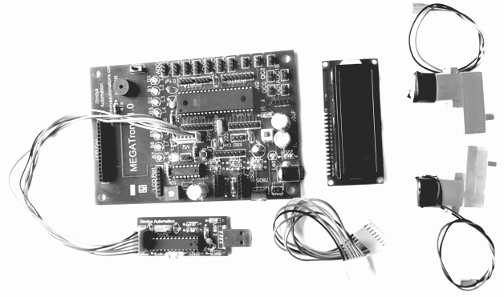

**Step 2:** Connecting the programmer with the development board

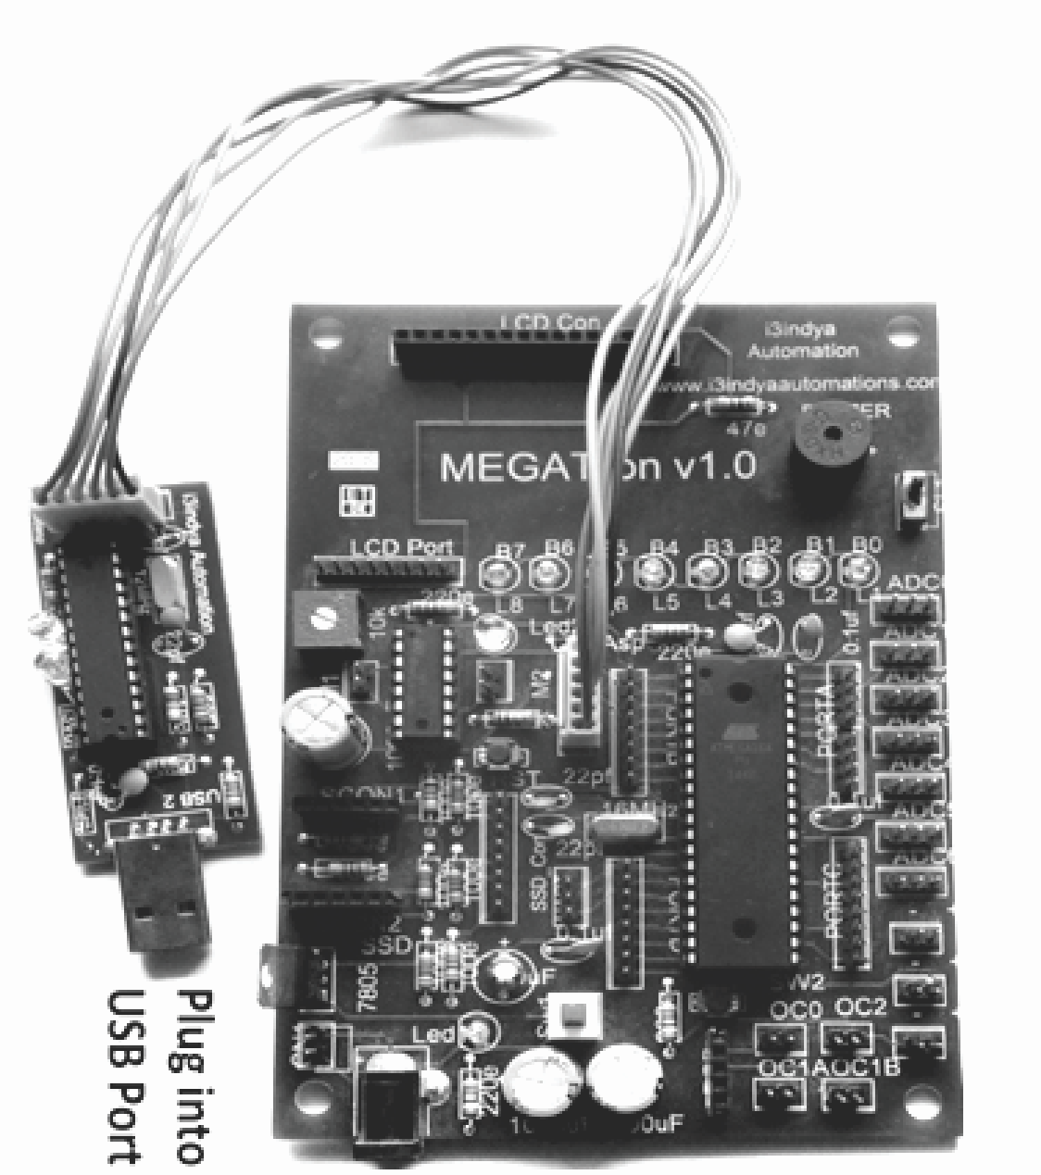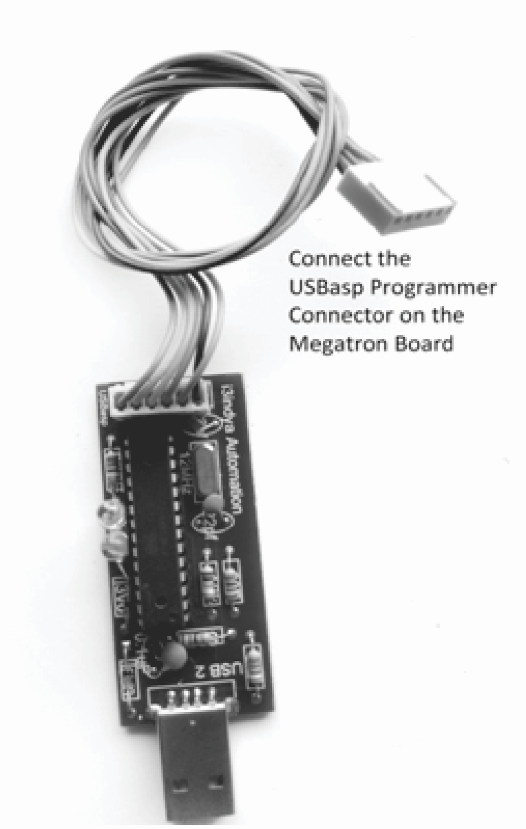

202 websit[e : **info@webteklabs.com**](http://www.i3indyatechnologies.com)

**Step3:** Connect the 8 Pin connector at PORTD and at LCD port and connect LCD.

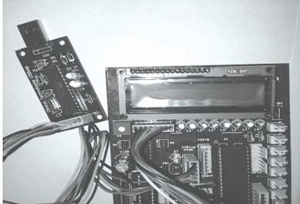

**Step4:** Connect the motors.

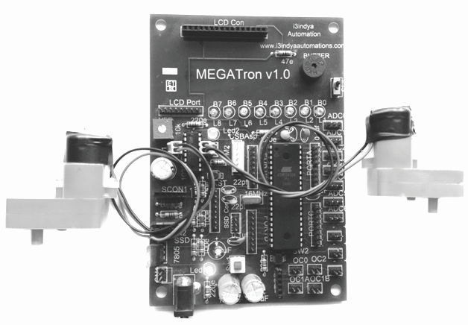

websit[e : **info@webteklabs.com**](http://www.i3indyatechnologies.com)

203

**Step 5:** Burn the hex file into the micro controller using I3AVR burner

è Click on the icon and you will get the following window:

è F i r s t ly, s e l e c t t h e M i c r o c o n t r o l l e r i . e . ATmega16. Then, locate the .hex file of your program by clicking the browse button under the flash category and click the write button. This will write your code onto the microcontroller flash memory



**Note:** Before “Write” click, make sure the USBasp Programmer is connected with the MEGATron™ Board (i.e. development board) and power must be turn ON.

**Result:** The motor moves clockwise and anti-clockwise

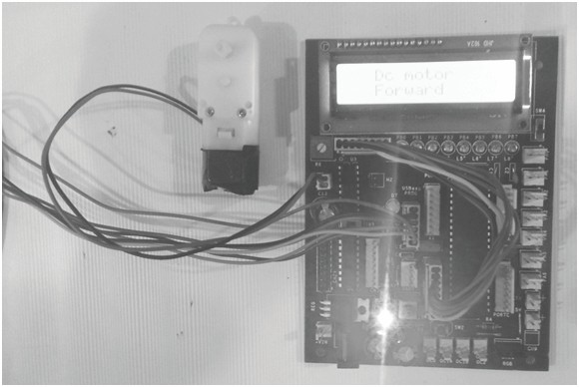

204 websit[e : **info@webteklabs.com**](http://www.i3indyatechnologies.com)

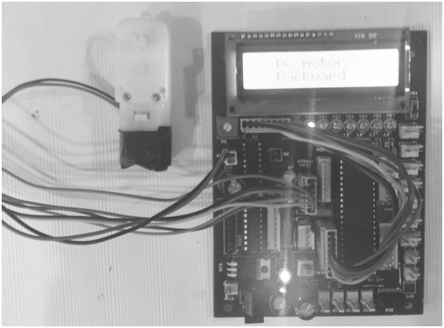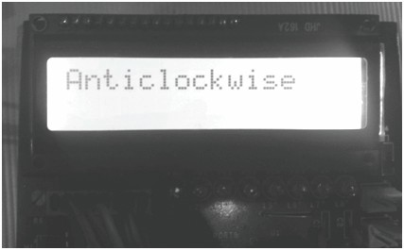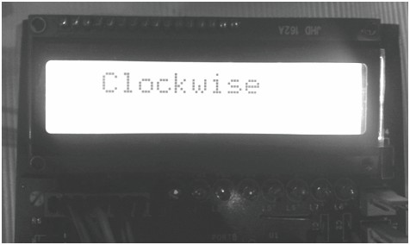

websit[e : **info@webteklabs.com**](http://www.i3indyatechnologies.com)

205

**Stepper Motors**



Stepper Motors have several features which distinguish them from AC, DC and Servo Motors. Let's

understand how a stepper motor is better than a DC motor.

1. **Exact Distance Movement:** Stepper motor are allow you to move exact distances which is not

possible with the help of DC motors e.g If you want your robot to move a distance of 5m and stop at

that location, you can't use DC motor for this operation since the DC motors may move a distance

of 5.1m or 5.2 m rather than 5.0 m which was accepted by you from the robot.

2. **Exact Angle Movement:** This is the property which cannot be exhibited by DC motors and is only

possible with the help of stepper motors. Thinking how?????? Don't worry we will look at every

aspect of stepper motors in the coming sections.

**Reason behind usage of Stepper motor in Robotics:**

**Brushless** - Steppers are brushless. Motors with contact brushes create sparks, undesirable in certain

environments. (Space missions, for example.)

**Holding Torque** - Steppers have very good low speed and holding torque. Steppers are usually rated in terms of their holding force (oz/in) and can even hold a position (to a lesser degree) without power applied, using magnetic 'detent' torque.

**Open loop positioning** - Perhaps the most valuable and interesting feature of a stepper is the ability to position the shaft in fine predictable increments, without need to query the motor as to its position. Steppers can run 'open-loop' without the need for any kind of encoder to determine the shaft position. Closed loop systems- systems that feed back position information, are known as servo systems. Compared to servos, steppers are very easy to control; the position of the shaft is guaranteed as long as the torque of the motor is sufficient for the load, under all its operating conditions.

**Load Independent** - The rotation speed of a stepper is independent of load, provided it has sufficient torque to overcome slipping. The higher rpm a stepper motor is driven, the more torque it needs, so all steppers eventually poop out at some rpm and start slipping. Slipping is usually a disaster for steppers, because the position of the shaft becomes unknown. For this reason, software usually keeps the stepping rate within a maximum top rate. In applications where a known RPM is needed under a varying load, steppers can be very handy.

206 websit[e : **info@webteklabs.com**](http://www.i3indyatechnologies.com)

**Types of steppers**

Stepper Motors come in a variety of sizes, and strengths, from tiny floppy disk motors, to huge machinery steppers rated over 1000 oz in. There are two basic types of steppers-- bipolar and unipolar. The bipolar stepper has 4 wires. Unipolar steppers have 5,6 or 8 wires. This document will discuss control of Unipolar Steppers.

**1. Unipolar Motors:**

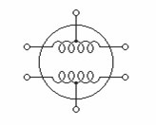

**Motor Basics**

The Unipolar Stepper motor has 2 coils, simple lengths of wound wire. The coils are identical and are not electrically connected. Each coil has a center tap - a wire coming out from the coil that is midway in length between its two terminals. You can identify the separate coils by touching the terminal wires together-- If the terminals of a coil are connected, the shaft becomes harder to turn. Because of the long length of the wound wire, it has a significant resistance (and inductance). You can identify the center tap by measuring resistance with a suitable ohm-meter (capable of measuring low resistance <10 ohm) the resistance from a terminal to the center tap is half the resistance from the two terminals of a coil. Coil resistance of half a coil is usually stamped on the motor; for example, '5 ohms/phase' indicates the resistances from center tap to either terminal of a coil. The resistance from terminal to terminal should be 10 ohms.

**Motor Control circuitry:-**

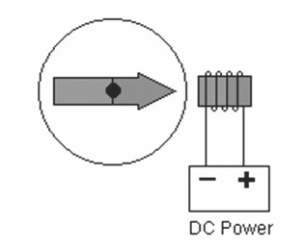

websit[e : **info@webteklabs.com**](http://www.i3indyatechnologies.com)

207

Current flowing through a coil produces a magnet field which attracts a permanent magnet rotor which is connected to the shaft of the motor. The basic principle of stepper control is to reverse the direction of current through the 2 coils of a stepper motor, in sequence, in order to influence the rotor. Since there are

2 coils and 2 directions, that gives us a possible 4-phase sequence. All we need to do is get the sequencing right and the motor will turn continuously. You may wonder how the stepper can achieve such fine stepping increments with only a 4-phase sequence. The internal arrangement of the motor is quite complex- the winding and core repeating around the perimeter of the motor many times. The rotor is advanced only a small angle, either forward or reverses, and the 4-phase sequence is repeated many times before a complete revolution occurs.

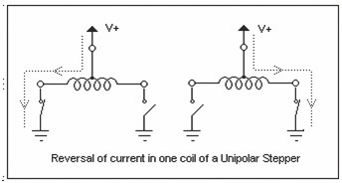

Let us return to the 4-phase sequence of reversing the current though the 2 coils. A Bipolar stepper controller achieves the current reversal by reversing the polarity at the two terminals of a coil. The Unipolar controller takes advantage of the center tap to achieve the current reversal with a clever trick -- The center tap is tied to the positive supply, and one of the 2 terminals is grounded to get the current flowing onedirection. The other terminal is grounded to reverse the current. Current can thus flow in both directions, but only half coils are energized at a time. Both terminals are never grounded at the same time, which would energize both coils, achieving nothing but a waste of power.

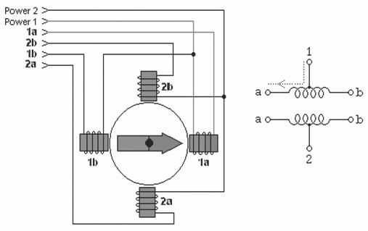

208 websit[e : **info@webteklabs.com**](http://www.i3indyatechnologies.com)

With center taps of the windings wired to the positive supply, the terminals of each winding are grounded, in sequence, to attract the rotor, which is indicated by the arrow in the picture. (Remember that a current through a coil produces a magnetic field.) This conceptual diagram depicts a 90 degree step per phase.

In a basic "Wave Drive" clockwise sequence, winding 1a is de-activated and winding 2a activated to advance to the next phase. The rotor is guided in this manner from one winding to the next, producing a continuous cycle. Note that if two adjacent windings are activated, the rotor is attracted mid-way between the two windings.

The following table describes 3 useful stepping sequences and their relative merits. The sequence pattern is represented with 4 bits; a '1' indicates an energized winding. After the last step in each sequence the sequence repeats. Stepping backwards through the sequence reverses the direction of the motor.

**Identifying stepper motors:-**

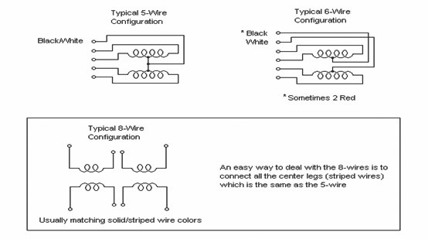

Stepper motors have numerous wires, 4, 5, 6, or 8. When you turn the shaft you will usually feel a "notched" movement. Motors with 4 wires are probably bipolar motors and will not work with a Unipolar control circuit. The most common configurations are pictured above. You can use an ohm-meter to find the center tap - the resistance between the center and a leg is 1/2 that from leg to leg. Measuring from one coil to the other will show an open circuit, since the 2 coils are not connected. (Notice that if you touch all the wires together, with power off, the shaft is difficult to turn!).

websit[e : **info@webteklabs.com**](http://www.i3indyatechnologies.com)

209

***Shortcut for finding the proper wiring sequence***

Connect the center tap(s) to the power source (or current-Limiting resistor.) Connect the remaining 4

wires in any pattern. If it doesn't work, you only need try these 2 swaps...

1 2 4 8 - (arbitrary first wiring order)

1 2 8 4 - switch end pair

1 8 2 4 - switch middle pair

You're finished when the motor turns smoothly in either direction. If the motor turns in the opposite

direction from desired, reverse the wires so that ABCD would become DCBA.

**2. Bipolar steeper motor and control**

**Introduction**

The Bipolar Stepper motor is very similar to the Unipolar Stepper discussed in part I of this Tutorial, except that the motor coils lack center taps. Because of this, the bipolar motor requires a different type of controller, one that reverses the current flow through the coils by alternating polarity of the terminals, giving us the name - Bipolar. A Bipolar motor is capable of higher torque since entire coil(s) may be energized, not just half-coils. Where 4-wire steppers are strictly 'Bipolar', 5 and 6 wire motors with center-taps can be used with the bipolar controller.

**Bipolar Basics**

The Bipolar Stepper motor has 2 coils. The coils are identical and are not electrically connected. You can identify the separate coils by touching the terminal wires together-- If the terminals of a coil are connected, the shaft becomes harder to turn.

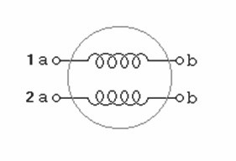

210 websit[e : **info@webteklabs.com**](http://www.i3indyatechnologies.com)

The Bipolar Controller must be able to reverse the polarity of the voltage across either coil, so current can flow in both directions. And, it must be able to energize these coils in sequence. Let us look at the mechanism for reversing the voltage across one of the coils...

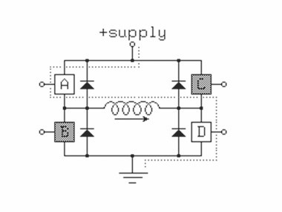

This circuit is called an H-Bridge, because it resembles a letter "H". The current can be reversed through

the coil by closing the appropriate switches - AD to flow one direction then BC to flow the opposite.

Another way of depicting the H-Bridge... Since each half of the bridge can both sink and source current, it

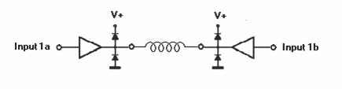

qualifies as a push-pull type amplifier, and can be drawn with the symbol for the amplifier.

H-bridges are applicable not only to the control of stepping motors, but also to the control of DC motors, solenoids and many other applications, where polarity reversal is needed. Diodes protect the switches from the kickback of inductive type loads, such as the coils of a stepper.

Two such circuits are needed to drive both coils of the bipolar stepper, and are commonly called a "Dual H- Bridge."

**Conceptual Model of Bipolar Stepper Motor**

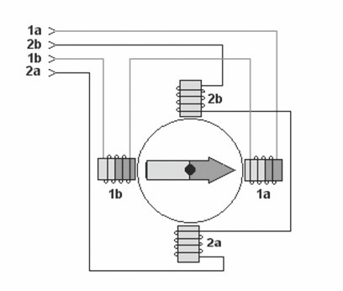

websit[e : **info@webteklabs.com**](http://www.i3indyatechnologies.com)

211

The coils are activated, in sequence, to attract the rotor, which is indicated by the arrow in the picture. (Remember that a current through a coil produces a magnetic field.) This conceptual diagram depicts a

90 degree step per phase. Assuming Terminal 1a is positive and 1b is negative, the rotor points to the East in this diagram. If these two terminals were reversed in polarity the rotor would point to the West. Coil 2 is entirely de-activated in the diagram.

In a basic "Wave Drive" clockwise sequence, winding 1 is de-activated and winding 2 activated to advance to the next phase. The rotor is guided in this manner from one winding to the next, producing a continuous cycle. Note that if two adjacent windings are activated, the rotor is attracted mid-way between the two windings.

The following table describes 3 useful stepping sequences and their relative merits. The polarity of terminals is indicated with +/-. After the last step in each sequence the sequence repeats. Stepping backwards through the sequence reverses the direction of the motor. Note that these sequences are identical to those for a Unipolar Stepper Motor.

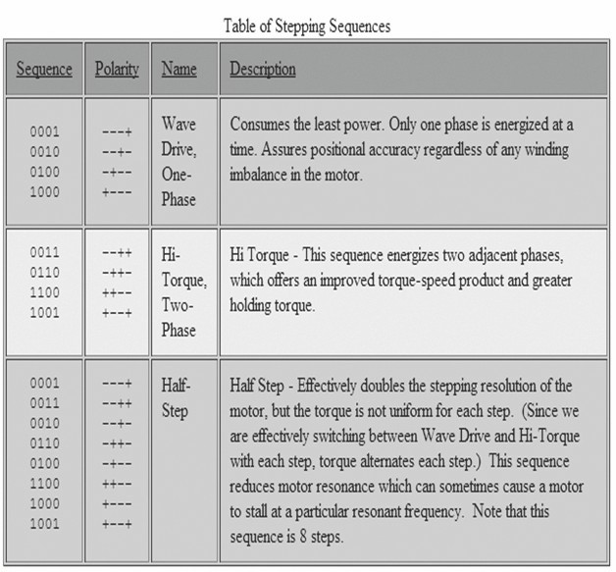

212 websit[e : **info@webteklabs.com**](http://www.i3indyatechnologies.com)

***Identifying Stepper Motors***

Stepper motors have numerous wires--4, 5, 6, or 8. When you turn the shaft you will usually feel a "notched" movement. Motors with 4 wires require a bipolar controller, such as the Dual H-Bridge. Others may be used with either a Unipolar or Bipolar controller. You can use an Ohm-meter to find the center tap-- the resistance between the center and a leg is 1/2 that from leg to leg. Measuring from one coil to the other will show an open circuit.

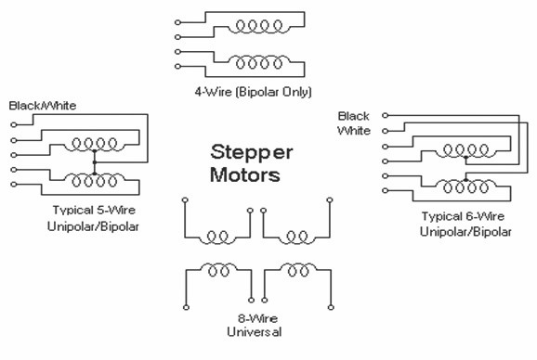

One of the benefits of the bipolar drive circuitry is that it allows us to use both "Bipolar" and "Unipolar" motors. Bipolar motors are simply Unipolar without the center taps, which simplifies construction of the motor. So we can drive 4, 6, and 8 wire steppers. Furthermore, ***Unipolar motors may be used in 2 different configurations--*** One, simply ignore the center taps. Two, use half the coil only by using the center tap and one of the terminals. This will produce less hold torque but allows higher top speeds because of the lower inductance.

websit[e : **info@webteklabs.com**](http://www.i3indyatechnologies.com)

213

***Shortcut for finding the proper wiring sequence***

Connect the 4 coil wires to the controller in any pattern. If it doesn't work at first, you only need try these

2 swaps...

1 2 4 8 - (arbitrary first wiring order)

1 2 8 4 - switch end pair

1 8 2 4 - switch middle pair

You're finished when the motor turns smoothly in either direction. If the motor turns in the opposite

direction from desired, reverse the wires so that ABCD would become DCBA.

***Selecting a current limiting resistor***

It is important that neither the motor nor controller exceed their rated currents. The value of a current- limiting resistor in series with the motor can be determined from the following equation...

Vsupply = Vdrop + (i * Rmotor) + (i * Rlimit)

Where, Vdrop = voltage drop of Transistors used (2 volts for Unipolar, 4 volts for Bipolar Drivers)

i = current in circuit

Rmotor = resistance of single motor coil

Rlimit = current limiting power resistor

The objective is to find Rlimit that satisfies the desired current rating I

For example, using a power supply of 12 volts, what current limiting resistor should be chosen to deliver 1

amp of current to a motor with a coil resistance of 5 ohms? Assume 2 volt drop due to the transistors.

12v = 2v + (1 amp * 5 ohm) + (1 amp * Rlimit)

12v = 2v + (5v) + (1 amp * Rlimit)

5v = 1 amp * Rlimit

Rlimit = 5v / 1 amp = 5 ohm

What will the voltage be across this resistor? 5v

214 websit[e : **info@webteklabs.com**](http://www.i3indyatechnologies.com)

What current will flow through this resistor? 1a

What power rating should this resistor be? 5v * 1a = 5 watt, minimum

This calculation is for determining the current in a single coil. Most motors and stepper circuits are rated in terms of this coil rating - amps per phase. If the hi-torque, or half-step sequence is to be used, then more than 1 coil will be activated, thus more current will be required of the power supply. Ideally, two matched current limiting resistors should be used, one in series with each of the 2 motor coils. (The Unipolar driver can get away with sharing a single power resistor, with the center taps tied together.) Here is the configuration for the Bipolar Controller...

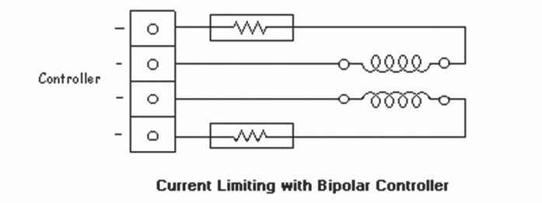

***Current Limiting with Bipolar Controller***

*Heat Considerations*

Over-heating can be an early indicator of a problem or need for additional heat sinking. This is true of both the controller and motors. Components can be warm to the touch, but not so hot that you can't leave your finger on them for a few seconds.

Motors are designed to be mounted in such a way that heat is drawn away from the motors. This is usually accomplished with a metal mounting bracket. Motors that are not yet mounted may require some type of temporary heat sinking. Motors heat more running at the LOW speeds or in Hold Mode.

If a component or motor is running too hot, try using the Wave Drive stepping mode only, if it still runs too

hot, try heat sinking, and/or a fan. If it still runs too hot, something is wrong.

In summation, make your calculations carefully, and always apply caution when making any kind of

modification to a circuit. Check the circuit often for over-heating.

websit[e : **info@webteklabs.com**](http://www.i3indyatechnologies.com)

215

**To interface stepper motor with microcontroller. We need an interfacing IC ULN 2803.**

**You have already learned about L293D in the previous topic. About ULN2803:**

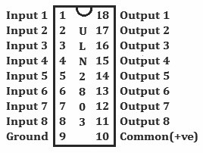

This IC is basically for interfacing the stepper motor to the micro-controller. This IC also prevents the micro-controller from the eddy current generated by the stepper motor. Thus it is also called buffer IC. Basically it's an 18 pin IC. The first eight pin are for inputs, pin 9 is for GND, pin 10 is for Vcc (common positive), and pin11 to 18 are for outputs. The input pins are directly connected with the micro-controller to take the corresponding code which is given in the program. The output of the ULN 2803 IC is just reverse of the input code given to the ULN2803 by the micro-controller through the program.

Let's have a look how a 4 –wire stepper motor is connected to microcontroller via ULN2803

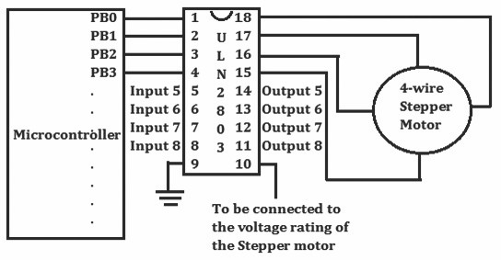

216 websit[e : **info@webteklabs.com**](http://www.i3indyatechnologies.com)

The Hex code table of a single 4 wire stepper motor is shown below. It shows the codes required to move

stepper motor in different directions. The program for the same is also given:

***Direction: Forward***

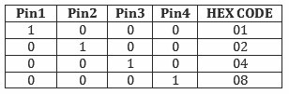

*int main()*

|  |  |  |  |
| --- | --- | --- | --- |
|  |  |  | |
|  |  |  | |
|  |  |  |  |
| *;* |  |  | *_delay_ms(5)*  *PORTB=0x02;* |
|  |  |  | *_delay_ms(5);* |
|  |  |  | *PORTB=0x04;* |
|  |  |  |  |
|  |  |  |  |
|  |  |  |  |
|  |  |  |  |
|  |  |  | |
|  | } |  | |

*{ DDRB=0xff;*

*while(1)*

*{ PORTB=0x01;*

*_delay_ms(5);*

*PORTB=0x08;*

*_delay_ms(5);*

*}*

return 0;

***Direction: Backward***

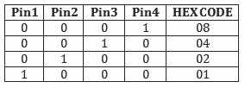

*int main ( )*

*{ DDRB=0xff;*

*while (1)*

*{ PORTB=0x08;*

*_delay_ms(5);*

*_delay_ms(5);*

|  |  |  |  |  |
| --- | --- | --- | --- | --- |
|  |  |  |  | *PORTB=0x04;* |
|  |  |  |  | *_delay_ms(5);* |
|  |  |  |  | *PORTB=0x02;* |
|  |  |  |  | *_delay_ms(5);* |
|  |  |  |  | *PORTB=0x01;* |
|  |  |  |  |  |
|  |  |  |  |  |
|  |  |  |  |  |
|  | *}* |  |  |  |

*}*

*return 0;*

websit[e : **info@webteklabs.com**](http://www.i3indyatechnologies.com)

217

Now if we want to connect two stepper motor with our microcontroller then similarly we connect it to the

remaining four pin of PORTB. In this case our programming code is like…

***Direction: Forward***

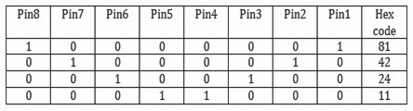

*void forward ( )*

*{ PORTB=0x81;*

*_delay_ms(5);*

*PORTB=0x42;*

*_delay_ms(5);*

*PORTB=0x24;*

*_delay_ms(5);*

*PORTB=0x18;*

*_delay_ms(5);*

*}*

***Direction: Backward***

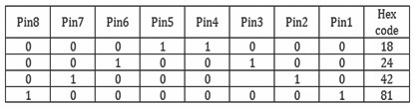

*void backward ( )*

|  |  |  |
| --- | --- | --- |
|  |  |  |
|  |  |  |
|  |  |  |
|  |  |  |
|  |  | *_delay_ms(5);* |
|  |  | *PORTB=0x42;* |
|  |  | *_delay_ms(5);* |
|  |  | *PORTB=0x81;* |
|  |  |  |
|  | *}* |  |

*{ PORTB=0x18;*

*_delay_ms(5);*

*PORTB=0x24;*

*_delay_ms(5);*

218 websit[e : **info@webteklabs.com**](http://www.i3indyatechnologies.com)

***Direction: left***

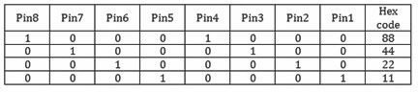

*void left ( )*

|  |  |  |
| --- | --- | --- |
|  |  |  |
|  |  |  |
|  |  |  |
|  |  |  |
|  |  |  |
|  |  |  |
|  |  |  |
|  |  |  |
|  |  |  |
|  |  |  |
|  |  |  |
|  | *}* |  |

*{ PORTB=0x88;*

*_delay_ms(5);*

*PORTB=0x44;*

*_delay_ms(5);*

*PORTB=0x22;*

*_delay_ms(5);*

*PORTB=0x11;*

*_delay_ms(5);*

***Direction: Right***

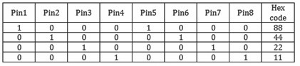

*void right ( )*

|  |  |  |
| --- | --- | --- |
|  |  |  |
|  |  |  |
|  |  |  |
|  |  |  |
|  |  |  |
|  |  |  |
|  |  |  |
|  |  |  |
|  |  |  |
|  |  |  |
|  |  |  |
|  | *}* |  |

*{ PORTB=0x88;*

*_delay_ms(5);*

*PORTB=0x44;*

*_delay_ms(5);*

*PORTB=0x22;*

*_delay_ms(5);*

*PORTB=0x11;*

*_delay_ms(5);*

websit[e : **info@webteklabs.com**](http://www.i3indyatechnologies.com)

219

**Calling of the Functions in the main program:**

*int main ( )*

*{ DDRB=0xff;*

*while(1)*

*{ Forward();*

*_delay_ms(5000);*

*PORTB=0x00;*

*_delay_ms(10);*

*Backward();*

*_delay_ms(5000);*

*PORTB=0x00;*

*_delay_ms(10);*

*Left();*

*_delay_ms(5000);*

*PORTB=0x00;*

*_delay_ms(10);*

*right();*

*_delay_ms(5000);*

*PORTB=0x00;*

*_delay_ms(10);*

*}*

*return 0;*

*}*

220 websit[e : **info@webteklabs.com**](http://www.i3indyatechnologies.com)

**Practical 9: Rotation in forward and**

**Backward Direction**



**Flowchart:**

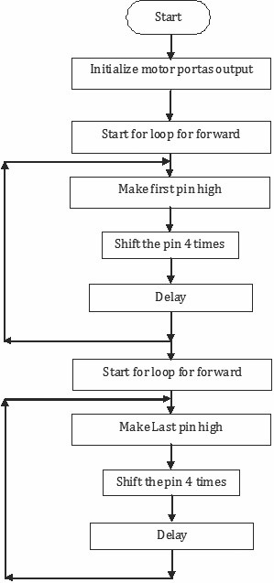

websit[e : **info@webteklabs.com**](http://www.i3indyatechnologies.com)

221

***Code:***

*#include<avr/io.h>*

*#include<util/delay.h>*

*int main()*

*{ unsignedint t=0;*

*DDRB=0xff;*

*while(1)*

|  |  |  |  |  |
| --- | --- | --- | --- | --- |
|  |  |  |  | |
|  |  |  |  | |
|  |  |  |  | |
|  |  |  |  | |
|  |  |  |  | |
|  |  |  |  | |
|  |  |  |  | |
|  |  |  |  | |
|  |  |  |  | |
|  |  |  |  | |
|  |  |  |  | |
|  |  |  |  | |
|  |  |  |  | |
|  |  |  |  | |
|  |  |  |  | |
|  |  |  |  | |
|  | | | | |
|  |  |  |  |  |
|  |  |  |  |  |
|  |  |  |  |  |
|  |  |  |  |  |
|  |  |  | *_delay_ms(1);* | *//for reverse direction* |
|  |  |  | *PORTB=0x02;* |  |
|  |  |  |  |  |
|  |  |  |  |  |
|  |  |  |  |  |
|  |  |  |  |  |
|  |  |  |  |  |
|  |  |  |  |  |
|  |  |  |  |  |
| *}*  *return 0;*  *}* | *t=0;* |  |  |  |

*{ while(t!=1000) // move backward for 10 second*

*{ PORTB=0x01;*

*_delay_ms(1);*

*PORTB=0x02;*

*_delay_ms(1); //for forward direction*

*PORTB=0x04;*

*_delay_ms(1);*

*PORTB=0x08;*

*_delay_ms(1);*

*t++;*

*}*

*t=0;*

*while(t!=1000) // move backward for 10 second*

*{ PORTB=0x08;*

*_delay_ms(1);*

*PORTB=0x04;*

*_delay_ms(1);*

*PORTB=0x01;*

*_delay_ms(1);*

*t++;*

*}*

222 websit[e : **info@webteklabs.com**](http://www.i3indyatechnologies.com)

**Write your code**

è Open the installed AVR studio 4.



è Click **“New Project”.**



websit[e : **info@webteklabs.com**](http://www.i3indyatechnologies.com)

223

è Select AVR GCC and name the project.

è Choose the location at which you want to save your project.



èSelect the simulator (AVR simulator in our case) and Atmega16 in device panel.



224 websit[e : **info@webteklabs.com**](http://www.i3indyatechnologies.com)

è Now start writing your code in the editor window



è After writing your code, click on “Build”. Option in the menu.

è After successful building operation select. “Build and Run.”

è To Burn/feed the program inside the Microcontroller, refer to “Getting the microcontroller

Ready for programming” article.



websit[e : **info@webteklabs.com**](http://www.i3indyatechnologies.com)

**Hardware Setup:**

**Step1:** Components Required

**Step 2:** Connecting the programmer with the development board

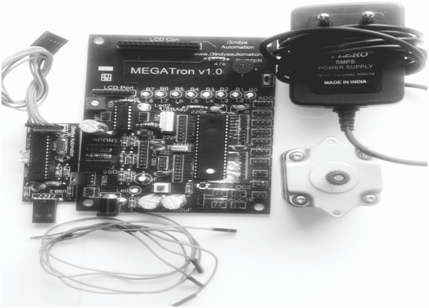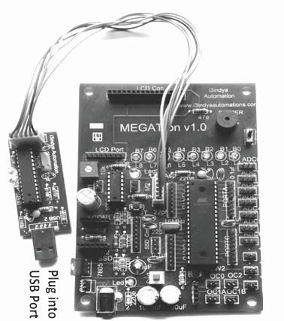

226 websit[e : **info@webteklabs.com**](http://www.i3indyatechnologies.com)

**Step 3**: Connect the motors.

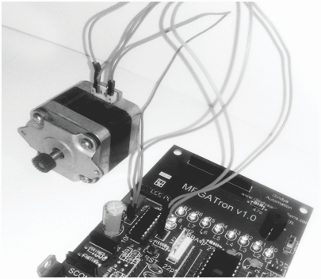

**Step 4:** Burn the hex file into the micro controller using I3AVR burner

è Click on the icon and you will get the following window:

è F i r s t ly, s e l e c t t h e M i c ro c o n t ro l l e r i . e . ATmega16. Then, locate the .hex file of your program by clicking the browse button under the flash category and click the write button. This will write your code onto the microcontroller flash memory



**Note:** Before “Write” click, make sure the USBasp Programmer is connected with the MEGATron™ Board (i.e. development board) and power must be turn ON.

websit[e : **info@webteklabs.com**](http://www.i3indyatechnologies.com)

227

**Practical 10: Controlling the speed of**

**Stepper motor**



**Flowchart:**

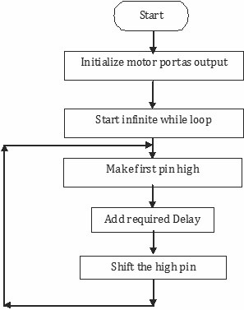

**Code:**

*#include<avr/io.h>*

*#include<util/delay.h>*

*int main()*

*{ unsignedint t=0;*

*DDRB=0xff;*

*while(1)*

*{ for (i=50;i<1000; i+50)*

|  |  |  |  |  |
| --- | --- | --- | --- | --- |
|  |  |  |  |  |
|  |  |  | *_delay_ms(i);* |
|  |  |  | *PORTB=0x02;* |
|  |  |  |  |  |
|  |  |  |  |  |
|  |  |  |  |  |
|  |  |  |  |  |
|  |  |  |  |  |
|  |  |  |  |  |
|  |  |  |  |  |
| *}*  *return 0;*  *}* |  | *}* |  |  |

*{ PORTB=0x01;*

*_delay_ms(i); //for forward direction*

*PORTB=0x04;*

*_delay_ms(i);*

*PORTB=0x08;*

*_delay_ms(i);*

228 websit[e : **info@webteklabs.com**](http://www.i3indyatechnologies.com)

**Sample Program: To rotate the robot in forward, backward, left & right**

**direction.**

***Code:***

*#include<avr/io.h>*

*#include<util/delay.h>*

*int main()*

*{ unsignedint t=0;*

*DDRB=0xff;*

*while(1)*

*{ while(t!=1000)*

*{ PORTB=0x11;*

*_delay_ms(1);*

*PORTB=0x22;*

*_delay_ms(1); //for forward direction*

*PORTB=0x44;*

*_delay_ms(1);*

*PORTB=0x88;*

*_delay_ms(1);*

*t++;*

*}*

*t=0;*

*while(t!=1000)*

*{ PORTB=0x88;*

*_delay_ms(1);*

*PORTB=0x44;*

*_delay_ms(1); //for reverse direction*

*PORTB=0x22;*

*_delay_ms(1);*

*PORTB=0x11;*

*_delay_ms(1);*

*t++;*

*}*

websit[e : **info@webteklabs.com**](http://www.i3indyatechnologies.com)

22

*t=0;*

*while(t!=1000)*

|  |  |  |  |  |  |
| --- | --- | --- | --- | --- | --- |
|  |  |  |  |  |  |
|  |  |  |  |  | *_delay_ms(1);* |
|  |  |  |  |  | *PORTB=0x20;* |
|  |  |  |  |  |  |
|  |  |  |  |  |  |
|  |  |  |  |  |  |
|  |  |  |  |  | *_delay_ms(1);* |
|  |  |  |  |  | *PORTB=0x80;* |
|  |  |  |  |  |  |
|  |  |  |  |  |  |
|  |  |  |  |  |  |
|  |  |  |  |  |  |
|  |  |  |  | *t=0;* |  |

*{ PORTB=0x10;*

*_delay_ms(1); //for right direction*

*PORTB=0x40;*

*_delay_ms(1);*

*t++;*

*}*

*while(t!=1000)*

*{ PORTB=0x01;*

*_delay_ms(1);*

*PORTB=0x02;*

*_delay_ms(1); //for left direction*

*PORTB=0x04;*

*_delay_ms(1);*

*PORTB=0x08;*

*_delay_ms(1);*

*t++;*

*}*

*t=0;*

*}*

*return 0;*

*}*

230 websit[e : **info@webteklabs.com**](http://www.i3indyatechnologies.com)

**Practical 12: Rotating Stepper motor at given Angle/Distance**

*#include<avr/io.h>*

*#include<util/delay.h>*

*int main()*

|  |  |  |  |  |  |  |
| --- | --- | --- | --- | --- | --- | --- |
|  |  | |  | | | |
|  |  | |
|  |  | |
|  |  | |  | |  |  |
|  |  |  |  |  | |  |
|  |  |  |  |  | |  |
|  |  |  |  |  | |  |
|  |  |  |  |  | |  |
|  |  |  |  |  | |  |
|  |  |  |  |  | |  |
|  |  |  |  |  | |  |
|  |  |  |  |  | |  |
|  |  |  |  |  | |  |
|  |  |  |  |  | |  |
|  |  |  |  |  | |  |
|  |  |  |  |  | |  |
|  |  |  |  |  | |  |
|  |  |  |  |  | |  |
|  |  |  |  |  | |  |
| *}* |  |  |  |  | |  |

*{ unsignedint t=0;*

*DDRB=0xff;*

*while(1)*

*{ for (i=0;i<31; i++) //To count 31 steps*

*{ PORTB=0x01;*

*_delay_ms(10);*

*PORTB=0x02;*

*_delay_ms(10); //for forward direction*

*PORTB=0x04;*

*_delay_ms(10);*

*PORTB=0x08;*

*_delay_ms(10);*

*}*

*}*

*return 0;*

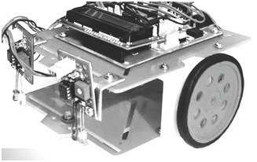Let's make Robots…

websit[e : **info@webteklabs.com**](http://www.i3indyatechnologies.com)

231

**Assemble your Chassis:**

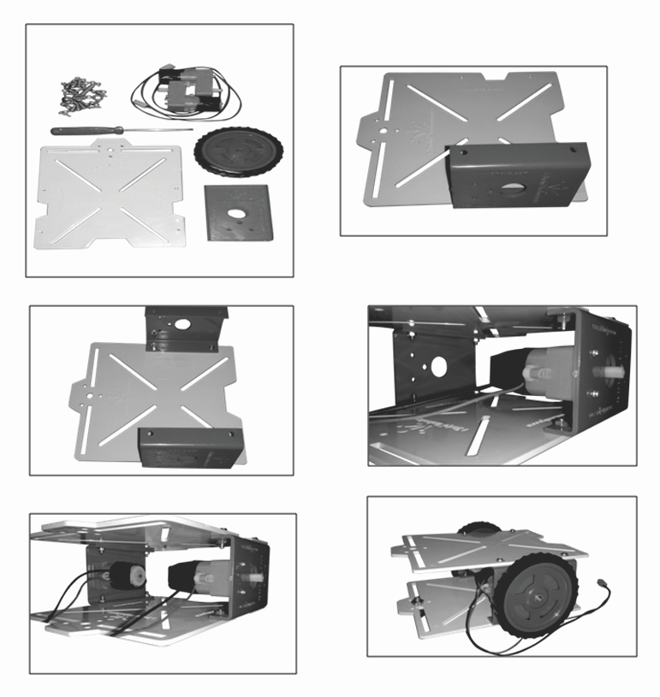

232 websit[e : **info@webteklabs.com**](http://www.i3indyatechnologies.com)

**Developing my first autonomous robot:**

Ready to develop your first robot, you don't have to think more, because it is just like LED programming, the only thing you need to know is where are input pins of L293D connected to your microcontroller. e.g if the input pins of L293D are connected on PB0, PB1, PB2 and PB3 of your microcontroller, we just have to give output on PORTS B.0, B.1,B.2 & B.3. But yes don't forget that you can't connect motors directly (just like LED, Buzzer, SSD, Dot matrix) with the microcontroller, we just have to pass through the L293D.

Ø **To move the motors in forward & reverse direction.**

*#include<avr/io.h>*

*#include<util/delay.h>*

*int main()*

*{ DDRB=0xff;*

*while(1)*

*{*

*PORTB=0b00000101; //both motors move in forward direction*

*_delay_ms (5000); // forward movement for 5 second*

*PORTB=0b00001010; // both motors move in reverse direction*

*_delay_ms (5000); // backward movement for 5 second*

*}*

*return 0;*

*}*

Ø **So interesting this time with practical!! So check your ability.**

**1) Move your first autonomous robot in all the possible directions.**

**2) Make the autonomous Robot to follow in a square.**

**3) Rotate your robot at 90 degree angle to right and left**



websit[e : **info@webteklabs.com**](http://www.i3indyatechnologies.com)